Name: ………………………………………………….. Index Number………………

443/2 Candidate’s Signature………
AGRICULTURE
Paper 2 Date…………………………
Oct/Nov 2012
2 hours

THE KENYA NATIONAL EXAMIANTIONS COUNCIL
Kenya Certificate of Secondary Education
AGRICULTURE
Paper 2
2 hours

Instructions to candidates

- Write your name and index number in the spaces provided above
- Sign and write the date of examination in the spaces provided above
- This paper consist of three sections; A B and C.
- Answer all the questions in sections A and B.
- Answer any two questions form section C.
- Answers should be written in the spaces provided
- This paper consists of 16 printed pages
443/2 – Agriculture Paper 2
Monday 11:00 am – 1:00 pm
19/11/2012 (2nd Session)
- Candidates should check the question paper to ascertain that all the pages are printed as indicated and that no questions are missing.

For Examiner’s Use Only

Section | Questions | Maximum  Score | Candidate’s  Score
A | 1 – 17 | 30
B | 18 -21 | 20
C |  | 20
C |  | 20
 | Total Score | 90

SECTION A (30 marks)

Answer ALL the questions in this section in the spaces provided

1. Apart from hides and skins, name the raw material obtained from each of the following livestock for the textile industry:

- goat ……………………………………………………………..(1/2 mark)

- sheep……………………………………………………………(1/2 mark)

- rabbit…………………………………………………………..(1/2 mark)

2. Give three reasons for candling eggs in poultry production (1 ½ marks)

……………………………………………………………………………………

……………………………………………………………………………………

……………………………………………………………………………………

3. Name two nutritional diseases of cattle (1 mark)

…………………………………………………………………………………….

…………………………………………………………………………………….

4. State two advantages of housing claves singly in cattle management (1 mark)

…………………………………………………………………………………….

…………………………………………………………………………………….

- Give four features of housing that help to control livestock diseases (2 marks)

……………………………………………………………………………………

……………………………………………………………………………………

……………………………………………………………………………………

…………………………………………………………………………………..
6. Name three methods of harvesting fish in a pond. (1 ½ marks)

……………………………………………………………………………………

……………………………………………………………………………………

……………………………………………………………………………………

7. State five methods of dehorning in cattle management (2 ½ marks)

……………………………………………………………………………………

……………………………………………………………………………………

……………………………………………………………………………………

……………………………………………………………………………………

……………………………………………………………………………………

8. Give the appropriate term that refers to each of the following:

(a) castrated chicken (1/2 mark)

…………………………………………………………………………………….

(b) young one of a rabbit (1/2 mark)

…………………………………………………………………………………….

(c) mature male goat (1/2 mark)

……………………………………………………………………………………

9. Give three ways in which farmers market beef cattle in Kenya (1 ½ marks)

……………………………………………………………………………………

……………………………………………………………………………………

……………………………………………………………………………………

10. State four causes of egg eating in a flock of layers (2 marks)

……………………………………………………………………………………

……………………………………………………………………………………

……………………………………………………………………………………

……………………………………………………………………………………

11. Name two practices that are carried out when preparing ewes for mating (1mark)

……………………………………………………………………………………

……………………………………………………………………………………

12. Give four reasons for identification in cattle management (2 marks)

……………………………………………………………………………………

……………………………………………………………………………………

……………………………………………………………………………………

…………………………………………………………………………………..

13. State three advantages of fold system in poultry rearing (1 ½ marks)

……………………………………………………………………………………

……………………………………………………………………………………

……………………………………………………………………………………

14. State four practices that immediately come after complete milking in a milking shade (2 marks)

……………………………………………………………………………………

……………………………………………………………………………………

……………………………………………………………………………………

…………………………………………………………………………………..

15. The following is a list of livestock diseases:

- Brucellosis
- Trypanosomiasis
- Newcastle
- Natrhax
- African swine fever
- Black quarter

Which two diseases are

(a) both bacterial and zoonotic? (1mark)

…………………………………………………………………………………………….

……………………………………………………………………………………………..

(b) caused by virus? (1 mark)

……………………………………………………………………………………………

…………………………………………………………………………………………….

16. State three functions of a lubrication system on a tractor. (1 ½ marks)

………………………………………………………………………………………………

………………………………………………………………………………………………

………………………………………………………………………………………………

17. Distinguish between the following terms as sued in livestock health:

(a) isolation and quarantine; (2 marks)

………………………………………………………………………………………

………………………………………………………………………………………

………………………………………………………………………………………

………………………………………………………………………………………

(b) curative drug and prophylactic drug (2 marks)

………………………………………………………………………………………

………………………………………………………………………………………

………………………………………………………………………………………

………………………………………………………………………………………

SECTION B (20 marks)

Answer ALL the questions in this section in the spaces provided

18. Below are illustrations of farm tools and equipment.

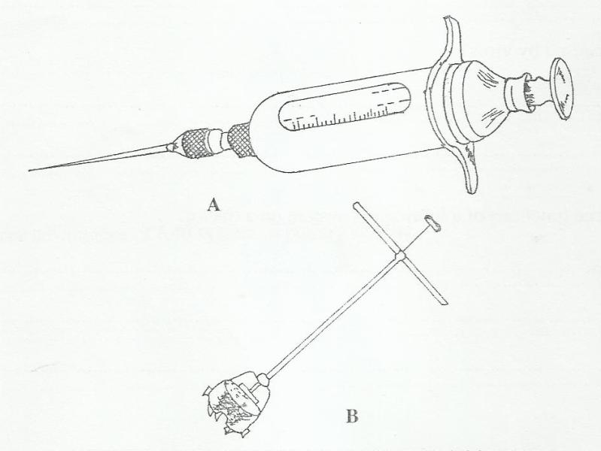

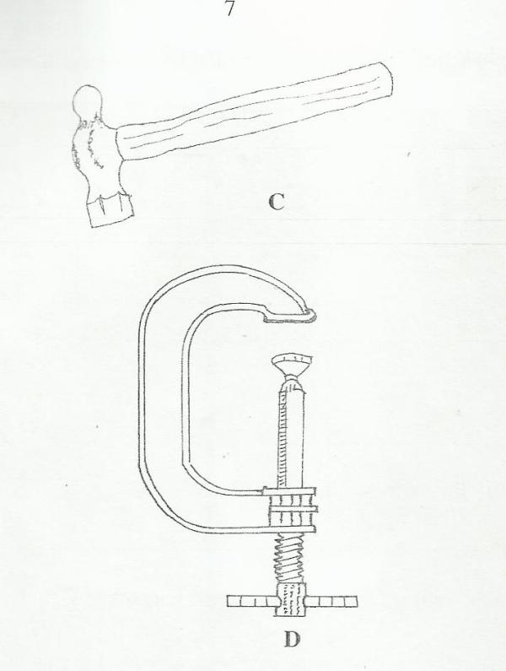

(a) Identify the tool/equipment labeled A and B.

A …………………………………………………………………… (1 mark)

B…………………………………………………………………… (1 mark)

(b) State one appropriate use of the tool labeled C. (1 mark)

……………………………………………………………………………………

(c) Explain two maintenance practices for the toll labeled D. (2 marks)

……………………………………………………………………………………..

………………………………………………………………………………………

19 The diagram below illustrates a livestock parasite.

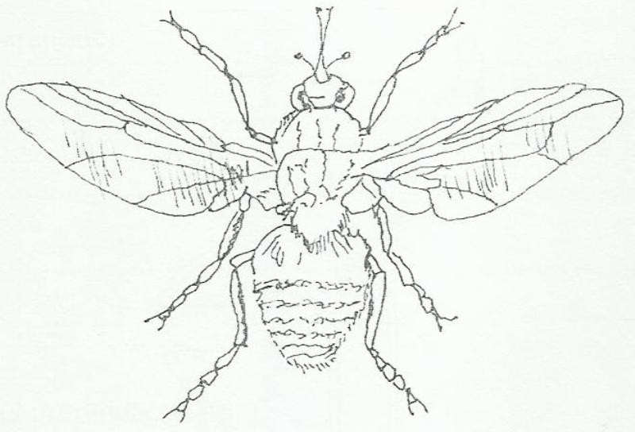

(a) Identify the parasite illustrated above. (1 mark)

………………………………………………………………………………………..

(b) State the major harmful effect of the parasite. (1 mark)

………………………………………………………………………………………

(c) Explain four control measures for the parasite (4marks)

………………………………………………………………………………………..

……………………………………………………………………………………….

……………………………………………………………………………………….

……………………………………………………………………………………….

………………………………………………………………………………………..

……………………………………………………………………………………….

……………………………………………………………………………………….

……………………………………………………………………………………….
20. The photograph below illustrates a method of identification labeled X in cattle.

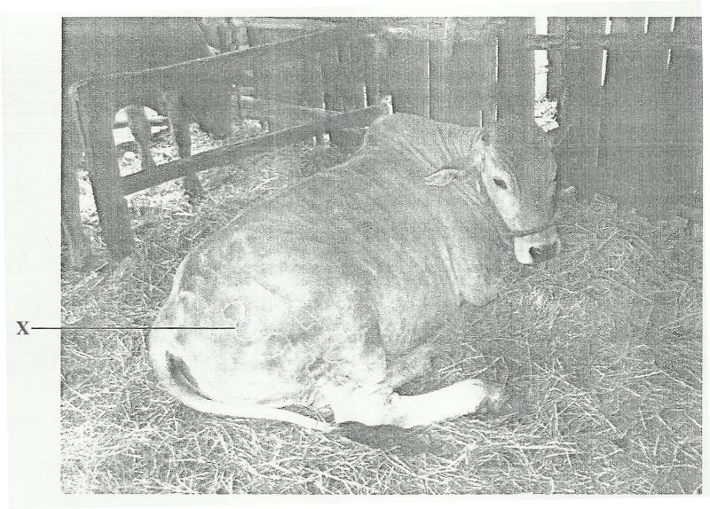

(a) Name the identification method (1 mark)

……………………………………………………………………………………

(b) Explain three disadvantages of the identification method (3 marks)

…………………………………………………………………………………….

……………………………………………………………………………………..

……………………………………………………………………………………..
21. The illustration below shows a cross section of a cattle dip.

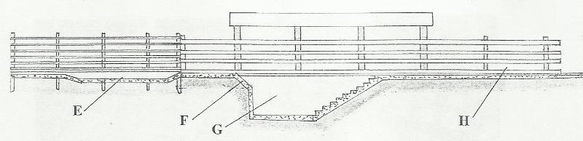

(a) Name the parts labeled E and G

E ………………………………………………………………. (1 mark)

G ………………………………………………………………. (1 mark)

(b) State one use for each of the parts labeled E, F and H (3 marks)

E ……………………………………………………………………………….

………………………………………………………………………………….

F…………………………………………………………………………………

………………………………………………………………………………….

H ………………………………………………………………………………..

…………………………………………………………………………………

SECTION C (40 marks)

Answer any TWO questions from this section in the spaces provided after question 24

22 (a) Describe the functions of the various types of pens in a piggery unit (4 marks)

(b) Describe the control measures for tapeworms (Taenia spp) in livestock (6 marks)

(c) Giving a relevant example in each case, describe the role of the various components of a balanced diet in livestock nutrition. (10 marks)

23 (a) Describe the management of one day old chicks in a brooder until they are eight weeks old. (12 marks)

(b) Give the reasons why embryo transfer use should be encouraged in dairy cattle breeding. (8 marks)

24. (a) Describe foot rot disease under the following sub-headings:

(i) casual organism (1 mark)

(ii) signs of infection (5 marks)

(iii) control measures (4 marks)

(b) Explain the importance of each of the functional differences between a disc plough and a mouldboard plough in land preparation. (10 marks)

………………………………………………………………………………………..

……………………………………………………………………………………….

……………………………………………………………………………………….

……………………………………………………………………………………….

………………………………………………………………………………………..

……………………………………………………………………………………….

……………………………………………………………………………………….

……………………………………………………………………………………….

………………………………………………………………………………………..

……………………………………………………………………………………….

……………………………………………………………………………………….

……………………………………………………………………………………….

………………………………………………………………………………………..

……………………………………………………………………………………….

……………………………………………………………………………………….

……………………………………………………………………………………….

………………………………………………………………………………………..

……………………………………………………………………………………….

……………………………………………………………………………………….

……………………………………………………………………………………….

………………………………………………………………………………………..

……………………………………………………………………………………….

……………………………………………………………………………………….

………………………………………………………………………………………..

……………………………………………………………………………………….

……………………………………………………………………………………….

……………………………………………………………………………………….

………………………………………………………………………………………..

……………………………………………………………………………………….

……………………………………………………………………………………….

……………………………………………………………………………………….

………………………………………………………………………………………..

……………………………………………………………………………………….

……………………………………………………………………………………….

……………………………………………………………………………………….

………………………………………………………………………………………..

……………………………………………………………………………………….

……………………………………………………………………………………….

……………………………………………………………………………………….

………………………………………………………………………………………..

……………………………………………………………………………………….

……………………………………………………………………………………….

……………………………………………………………………………………….

………………………………………………………………………………………..

……………………………………………………………………………………….

……………………………………………………………………………………….

………………………………………………………………………………………..

……………………………………………………………………………………….

……………………………………………………………………………………….

……………………………………………………………………………………….

………………………………………………………………………………………..

……………………………………………………………………………………….

……………………………………………………………………………………….

……………………………………………………………………………………….

………………………………………………………………………………………..

……………………………………………………………………………………….

……………………………………………………………………………………….

……………………………………………………………………………………….

………………………………………………………………………………………..

……………………………………………………………………………………….

……………………………………………………………………………………….

……………………………………………………………………………………….

………………………………………………………………………………………..

……………………………………………………………………………………….

……………………………………………………………………………………….

……………………………………………………………………………………….

………………………………………………………………………………………..

……………………………………………………………………………………….

……………………………………………………………………………………….

………………………………………………………………………………………..

……………………………………………………………………………………….

……………………………………………………………………………………….

……………………………………………………………………………………….

………………………………………………………………………………………..

……………………………………………………………………………………….

……………………………………………………………………………………….

……………………………………………………………………………………….

………………………………………………………………………………………..

……………………………………………………………………………………….

……………………………………………………………………………………….

……………………………………………………………………………………….

………………………………………………………………………………………..

……………………………………………………………………………………….

……………………………………………………………………………………….

……………………………………………………………………………………….

………………………………………………………………………………………..

……………………………………………………………………………………….

……………………………………………………………………………………….

……………………………………………………………………………………….

………………………………………………………………………………………..

……………………………………………………………………………………….

……………………………………………………………………………………….

………………………………………………………………………………………..

……………………………………………………………………………………….

……………………………………………………………………………………….

……………………………………………………………………………………….

………………………………………………………………………………………..

……………………………………………………………………………………….

……………………………………………………………………………………….

……………………………………………………………………………………….

………………………………………………………………………………………..

……………………………………………………………………………………….

……………………………………………………………………………………….

……………………………………………………………………………………….

………………………………………………………………………………………..

……………………………………………………………………………………….

……………………………………………………………………………………….

……………………………………………………………………………………….

………………………………………………………………………………………..

……………………………………………………………………………………….

……………………………………………………………………………………….

……………………………………………………………………………………….

………………………………………………………………………………………..

……………………………………………………………………………………….

……………………………………………………………………………………….

