Name: …………………………………………………………… Index no ……..…...................................

School: ……………………………………………………....…. Candidate’s sign ……………………....

Date: ……………………………………………………………

451/1
COMPUTER STUDIES
PAPER 1
(THEORY)
JULY /AUGUST 2011
TIME 2 ½ HOURS.

Kenya Certificate of Secondary Education (K.C.S.E.)

COMPUTER STUDIES
PAPER 1
2 HOURS 30 MINUTES

INSTRUCTION TO CANDIDATES

- Write your name and index number in the spaces provided above
- This paper consists of Two sections A and B.
- Answer ALL questions in section A.
- .Answer question 16 and any other THREE questions from section B.
- All answers should be written in the spaces provided on the question paper.

FOR OFFICIAL USE ONLY

SECTION | QUESTIONS | QUESTION’S ACTUAL SCORE | CANDIDATES SCORE
A | 1-15
B | 16
B | 17
B | 18
B | 19
B | 20
 | TOTAL SCORE

This paper consists of 7 printed pages. Candidates should check the question paper to ensure that all pages are printed as indicated and no questions are missing.

SECTION A (40 MARKS)
Answer all the questions in space provided.

1. List five hardware components that form a complete computer system. (2½ mks)
………………………………………………………………………………………………………………
………………………………………………………………………………………………………………
………………………………………………………………………………………………………………
………………………………………………………………………………………………………………
2. What do you understand by the term ‘Disk initializing’? (lmk)
………………………………………………………………………………………………………………
………………………………………………………………………………………………………………
3. Draw an illustration of:
a) Parallel cable (lmk)
………………………………………………………………………………………………………………
b) USB port (lmk)
………………………………………………………………………………………………………………
4. Explain the three parts of a task bar. (3mks)
………………………………………………………………………………………………………………
………………………………………………………………………………………………………………
………………………………………………………………………………………………………………
………………………………………………………………………………………………………………
………………………………………………………………………………………………………………
………………………………………………………………………………………………………………

5. Name three examples of flat-panel monitors available in market today. (3mks)
………………………………………………………………………………………………………………
………………………………………………………………………………………………………………
………………………………………………………………………………………………………………
………………………………………………………………………………………………………………
6. (a) What is the difference between Real data type and an Integer data type as used in
programming? (2mks)
………………………………………………………………………………………………………………
………………………………………………………………………………………………………………
………………………………………………………………………………………………………………
(b) Differentiate between a source code and an object code. (2mks)
………………………………………………………………………………………………………………
………………………………………………………………………………………………………………
7. State three changeover strategies that can be used to move from the old system to a new one. (3mks)
………………………………………………………………………………………………………………
………………………………………………………………………………………………………………
………………………………………………………………………………………………………………

8. Explain the three factors used to classify operating systems. (3mks)
………………………………………………………………………………………………………………
………………………………………………………………………………………………………………
………………………………………………………………………………………………………………
………………………………………………………………………………………………………………
9. What is the meaning of the following as used in word-processing: (2mks)
i) Word wrap
………………………………………………………………………………………………………………
………………………………………………………………………………………………………………
ii) Drop caps
………………………………………………………………………………………………………………
………………………………………………………………………………………………………………
10. Using the long division method convert 45º into binary. (1mk)
………………………………………………………………………………………………………………
………………………………………………………………………………………………………………
11. a) Differentiate between a formula and a function as used in Excel (2mks)
………………………………………………………………………………………………………………
………………………………………………………………………………………………………………
b) What is the effect of the following function: COUNTIF(A1O:E10, “eggs”). (1mk)
………………………………………………………………………………………………………………
………………………………………………………………………………………………………………
c) Explain the meaning of legends as used in Excel. (l mk)
………………………………………………………………………………………………………………
………………………………………………………………………………………………………………
12. a) Name four database models. (2mks)
………………………………………………………………………………………………………………
………………………………………………………………………………………………………………
………………………………………………………………………………………………………………
………………………………………………………………………………………………………………
b) State the work/function of the following field properties if set: (2mks)
i) Format.
………………………………………………………………………………………………………………
………………………………………………………………………………………………………………
ii) Default value
………………………………………………………………………………………………………………
………………………………………………………………………………………………………………

13. (a) List any four examples of DTP software available in the market today. (2mks)
………………………………………………………………………………………………………………
………………………………………………………………………………………………………………
………………………………………………………………………………………………………………
………………………………………………………………………………………………………………
(b) What is the difference between the pasteboard and printable area? (2mks)
………………………………………………………………………………………………………………
………………………………………………………………………………………………………………
14. In electronic mailing (e-mail), what do the following domain refer to in an e-mail address (2mks)
e.g. — Oketchjunior@yahoo.com
• edu……………………………………………………..
• org………………………………………………………
• gov……………………………………………………..
• co………………………………………………………

15. Define the word protocol. (1mk)
………………………………………………………………………………………………………………

SECTION B (60 MARKS)
Answer question 16 and any other three questions from this section
16. a) Design a flowchart for a simple program that can be used to categorize people according to age.
If the person is above or equal 18 years, output “Adult” otherwise output “Young” (8 mks)

b) What is the difference between looping and selection? (2mks)
………………………………………………………………………………………………………
…………………………………………………………………………………………………………
c) Name the stage of program development cycle when: (2mks)

- A user guide would be written
………………………………………………………………………………………………………
………………………………………………………………………………………………………

- A programmer dry-run the code.
………………………………………………………………………………………………………
………………………………………………………………………………………………………

iii) System charts would be drawn
………………………………………………………………………………………………………
………………………………………………………………………………………………………

iv) Staff training is done.
………………………………………………………………………………………………………
d) State the three translators used in programming. (3mks)
………………………………………………………………………………………………………………
………………………………………………………………………………………………………………
………………………………………………………………………………………………………………

17. a) (i) Give the name of the communication media depicted in the diagram below. (l mk)

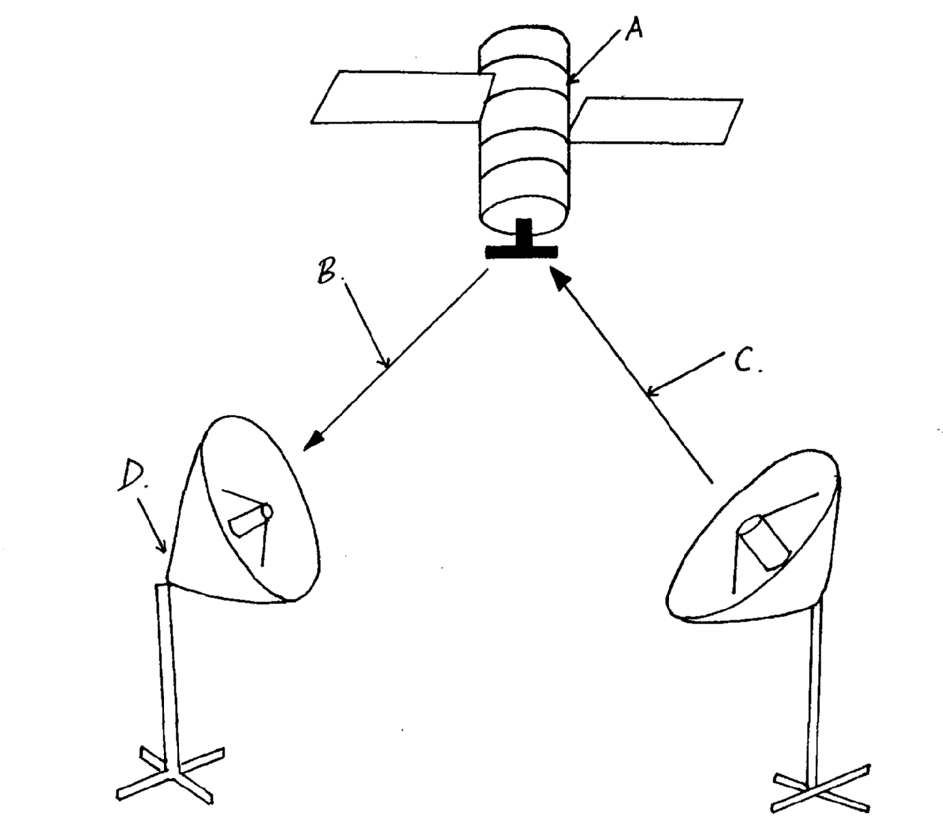

(ii) Give names to the parts indicated by A,B,C, and D. (4mks)
A………………………………………..
B………………………………………..
C………………………………………..
D………………………………………..
(iii) List three advantages of the communication media above. (3mks)
………………………………………………………………………………………………………………
………………………………………………………………………………………………………………
………………………………………………………………………………………………………………

b) Explain the three major types of computer networks. (3mks)
………………………………………………………………………………………………………………
………………………………………………………………………………………………………………
………………………………………………………………………………………………………………

c) Explain the purpose of the following on a network. (4mks)
i) A hub
………………………………………………………………………………………………………………
………………………………………………………………………………………………………………
ii) A switch
………………………………………………………………………………………………………………
………………………………………………………………………………………………………………

18. a) Describe any three mouse techniques/skills. (3mks)
………………………………………………………………………………………………………………
………………………………………………………………………………………………………………
………………………………………………………………………………………………………………

b) List four key groupings on a computer keyboard citing two examples in each. (4mks)
………………………………………………………………………………………………………………
………………………………………………………………………………………………………………
………………………………………………………………………………………………………………
………………………………………………………………………………………………………………

c) Name and explain the function of the following key symbols.

i) (2mks)


ii) (2mks)

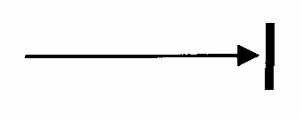

iii) (2mks)

iv) Esc (2mks)

19. a) Describe the following careers in the computing field. (3mks)
a) Computer Engineers
………………………………………………………………………………………………………………
………………………………………………………………………………………………………………
b) Software engineers
………………………………………………………………………………………………………………
………………………………………………………………………………………………………………
c) Computer technician
………………………………………………………………………………………………………………
………………………………………………………………………………………………………………
b) Identify any three duties of an information system manager. (3mks)
………………………………………………………………………………………………………………
………………………………………………………………………………………………………………
……………………………………………………………………………………………………………… c) Giving an example, mention three categories of places where you can advance your computer
skills after sitting for your K.C.S.E. (3mks)
………………………………………………………………………………………………………………
………………………………………………………………………………………………………………
……………………………………………………………………………………………………………… d) Mention any four formatting features used in Ms Word application. (2mks)
………………………………………………………………………………………………………………
………………………………………………………………………………………………………………
………………………………………………………………………………………………………………
………………………………………………………………………………………………………………
e) Define the term electronic spreadsheet. (1mk)
………………………………………………………………………………………………………………
………………………………………………………………………………………………………………
f) Explain the following terms as used in Ms Excel spread sheet package. (3mks)
i) Range
………………………………………………………………………………………………………………
………………………………………………………………………………………………………………
ii) What if analysis
………………………………………………………………………………………………………………
………………………………………………………………………………………………………………
iii) Automatic recalculation
………………………………………………………………………………………………………………
………………………………………………………………………………………………………………

20. (a) (i) Define the term telecommuting. (lmk)
………………………………………………………………………………………………………………
………………………………………………………………………………………………………………
(ii) Give two advantages of telecommuting
………………………………………………………………………………………………………………
………………………………………………………………………………………………………………
(b) (i) What is the difference between a teletext and a videotext for communication. ( ½ mk)
………………………………………………………………………………………………………………
………………………………………………………………………………………………………………
………………………………………………………………………………………………………………
(ii) Give two advantages of using teletext / videotext for communication. (2mks)
………………………………………………………………………………………………………………
………………………………………………………………………………………………………………
(c) Describe three ways in which computers are used as industrial systems. ( ½ mks)
………………………………………………………………………………………………………………
………………………………………………………………………………………………………………
………………………………………………………………………………………………………………
In relation to weather forecasting
(i) Write GIS in full. (1mk)
………………………………………………………………………………………………………………
………………………………………………………………………………………………………………
(ii) What is the use of GIS. (l mk)
………………………………………………………………………………………………………………
………………………………………………………………………………………………………………
(e) Use one’s complement to calculate. 1101—11 (3 ½ mks)
………………………………………………………………………………………………………………
………………………………………………………………………………………………………………
………………………………………………………………………………………………………………
………………………………………………………………………………………………………………
………………………………………………………………………………………………………………
………………………………………………………………………………………………………………
………………………………………………………………………………………………………………
………………………………………………………………………………………………………………

