jitahidi high SCHOOL.
FORM 3 GEOGRAPHY EXAM
MID-TERM TERM 1 YEAR

NAME: ……………………………………………………ADM…………..CLASS:……………

- The diagram below represents zones of natural vegetation on a mountain.
Use it to answer question (a).

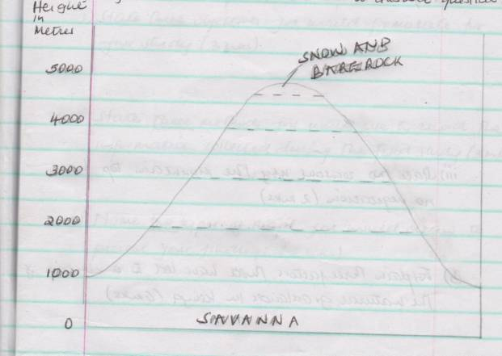

(a) i) In your answer booklet, name the zones marked X Y and Z ( 3 mks)

ii) Describe the characteristics of a tropical savanna vegetation ( 6 mks)

iii) State two reasons why the mountain top has no vegetation ( 2 mks)

b) Explain three factors that have led to a decline of the natural grasslands in Kenya
( 6 mks)

c) Suppose you were to carry out a field study on the relationships between
vegetation and a altitude.
i) State three objectives you would formulate for your study. ( 3 mks)

ii) State three methods you would use to record the information collected during the field study. ( 3 mks)

iii) Name two types of maps you would draw to present your findings ( 2 mks)
2.(a) (i) What is forestry ( 2 mks)

ii) Define agro-forestry ( 2 mks)

b) Explain how the following factors influence the distribution and types of natural
forests
i) Climate ( 4 mks)

ii) Altitude ( 2 mks)

iii) Soils ( 2 mks)

c) Describe the characteristics of soft wood forests in cananda. ( 7 mks)

d) Explain three positive significances of forests and forest products to Kenya
( 6 mks)

3. (a) (i) Distinguish between a solfatara and a mofette ( 2 mks)

ii) Name two areas in Kenya where geysers are found ( 2 mks)

iii) State two economic benefits of geysers ( 2 mks)

b) With the aid of well labeled diagrams describe how a caldera is formed by violent
explosion. ( 8 mks)

c) Explain three negatative effects of volcanicity in Kenya ( 6 mks)

d) Yours class intends to carry out a study on a volcanic landscape.
i) State two objectives for the study. ( 2 mks)

ii) State three follow-up activities you are likely to carry out. ( 3 mks)

4. The map below shows some vegetation regions of the world. Use it to answer questions (a) to (c)

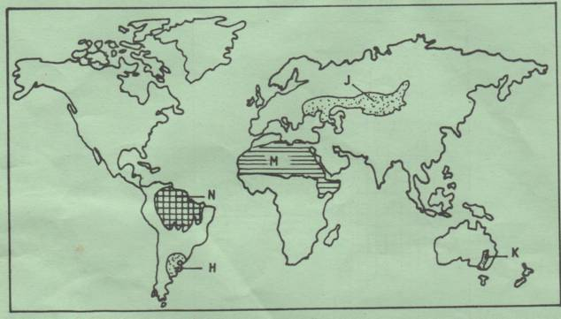

(a) Name the temperature grasslands marked H, J and K. ( 3 mks)

(b) Describe the characteristics of the natural vegetation found in the shaded area
marked N. ( 6 mks)

c) (i) Explain four ways in which the vegetation found in the area marked M adopts
to the environmental conditions of the region. ( 8 mks)

ii) Give two reasons why the Tundra region has scanty vegetation. ( 2 mks)

d) You are required to carry out a field study of the vegetation within the local
environment:
- Apart from identifying the different types of plants, state three other activities you will carry out during the field study. ( 3 mks)

ii) How will you identify the different types of plants? ( 3 mks)

