**SUNSHINE SECONDARY SCHOOL**

**FORM 2**

**GEOGRAPHY**

**END TERM EXAM –MAY/JUNE 2014**

**TIME : 2 ½ HRS**

**NAME………………………………………………….. ADMIN No………. CLASS…………**

Answer all the questions in the spaces provided

|  |  |
| --- | --- |
| **SECTION A** |  |
| **6** |  |
| **7** |  |
| **8** |  |
| **TOTAL** |  |

1. (a) (i) Define the term equinox. (2 mks)

………………………………………………………………………………………………

………………………………………………………………………………………………

(ii) Differentiate between lunar eclipse and solar eclipse. (2 mks)

………………………………………………………………………………………………

………………………………………………………………………………………………

………………………………………………………………………………………………

(b) Describe the outer core of the structure of the earth. (4 mks)

(i) ………………………………………………………………………………………

(ii) ………………………………………………………………………………………

(iii) ………………………………………………………………………………………

(iv) ………………………………………………………………………………………

1. (a) Give reasons for the variation of the length of day and night on the earth surface.

(2 mks)

1. ………………………………………………………………………………………

(ii) ………………………………………………………………………………………

(b) Explain how the rotation of the earth causes day and night. (3 mks)

………………………………………………………………………………………………

………………………………………………………………………………………………

………………………………………………………………………………………………

………………………………………………………………………………………………

………………………………………………………………………………………………

………………………………………………………………………………………………

1. (a) What are internal land forming processes? (2 mks)

………………………………………………………………………………………………

………………………………………………………………………………………………

………………………………………………………………………………………………

(b) State the factors that influence earth movements. (3 mks)

(i) ………………………………………………………………………………………

(ii) ………………………………………………………………………………………

(iii) ………………………………………………………………………………………

1. (a) State four causes of earth movements. (4 mks)

(i) ………………………………………………………………………………………

(ii) ………………………………………………………………………………………

1. ………………………………………………………………………………………
2. ………………………………………………………………………………………

(b) State three characteristics the earth. (3 mks)

(i) ………………………………………………………………………………………

(ii) ………………………………………………………………………………………

(iii) ………………………………………………………………………………………

1. Study the map of Geo city and answer the questions that follow.
2. (i) Name the natural features found in grid square 2104. (2 mks)

………………………………………………………………………………………………

………………………………………………………………………………………………

(ii) What is the distance and direction of the school from the posho mill? (2 mks)

………………………………………………………………………………………………

(iii) Calculate the area of the swamp. (2 mks)

………………………………………………………………………………………………

………………………………………………………………………………………………

1. Give the 6 figure grid reference of the dam. (2 mks)

………………………………………………………………………………………………

1. (i) Reduce the area covered by the map to a ½.

On the new sketch, mark and name the : (6 mks)

* Hill
* Forest
* Swamp
* School

1. Convert the linear scale on the map into an representative fraction scale. (2 mks)

………………………………………………………………………………………………

………………………………………………………………………………………………

1. (i) Citing examples, explain the problems the students from the School face. (6 mks)

………………………………………………………………………………………………

………………………………………………………………………………………………

………………………………………………………………………………………………

(ii) Citing evidence, give 2 evidence that show that the region receives unreliable

rainfall. (2 mks)

………………………………………………………………………………………………

………………………………………………………………………………………………

1. Study the map provided and answer the questions that follow.

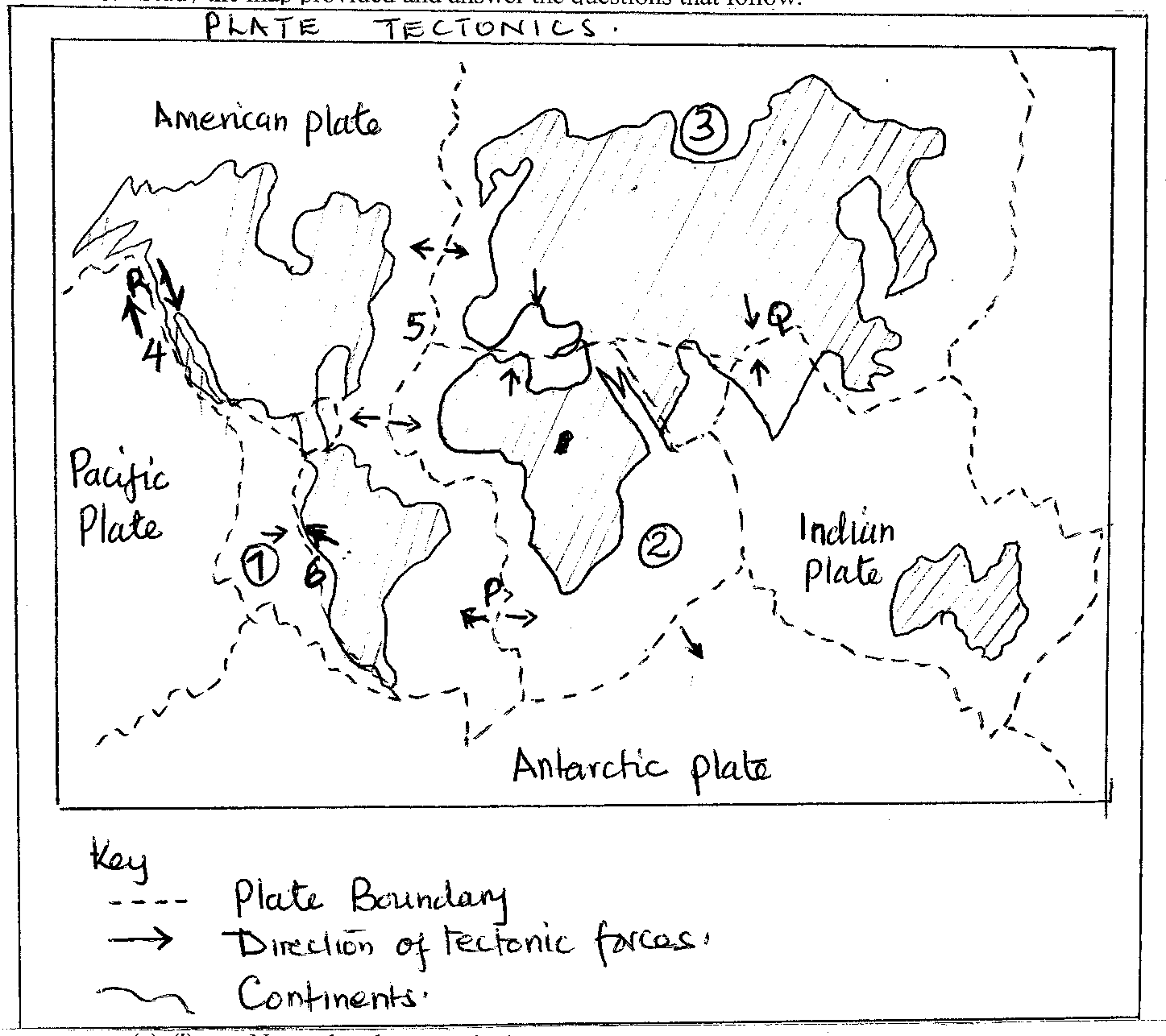

1. (i) Name the plates marked: (3 mks)

1……………………………………………………………………………………

2……………………………………………………………………………………

3……………………………………………………………………………………

(ii) Name the type of boundary marked: (3 mks)

4……………………………………………………………………………………

5……………………………………………………………………………………

6……………………………………………………………………………………

1. Name the features formed at the boundary. (2 mks)

4……………………………………………………………………………………

5……………………………………………………………………………………

1. Name the tectonic forces marked P, Q, R. (3 mks)

P……………………………………………………………………………………

Q……………………………………………………………………………………

R……………………………………………………………………………………

1. State four characteristics of plate tectonics. (4 mks)

………………………………………………………………………………………………

………………………………………………………………………………………………

………………………………………………………………………………………………

1. Describe how the present continents originated. (5 mks)

………………………………………………………………………………………………

………………………………………………………………………………………………

………………………………………………………………………………………………

………………………………………………………………………………………………

………………………………………………………………………………………………

………………………………………………………………………………………………

………………………………………………………………………………………………

………………………………………………………………………………………………

………………………………………………………………………………………………

………………………………………………………………………………………………

(d) Do you believe in your presentation in c (i)? (3 mks)

(i)Yes: give 3 reasons:

………………………………………………………………………………………

………………………………………………………………………………………

.………………………………………………………………………………………

………………………………………………………………………………………

………………………………………………………………………………………

………………………………………………………………………………………

1. No: give 2 reasons:

………………………………………………………………………………………

.………………………………………………………………………………………

………………………………………………………………………………………

………………………………………………………………………………………

1. Study the photograph provided and answer the questions that follow.
2. (i) Name the type of photograph give reasons for your answer. (2 mks)

………………………………………………………………………………………………

(ii) What time of day was the photograph taken? Give reasons for your answer. (3mks)

………………………………………………………………………………………………

………………………………………………………………………………………………

(iii) Name three minerals mined by this method. (3 mks)

………………………………………………………………………………………………

………………………………………………………………………………………………

………………………………………………………………………………………………

1. Sketch the photograph. (5 mks)
2. (i) Describe the shaft method of mining. (6 mks)

………………………………………………………………………………………………

………………………………………………………………………………………………

………………………………………………………………………………………………

………………………………………………………………………………………………

………………………………………………………………………………………………

………………………………………………………………………………………………

………………………………………………………………………………………………

………………………………………………………………………………………………

………………………………………………………………………………………………

………………………………………………………………………………………………

………………………………………………………………………………………………

(ii) Explain three problems faced by shaft mining. (6 mks)

………………………………………………………………………………………………

………………………………………………………………………………………………

………………………………………………………………………………………………

………………………………………………………………………………………………

………………………………………………………………………………………………

………………………………………………………………………………………………

………………………………………………………………………………………………

