

**MURANG’A UNIVERSITY OF TECHNOLOGY**

**UNIVERSITY EXAMINATION 2016/2017**

**1ST YEAR 1ST SEMESTER EXAMINATION FOR THE DEGREE OF BACHELOR OF SCIENCE (ACTUARIAL SCIENCE)**

**(REGULAR)**

**COURSE CODE: SAS 201**

**TITLE: SAMPLE SURVEYS**

**DATE: 15/4/17 TIME: 2.00-4.00 PM**

**DURATION: 2 HOURS**

**INSTRUCTIONS**

1. **This paper contains SIX (6) questions**
2. **Answer question 1 (Compulsory) and ANY other 2 Questions**
3. **Write all answers in the booklet provided**



**MURANG’A UNIVERSITY OF TECHNOLOGY**

**BACHELOR OF SCIENCE – ACTUARIAL SCIENCE**

**YEAR ONE SEMESTER ONE**

**SAS 201: SAMPLE SURVEY**

**QUESTION ONE (COMPULSORY 30MKS)**

1. Define the following terms as used in sample survey:
2. Sample survey (2mks)
3. Sampling unit (2mks)
4. Sampling frame (2mks)
5. State and explain **THREE** properties of estimators (6mks)
6. If random samples of size three and drawn without replacement from the population consisting of four numbers 4, 5, 5, 7. Find sample mean  for each sample and make sampling distribution of. Calculate the mean and standard deviation of this sampling distribution. Compare your calculations with population parameters (5mks)

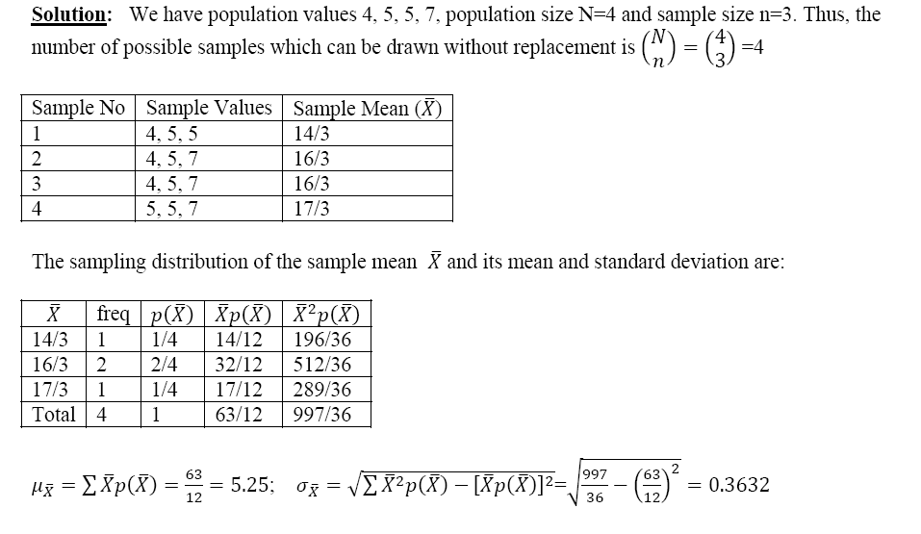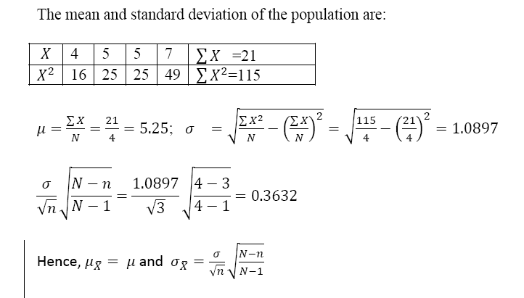

1. A corporation desires to estimate the total number of worker-hours lost for a given month because of accidents among all employees. Because laborers, technicians and administrators have different accident rates, the researcher decides to use stratified random sampling, with each group forming a separate stratum. Summary statistics are as follows:

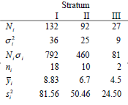

Determine Neyman allocation for a sample of n=30 employees. (4mks)

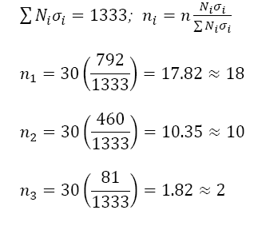

1. National income from manufacturing industries is to be estimated for 1989 from a sample of 6 of the 19 industry categories that reported figures early for that year. Incomes from all 19 industries are known for 1980 and the total is $674 billion. From the data provided, find a difference estimator of the 1989 total income, and place a bound on the error of estimation. (4mks)
2. A study was conducted to measure the body temperatures of a sample of female and male students at JOOUST. The summary statistics for these data are as follows:

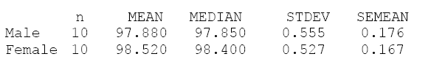

Find:

1. An approximate 95% confidence interval for the mean body temperature of men in the population (2mks)
2. An approximate 95% confidence interval for the difference in mean body temperature between women and men (3mks)

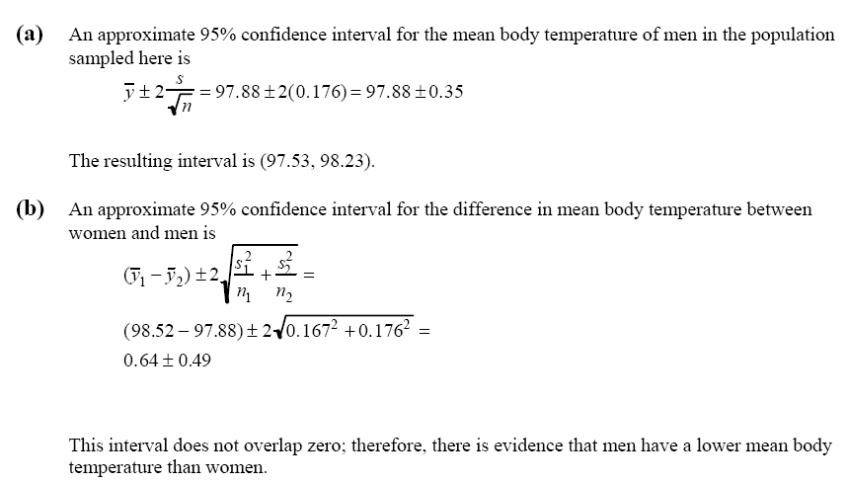

**QUESTION TWO (20MKS)**

1. Consider the following population elements where a sample of size 2 is to be drawn. Show that for a simple random sampling without replacement, the standard estimate of the population mean is unbiased. (10mks)
2. Prove that in simple random sampling without replacement  (10mks)

**QUESTION THREE (20MKS)**

1. A sample of 30 students is to be drawn from a population of 300 students belonging to two colleges A and B. The means and standard deviations of their marks are given below;

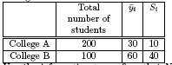

Use the information to confirm that Neyman’s allocation scheme is a more efficient scheme when compared to proportional allocation (10mks)

1. The “spring-like” effect in a golf club could be determined by measuring the coefficient of restitution. Drivers are randomly selected from two club makers and the coefficient of restitution is measured. The summary statistics for these data are as follows:

|  |  |  |  |  |  |
| --- | --- | --- | --- | --- | --- |
|  | n | Mean | Median | Stdev | SeMean |
| Club 1 | 10 | 0.9788 | 0.9785 | 0.55 | 0.176 |
| Club 2 | 10 | 0.9852 | 0.984 | 0.52 | 0.167 |

Is there sufficient evidence to conclude that the coefficient of restitution for Club 1 differs from that for Club 2? (5mks)

1. A simple random sample of 100 water meters within a community is monitored to estimate the average daily water consumption per household over a specified dry spell. The sample mean and sample variance are found to be 

If we assume that there are N = 10,000 households within the community, estimate, the true mean daily consumption, and place a bound on the error of estimation. (5mks)

**QUESTION FOUR (20MKS)**

1. All the farms in a country are stratified by farm size and mean number of hectares of wheat per farm in each stratum, with the following results.

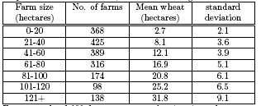

For a sample of 100 farms, compute the sizes in each stratum under stratified simple random

Sampling with;

Proportional allocation (5mks)

Neyman allocation. (5mks)

1. Let be the estimate of  from the systematic sample, then show that

 (10mks)

**QUESTION FIVE (20MKS)**

1. Signatures to a petition were collected on 676 sheets each sheet had enough space for 42 signatures, but on many sheets, a smaller number of signatures had been collected. The numbers of signatures per sheet were counted on a random sample of 50 sheets (about a 7% sample). The results are given in the table below.



Estimate the total number of signatures to the petition and the 80% confidence limits. (10mks)

1. Prove that proportional allocation is more efficient than Neyman’s allocation (10mks)