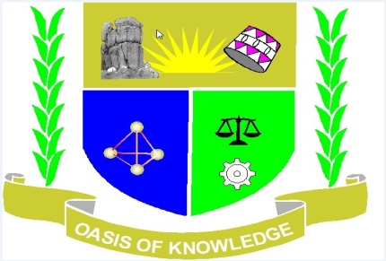

JARAMOGI OGINGA ODINGA UNIVERSITY OF SCIENCE AND TECHNOLOGY
SCHOOL OF HUMANITIES AND SOCIAL SCIENCES
UNIVERSITY EXAMINATION FOR MASTER OF ARTS IN GEOGRAPHY
YEAR 1 SEMESTER 1 2016/2017ACADEMIC YEAR
MAIN CAMPUS
SCHOOL BASED
_____________________________________________________________________________-
COURSE CODE: NGE 801
COURSE TITLE: ADVANCED RESEARCH METHODS
EXAM VENUE: - STREAM: MA GEOGRAPHY
DATE: 24/04/2017 EXAM SESSION: 9.00 – 12.00 NOON
TIME: 3 HOURS

Instructions:
- Answer any THREE Questions
- Candidates are advised not to write on the question paper.
- Candidates must hand in their answer booklets to the invigilator while in the examination room.

- Examine critically the main characteristics of geographical research (20 marks)
- Examine the role of research in National Development (20 marks)
- Explain the main steps in the preparation of geographic research proposal (20 marks)
- Discuss the major sources of error in geographic research and suggest their possible remedies. (20 marks)
- Discuss the major ethical considerations that should be taken into account during research process. (20 marks)

(END)

