

**MURANG’A UNIVERSITY OF TECHNOLOGY**

**SCHOOL OF ENGINEERING AND TECHNOLOGY**

**UNIVERSITY EXAMINATIONS FOR THE DEGREE OF SCIENCE IN:**

**BUILDING CONSTRUCTION AND MANAGEMENT**

**1ST YEAR 1ST SEMESTER 2015/2016ACADEMIC YEAR**

**CENTRE: MAIN CAMPUS**

**___________________________________________________________________________**

**COURSE CODE: TLM 3111**

**COURSE TITLE: ENGINEERING DRAWING 1**

**EXAM VENUE: CR STREAM: BSc IN CONSTRUCTION**

**DATE: 19/4/16 EXAM SESSION: 9.00 – 11.00 AM**

**TIME: 2 HOURS**

**Instructions**

1. **Answer Question 1 (compulsory) and ANY other two questions**
2. **Candidates are advised not to write on question paper.**
3. **Candidates must hand in their answer booklets to the invigilator while in the examination room**

**QUESTION ONE (20 MARKS)**

1. What do you understand by the term **engineering *drawing***? (**1MARKS**)
2. In line with your profession how do you expect to apply engineering drawing in future? (**2 MARKS**)
3. How can you use the following instruments effectively in the process of making a technical drawing (**6Marks**)
4. French curve / Irregular curves
5. Erasing shield
6. Scale rule
7. Outline the procedure for drawing a large circle while using free hand sketching techniques (**5 Marks)**
8. A ***scale*** is always presented in every engineering drawing
9. Explain what the term means to you (**1.5 Marks**)
10. Explain the purpose of a scale in a drawing (**1.5Marks**)
11. Calculate the corresponding plan/paper distance for a ground distance of 2.25km for a plan whose scale is 1:2500.(**2 MARKS**)
12. Differentiate between pictorial and orthographic projections as used in engineering drawing (8 **MARKS**)
13. One may classify pictorial drawings as axonometric (isometric and others), perspective and oblique. Understand what circumstance would oblique have an advantage over isometric (**3 Marks**)

**QUESTION TWO (15 MARKS)**

Develop sufficient orthographic views of the given object to give sufficient details for its fabrication (use first angle method of projection).

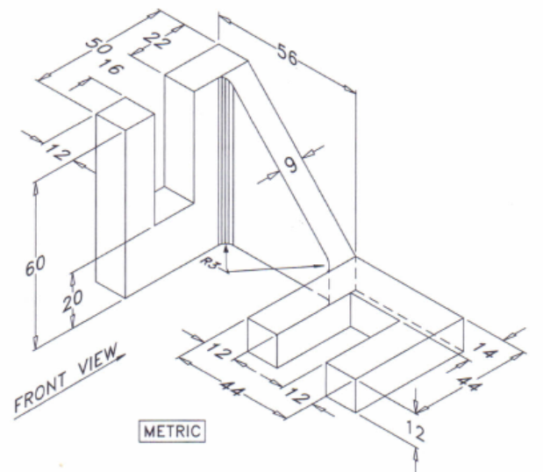

**QUESTION THREE (15 MARKS)**

Given the orthographic multi-views of an object below, develop the pictorial view using the isometric method



**QUESTION FOUR (15 MARKS)**

Draw an oblique view of the object given in the orthographic views below

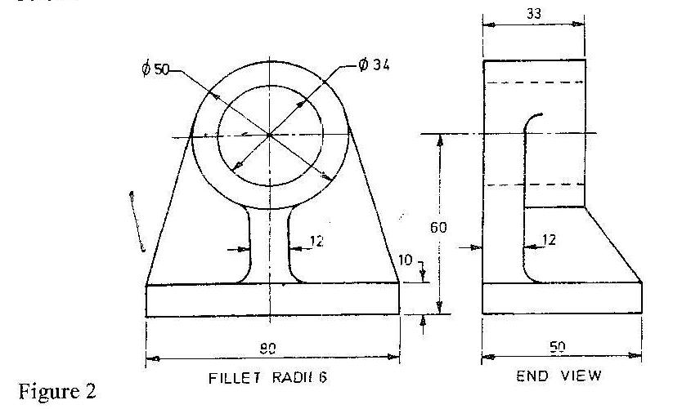

**QUESTION FIVE (15 MARKS)**

1. Draw a true ellipse given the minor diameter as 60mm and the major diameter as 100mm (**9 Marks**)
2. Construct a hexagon within a circle of diameter 6cm. (**6Marks**)