JARAMOGI OGINGA ODINGA UNIVERSITY OF SCIENCE & TECHNOLOGY
SCHOOL OF BIOLOGICAL AND PHYSICAL SCIENCES
DEPARTMENT OF BIOLOGICAL SCIENCES
UNIVERSITY EXAMINATION FOR THE DEGREE OF BACHELOR OF SCIENCE IN BIOLOGICAL SCIENCES
4th YEAR FIRST SEMESTER 2016/2017 ACADEMIC YEAR
MAIN CAMPUS - REGULAR
COURSE CODE: SBH 3431
COURSE TITLE: BIOINFORMATICS AND COMPUTATIONAL BIOLOGY
EXAM VENUE: STREAM:
DATE: EXAM SESSION:
TIME: 2 HOURS
Instructions:
- Answer ALL questions in Section A and Any two questions in Section B
- Candidates are advised not to write on question paper
- Candidates must hand in their answer booklets to the invigilator while in the examination room

SECTION A: SHORT ANSWER QUESTIONS (30 MARKS)
- Describe three different kinds of DNA sequences (3 Marks)
- Briefly distinguish the terms homologs, orthologs and paralogs. (3 Marks)
- Outline three advantages of evolutionary computation (3 Marks)
- Describe three hierarchical levels of protein structure (3Marks)
- Explain what is meant by gene ontology. Identify two organizing principles
of gene ontology (3 Marks)
- Define sequence alignment. Describe the difference between local and global alignment (3 Marks)
- Consider the (pairwise) global alignments below resulting from the application of the algorithm Needleman-Wunsch to the sequences S1, S2 and S3 using the following scoring scheme: match=+2; mismatch=-1 and gap=-1. (3 Marks) 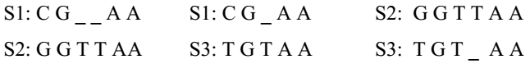
- Distinguish among protein domain, motif and family. (3 Marks)
- Identify three databases available through Entrez (3 Marks)
- Based on the data in the table shown below, draw a phylogenetic tree that reflects the evolutionary relationships of the organisms based on the differences in their cytochrome c amino-acid sequences and explain the relationships of the organisms. Based on the data, identify which organism is most closely related to the chicken and explain your choice. (3 Marks)
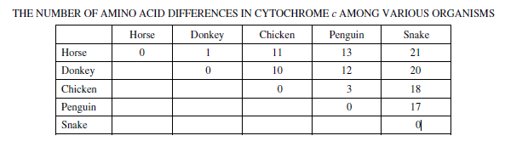

SECTION B: ESSAY QUESTIONS (40 MARKS).
- Discuss the basic principle of shotgun genome sequencing, assembly and annotation.
(20 Marks)
- Describe the dot matrix analysis plot method of pairwise sequence alignment. (20Marks)
- Discuss the use of computational biology and bioinformatics in functional genomics and proteomics. (20 Marks)
- Describe the features and importance of NCBI (National Center for Biotechnology Information). (20 Marks)

