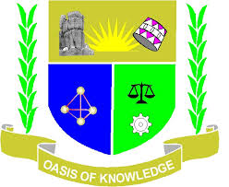

JARAMOGI OGINGA ODINGA UNIVERSITY OF SCIENCE AND TECHNOLOGY, SCHOOL OF HUMANITIES AND SOCIAL SCIENCES
UNVERSITY EXAMINATION FOR THE DEGREE OF BACHELOR OF EDUCATION
4TH YEAR 1ST SEMETER 2016/2017 ACADEMIC YEAR
MAIN CAMPUS - SCHOOL BASED

COURSE CODE:ZRE 4103
COURSE TITLE: RELIGION, EDUCATION AND DEVELOPMENT
EXAM VENUE LR __________________ SCHOOL BASED
TIME 1 ½ HOURS EXAM SESSION ______________

INSTRUCTIONS
- Answer questions ONE (COMPULSORY) and ANY other 2 questions.
- Candidates are advised not to write on the question paper
- Candidates must hand in their answer booklet to the invigilator while in the examination room.

- a) Give the meaning of the following terms as applied in religion, education and development. (15mks)

- Religion
- Development
- Education
- Socialization
- Christianization
b. Outline the main role of Religion to the Society (15mks)
- Religion has played a major role in the development of Kenya. Discuss (20mks)

- Critically examine the evils of colonialism that prohibited development in Kenya (20mks)

- Discuss four major Africa traditional modes of Education, both formal and informal (20mks)

- Religion has impacted greatly in poverty Education in Kenya, illustrate by giving four examples based on any one denomination (20mks)

