JARAMOGI OGINGA ODINGA UNIVERSITY OF SCIENCE & TECHNOLOGY
SCHOOL OF BIOLOGICAL AND PHYSICAL SCIENCES
DEPARTMENT OF BIOLOGICAL SCIENCES
UNIVERSITY EXAMINATION FOR THE DEGREE OF BACHELOR OF EDUCATION WITH IT
2nd YEAR 1STSEMESTER 2016/2017 ACADEMIC YEAR
MAIN CAMPUS - REGULAR
COURSE CODE: SBT 222
COURSE TITLE: GYMNOSPERM AND ANGIOSPERM TAXONOMY
EXAM VENUE: LAB 10 STREAM: (EDS)
DATE: 24/04/17 EXAM SESSION: 2.00 – 4.00 PM
TIME: 2 HOURS
Instructions:
- Answer ALL questions in Section A and Any two questions in Section B
- Candidates are advised not to write on question paper
- Candidates must hand in their answer booklets to the invigilator while in the examination room

SECTION A: SHORT ANSWER QUESTIONS (30 MARKS)
- Sketch a hypothetical leaf with the following descriptions: Leaf palmately compound, the leaflets lanceolate, entire, cuneate and mucronate. (3 Marks)
- What advantage does the reproductive system of the gymnosperms have over that of the ferns? (3 Marks)
- Describe three types of botanical classification of gymnosperms (3 Marks)
- Give the type of placentation and number of locules for the following ovary types (drawings represent ovary cross-sections): (3 Marks)
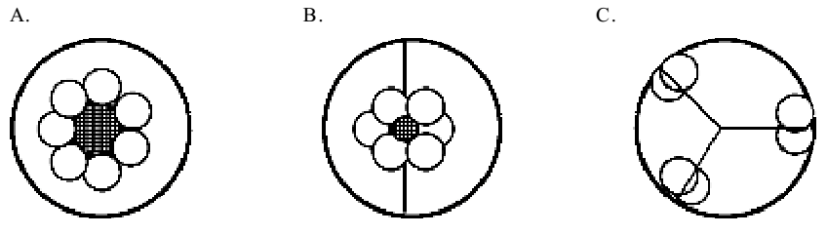
- With specific examples enumerate the economic importance of the family Rosaceae(3Marks)
- Using corolla characteristics only, distinguish between the subfamilies in the family Leguminosae. (3 Marks)
- Describe briefly the logical steps used in numerical taxonomy methodology. (3Marks)
- Outline any three basic principles that control and regulate the naming of plants.(3 Marks)
- Provide short definitions for the following terms: dioecioius, polypetalous and
monophyletic (3 Marks)
- Briefly contrast the following pairs of terms. (3 Marks)
A. Adnate vs. Connate
B. Androecium vs. Gynoecium
C. Rhizome vs. Bulb

SECTION B: ESSAY QUESTIONS (40 MARKS).
- Discuss at length the role of herbarium plant collections in enhancing taxonomic research today. (20 Marks)
- Discuss in detail the modern taxonomic evidence that may be applied to taxonomic research.(20 Marks)
- Describe the morphological and economic importance of the family Compositeae (Asteraceae).(20 Marks)
- Using examples, discuss the rules for giving scientific names to plants in accordance to the International Code of Botanical Nomenclature. (20 Marks)

