

**JARAMOGI OGINGA ODINGA UNIVERSITY**

**OF SCIENCE & TECHNOLOGY**

**UNIVERSITY EXAMINATIONS 2012/2013**

**2ND YEAR 1ST SEMESTER EXAMINATION FOR THE DEGREE OF BACHELOR OF EARLY CHILDHOOD EDUCATION (ARTS) WITH IT**

**(KISUMU-SCHOOL BASED)**

**COURSE CODE: SCS 3111**

**COURSE TITLE: COMPUTER ORGANIZATION AND APPLICATION**

**DATE: 27/8/2013 TIME: 9.00 - 11.00 AM**

**DURATION: 2 HOURS**

**INSTRUCTIONS**

1. **This paper consists of 5 Questions.**
2. **Answer Question 1 (Compulsory) and any other 2 questions.**
3. **Write your answers on the answer booklet provided.**

**Question 1 30marks**

1. State any **four** reasons why an organization may prefer using computer systems as  
   opposed to manual systems [2 Marks]
2. Give at least **three** examples of input and output devices [2 Marks].
3. Identify **five** icons found on the desktop and state their functions. [5marks]
4. List **four** types of system software and Application Software [2 Marks]
5. Briefly explain the roles or functions of the following components in a computer system
6. Hardware
7. Software
8. Memory
9. Central Processing Unit
10. Registers [10 Marks]
11. Name **four** basic parts of the computer and give their functions [6 Marks]

**Question 2 20marks**

1. Explain the sources of vulnerability of data and information in computers. [10 Marks]
2. Discuss **six** **security measures** that can be taken contain vulnerability of data [10 Marks]

**Question 3 20marks**

1. Explain **THREE** advantages of having a computer [3 Marks]
2. Name **FOUR** types of computer networks [2 Marks]
3. Define the following terms:
   1. The World Wide Web (WWW) [2 Marks]
   2. The Internet. [2 Marks]
   3. Internet Protocol [2 Marks]
   4. Web browser [2 Marks]
4. List and explain the basic requirements to able to access the Internet [4 Marks]
5. Explain what you understand by the term Uniform Resource Locators (URLs) and list its components.

[5 Marks]

**Question 4 20marks**

1. What are the benefits of using word processor? [2 Marks]
2. Outline **four** features of a word processor [2 Marks]
3. Name and state the use of any **four** bars found in the Ms Word 2007 environment [4 Marks]
4. Explain how you would carry out the following in Ms Word 2007
   1. Delete character or space immediately to the left of insertion point [2 Marks]
   2. Drop the first letter of paragraph to four lines. [2 Marks]
   3. Select a whole paragraph [2 Marks]
   4. Save the document for the first time [2 Marks]
   5. Insert a picture in a document [2 Marks]
   6. Change the number of column of a paragraph to two. [2 Marks]

**Question 5 20marks**

1. Describe any **two** functions of spreadsheets. [4 Marks]
2. Name the following parts of ms excel 2007 window [6 Marks]

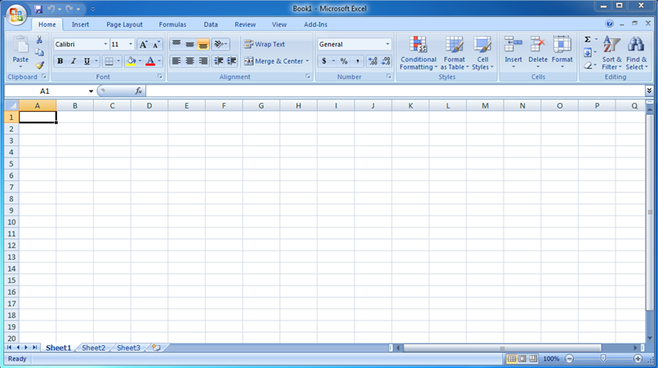

1

12

3

7

2

10

11

5

8

4

6

9

1. Explain how you would carry out the following in Ms excel 2007
2. Merge cells [2 Marks]
3. Insert arrow. [2 Marks]
4. Select many cells in arrange [2 Marks]
5. **Create a Chart** [2 Marks]
6. **Rotate text to diagonal angle** [2 Marks]