JARAMOGI OGINGA ODINGA UNIVERSITY OF SCIENCE AND TECHNOLOGY

SCHOOL OF INFORMATICS AND INNOVATIVE SYSTEMS

DEPARTMENT OF COMPUTER SCIENCE & SOFTWARE ENGINEERING

UNIVERSITY EXAMINATION FOR THE DEGREE OF BACHELOR OF SCIENCE IN BUSINESS COMPUTER INFORMATION SYSTEMS

2ND YEAR 2ND SEMESTER 2015/2016 ACADEMIC YEAR

MAIN CAMPUS

COURSE CODE: IIS 3222

COURSE TITLE: INFORMATION SYSTEM AND NETWORKING LAB
EXAM VENUE: LR 7 STREAM: BSc. BIS
DATE: 07/09/16 EXAM SESSION: 9.00 – 11.00 AM

TIME: 2.00 HOURS
______________________________________________________________________________

INSTRUCTIONS

Answer Question 1 (Compulsory) and ANY other TWO questions

Candidates are advised not to write on the question paper

Candidates must hand in their answer booklets to the invigilator while in the examination room

Question 1 [30 Marks]
- Define the following terms:
  - Load balancing (2 mark)
  - Subnet Mask (2 mark)
  - Default Gateway (2 mark)
  - Protocol analyzer (2 mark)
  - Packet switching (2 mark)

- The figure below shows a type of attack. Discuss this type of attack. How would you mitigate against this type of attack? Give examples of these type of attack (3 mark)

- State three categories of IPv4 addresses (3 mark)

- Prefix-Notation is usually referred to as “slash” notation. The number after the slash refers to the number of one bit in the subnet mask. The subnet mask always has contiguous 1 bit from left-to-right. Provide the dotted decimal notation for the following prefix notation. (8 marks)

  - /24
  - /9
  - /27
  - /18

- Differentiate between routing and routed protocol. Give two examples of each. (6 marks)

Question 2 [20 Marks]
- Give three reasons why subnetting is important. (3 mark)

- State any four tools available to a network administrator for monitoring network resources and reports. (4 marks)

- The figure below represents an example of a TCP SYN Flood attack. Briefly describe this type of attack using the information provided below. How would you mitigate such attacks (5 marks)

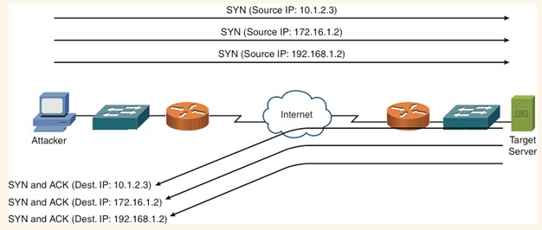

- Discuss the TCP/IP stack. (8 marks)
Question 3 [20 Marks]
- If a routing protocol knows of multiple paths to reach a network, how does it choose a path? (4 mark)

- Identify any five types of information found on TCP segment. (5 marks)

- What is the key difference between TCP and UDP segment? (4 marks)

- Identify the protocols associated with the port numbers. (7 marks)

    - 23
    - 25
    - 21
    - 53
    - 80
    - 443
    - 67

Question 4 [20 Marks]
- The network engineer gives you the following network address and subnet mask: 192.168.1.0/27. (6 marks)

  - Determine the number of subnets that can be created from this network address
  - Calculate the number of assignable IP addresses for each subnet created

- Understanding Layer 3 protocols and services is critical to troubleshooting many issues. Identify the common Layer 3 issues. (3 marks)

- Identify four differences between IPv4 and IPv6 headers (4 marks)

- TCP is the most widely used protocol on the Internet. It is used by most of the popular applications, such as HTTP, SSH/TLS, NetBIOS (NBT—NetBIOS over TCP), Telnet, FTP, and electronic mail (SMTP). It provides a reliable, connection-oriented, byte stream, and transport-layer service built using many of these techniques. Briefly describe how TCP provides reliable transmission of packets. (7 marks)

Question 5 [20 Marks]
Intermode, Inc, a manufacturer of new electric motorcycles. Intermode, Inc has chosen you to design a new network that will let the company scale to a larger size. The campus network will support about 200 employees and a new data center. Another feature of the campus network will be a state-of-the-art manufacturing facility with networked equipment that communicates with servers in the data center that support real-time control and management. Engineers will access the servers from their PCs in the access layer of the campus network. Intermode, Inc will sell its new motorcycle both online and through a large retail company. For online sales, Intermode, Inc plans to have a DMZ that connects a public web server, a DNS server, and an email server. The web server needs to communicate with back-end servers in the data center that hold customer billing data. Intermode, Inc also plans to open a branch sales office in the city where the retail company’s corporate headquarters reside, about 500 miles from Intermode, Inc’s headquarters. Using CISCO hierarchical network design concept design and draw a logical topology that will support Intermode, Inc’s needs. In addition to meeting the specified needs, be sure to consider security. (20 marks)

