THE KISUMU NATIONAL POLYTECHNIC
MECHANICAL ENGINEERING DEPARTMENT
END TERM EXAMS
PDT &PLT 210S17
MECHANICAL ENGINEERING SCIENCE
TIME: 2HRS
ATTEMPT ALL THE QUESTIONS
1a) Define moment of a force (1mk)
b) State the principles of moments (2mks)
b) A uniform beam 4m lomg is simply supported at two points A and B. The beam carries loads as shown in figure below
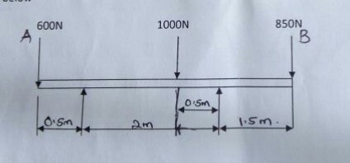

i) calculate the magnitude of the support reactions A and B
ii) determine the point at which the load of 100N should be applied to make the support reactions equal (17mks)
2a) state the following theorems
i)parallelogram law
ii)triangle of forces
iii)polygon of forces. (6mks)
b) With the aid of a sketch explain the Bows notation. (3mks)
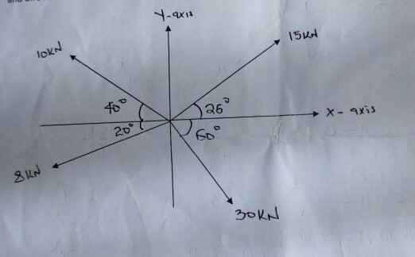
c) The following coplanar forces are acting at point O as shown in the figure.

Determine the magnitude and direction of the resultant force using analytical method. (11mks)
3 a). Define the following terms
i) equilibrium
ii) resultant
iii) coplanar forces
iv) equilibrant
v) concurrent forces. (10mks)
b) The figure below shows a system of forces acting at point O.Determine the magnitude of the forces P and Q if the system is in equilibrium
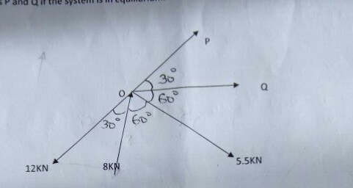

4a) Define a couple. (2mks)
b) Give three typical applications of couples. (3mks)
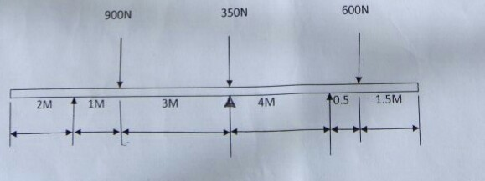
C) The figure below shows a beam 12m long simply supported at A and B. If the point loads are placed at various sections of the beam as shown

i) Determine the reaction at point A and B.
i) At what point should a load of 1000N be placed to make the reactions equal (15mks)

