JARAMOGI OGINGA ODINGA UNIVERSITY OF SCIENCE AND TECHNOLOGY
SCHOOL OF INFORMATICS AND INNOVATION
UNIVERSITY EXAMINATION FOR THE DEGREE OF BACHELOR IN BUSINESS ADMINISTRATION
______________________________________________________________________________
UNIT CODE: SCS 2114
UNIT TITLE: INTRODUCTION TO SPREADSHEET AND DATABASE
EXAM VENUE: 9TH FLOOR
DATE: 15/ DEC/2016
TIME: 2HOURS
EXAM SESSION: 2:00PM-4; 00PM
______________________________________________________________________________

INSTRUCTIONS
- Answer QUESTION ONE (compulsory) and ANY other TWO questions.
- Candidates are advised not write on the question paper.
- Candidates must hand in their answer booklets to the invigilator while in the examination room.

QUESTION ONE:
- Define the following terms: (4marks)
- Primary key
- Field
- Record
- Forms
- Differentiate the following terms: (4marks)
- row and column
- spreadsheet and database
- Explain any four responsibilities of a database administrator. (4marks)
- Database design can be divided in six major steps, name these six steps (6marks)
- Name and explain the functions of the following A-H in a spreadsheet in the figure below. (12marks)
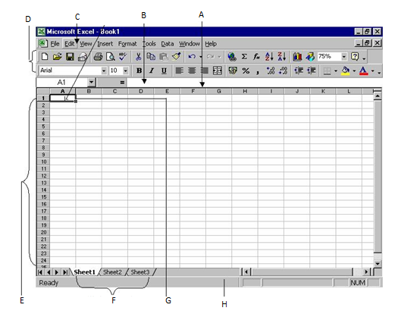
QUESTION TWO
- Name any three people who deal with database (2marks)
- Explain any four benefits of good database design (8marks)
- Name and explain any five types of database systems (10marks)

QUESTION THREE
- Explain benefits of using database to store information. (10marks)
- Discuss any five applications of spreadsheets (10marks)

QUESTION FOUR
- Explain any four Disadvantages of Database Systems (8marks)
- Discuss four database systems languages that are being used during database management systems (12marks)

QUESTION FIVE
- Explain five applications of database systems (10marks)
- Outline and discuss any five classifications of database management systems. (10marks)

