

**JARAMOGI OGINGA ODINGA UNIVERSITY OF SCIENCE AND TECHNOLOGY SCHOOL OF BIOLOGICAL AND PHYSICAL SCIENCES**

**UNIVERSITY EXAMINATION FOR THE DEGREE OF BACHELOR OF SCIENCE IN**

**BUILDING AND CONSTRUCTION MANAGEMENT**

**RENEWABLE ENERGY**

**WATER RESOURCE MANAGEMENT**

**AGRICULTURE**

**1ST YEAR 1ST SEMESTER**

**MAIN**

**REGULAR**

**COURSE CODE: SPH 3111**

**COURSE TITLE: PHYSICS 1**

**EXAM VENUE: STREAM: (BED SCI)**

**DATE: EXAM SESSION:**

**TIME: 2:00HRS**

**________________________________________________________________________**

**Instructions:**

1. **Answer question 1 (Compulsory) and ANY other 2 questions.**
2. **Candidates are advised not to write on the question paper.**
3. **Candidates must hand in their answer booklets to the invigilator while in the examination room.**

***QUESTION 1 (30 MARKS)***

(a) Define the term Mechanics.  **(1 mark)**

(b) State **ONE** importance of studying properties of matter to an engineer.

**(1 mark)**

(c) Obtain an expression for the angle between the vectors  and

**(3 marks)**

(d) An Architect throws a plumbline to his colleague at the top of a building

duringconstruction at an initial velocity of. Determine the time it takes

the plumb line to reach the colleague who is  from the release point.

(**3 marks)**

(e) (i) State **TWO** assumptions made in the analysis of projectile motion.**(2 marks)**

(ii) A projectile is launched at an angle of above the horizontal at a velocity

of . Determine the horizontal range of the projectile. **(2 marks)**

(f) State Newton’s second law of motion. **(1 mark)**

(g) Two forces and  act at a point. The magnitude of  is  and its

direction is  above the x-axis in the second quadrant. The magnitude of 

is and its direction is  below the x-axis in the third quadrant.

Calculate the magnitude of the resultant force.  **(3 marks)**

(h) Explain the fact that a body undergoing uniform circular motion accelerates.

**(1 mark)**

(i) Show that the frequency of a body undergoing simple harmonic motion is given by  where each symbol has its usual meaning.**(2 marks)**

(j) Distinguish between viscosity and surface tension.  **(1 mark)**

(k) A square steel bar  on side and long is subjected to an axial tension

of . The decrease in lateral dimension due to the load is.

Determinethe Poisson’s ratio of the bar. **(3 marks)**

(l) Distinguish between conduction and convection as mechanisms of heat transfer.

**(2 marks)**

(m) Write down the form of Stefan’s law used in blackbody radiation**(1 mark)**

(n) The speed of sound in granite is . Calculate the ratio of linear

density to the tension on the material.**(2 marks)**

(o) Define the term ultrasonic wave, stating one of its applications. **(2 marks)**

**SECTION B**

***Attempt any TWO questions in this section*****

***QUESTION 2 (20 MARKS)***

(a) Derive the equation of wave motion governing the travel of waves of any type.

**(13 marks)**

(b) Show that the vector product of any two vectorsand  in three dimensions

in terms of the components is given by**(5 marks)**

(c) A force  acts on a wheel at a point  from the

centre of the wheel. Calculate the torque on the wheel. **(2 marks)**

***QUESTION 3 (20 MARKS)***

(a) To approximate the depth of water well, Martha and John dropped a heavy

rock into the well, 8 seconds later after the rock was dropped, they heard a

splash caused by the impact of the rock on the water. Calculate the depth of the

well. **(5 marks)**

(b) Derive the expression for calculating the scalar product of two vectors in terms

of their components. **(5 marks)**

(c) Two vectors are defined by  and .Calculate:

(i) **(2 marks)**

(ii) **(5 marks)**

(iii) A unit vector in the direction of  **(3 marks)**

***QUESTION 4 (20 MARKS)***

(a) Consider a traffic light suspended by cords as shown in Figure 4.1. Determine the

tension in each cord, given that the weight  of the traffic light is .

**(10 marks)**

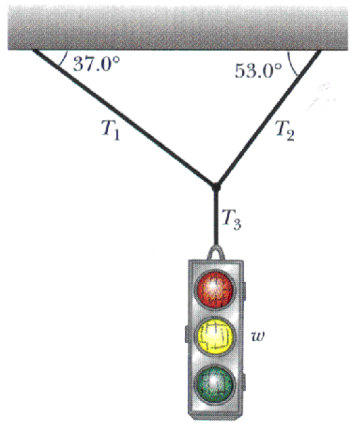

Figure 4.1. A traffic light in equilibrium

(b) Show that the trajectory of a projectile is parabolic and takes the form

 where each symbol has its usual meaning. **(10 marks)**

***QUESTION 5 (20 MARKS)***

(a)  of liquid water at  is converted to steam at  by boiling at

standard atmospheric pressure . The volume of the water changes

from an initial value of  as liquid to  as steam. Determine:

(i) The work done by the system**(2 marks)**

(ii)The energy transferred as heat during the process(Latent heat of

vaporization=).**(2 marks)**

(iii) The change in the internal energy of the system. **(2 marks)**

(b) Derive the equation for the root mean square velocity of an ideal gas in the

form  where the symbols have their usual meanings. **(9 marks)**

(c) A mass of is attached to the end of a vertical wire of length and

diameter . Given that the mass causes an extension of, calculate

Young’s modulus of the wire **(5 marks)**