

**JARAMOGI OGINGA ODINGA UNIVERSITY OF SCIENCE AND TECHNOLOGY SCHOOL OF BIOLOGICAL AND PHYSICAL SCIENCES**

**UNIVERSITY EXAMINATION FOR THE DEGREE OF BACHELOR OF EDUCATION SCIENCE WITH IT**

**3RD YEAR 1ST SEMESTER 2016/2017 ACADEMIC YEAR**

**MAIN CAMPUS**

**COURSE CODE: SPH 307**

**COURSE TITLE: INTRODUCTION TO ELECTRONICS**

**EXAM VENUE: LR 1 STREAM: (BED Sc.)**

**DATE: 22/04/16 EXAM SESSION: 11.30 – 1.30 PM**

**TIME: 2 HOURS**

**______________________________________________________________________________ Instructions:**

1. **Answer question 1 (compulsory) and ANY other 2 questions.**
2. **Candidates are advised not to write on the question paper.**
3. **Candidates must hand in their answer booklets to the invigilator while in the examination room.**

**SPH 307INTRODUCTION TO ELECTRONICS 2016.17 SEM I MS**

**INSTRUCTIONS TO CANDIDATES**

Answer all questions in **SECTION A** and any **TWO** questions from **SECTION B**.

Question **ONE** carries **30** marks while all the other questions carry **20** marks each.

**QUESTION 1 (30 MARKS)**

1. State Barkhausen criterion **1mk**
2. Define the term ‘phase reversal’ as used in common emitter amplifiers **1mk**
3. Semiconductors have negative temperature coefficient of resistance. Explain **2mks**
4. Sketch current – voltage (IV) characteristics of a PN junction **2mks**
5. Give any two differences between an alternator and an oscillator **2mks**
6. A differential amplifier has an open-circuit voltage gain of 200. The input signals are 3.35 V and 3.15V. Determine the output voltage. **2mks**
7. Determine the current *I* in the circuit shown in Figure 1. Assume the diodes to be of silicon and forward resistance of diodes to be zero. **3mks**

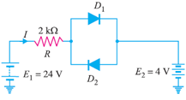

*Figure 1*

1. What happens when a p-type semiconductor is joined to an n-type semiconductor material? **3mks**
2. For a transistor, β = 45 and voltage drop across 1kΩ which is connected in the collector circuit is 1 volt. Find the base current for common emitter connection. **3mks**
3. In a transistor circuit, collector load is 4 kΩwhereas quiescent current (zero signal collector current) is 1mA.
4. What is the operating point if VCC = 10 V ? **2mks**
5. What will be the operating point if RC = 5 kΩ? **2mks**
6. With an aid of a diagram identify the three transistor configurations **3mks**
7. The circuit of Figure 2 uses two Zener diodes, each rated at 15 V, 200 mA. If the circuit is connected to a 45-volt unregulated supply, determine:
   1. The regulated output voltage **1mk**
   2. The value of series resistance R **3mks**

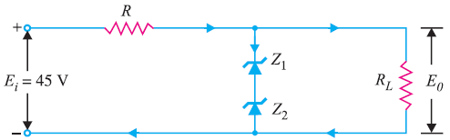

*Figure 2*

**QUESTION 2 (20 MARKS)**

1. Outline any three properties of Semiconductors **3mks**
2. Using a well labeled diagram, describe the formation of N type and P type semiconductors **8mks**
3. Using the band theory of solids, highlight the major differences between conductors, semiconductors and insulators **9mks**

**QUESTION 3 (20 MARKS)**

1. Derive the relation between β and α **6mks**
2. For the circuit shown in Figure 3 , find:
3. the output voltage
4. the voltage drop across series resistance
5. The current through Zener diode. **9mks**

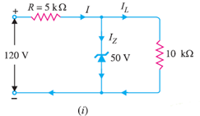

Figure 3

1. The forward characteristic of a diode is shown in Figure 4. Use the characteristic to determine
2. the current flowing in the diode when a forward voltage of 0.4V is applied, **1mk**
3. the voltage dropped across the diode when a forward current of 9mA is flowing in it, **1mk**
4. the DC forward resistance of the diode when the forward voltage is 0.6V, and **2mks**
5. Whether the diode is a Ge or Si type. **1mk**

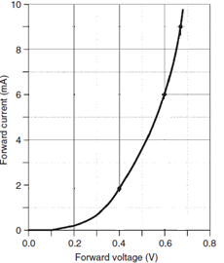

*Figure 4*

**QUESTION 4 (20 MARKS)**

1. In the Wien bridge oscillator shown in Figure5, R1 = R2 = 220 kΩand C1 = C2 = 250 pF. Determine the frequency of oscillations. **4mks**

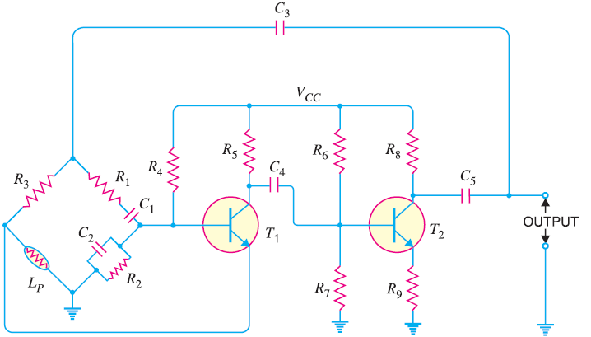

Figure 5

1. Determine the (i) operating frequency and (ii) feedback fraction for Collpitt’s oscillator shown in Figure 6 **8mks**

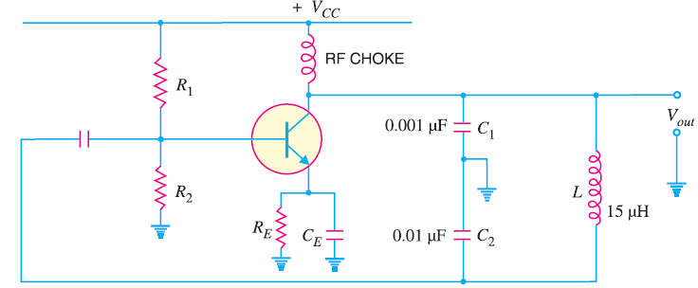

*Figure6*

1. In the circuit diagram shown in Figure 7 if VCC = 12V and RC = 6 kΩ, draw the d.c. load line. What will be the Q point if zero signal base current is 20μA and β = 50? **8mks**

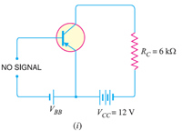

*Figure7*

**QUESTION 5 (20 MARKS)**

1. Determine the maximum operating frequency for the circuit shown in Figure 8. The slew rate is 0.5 V/μs. **5mks**

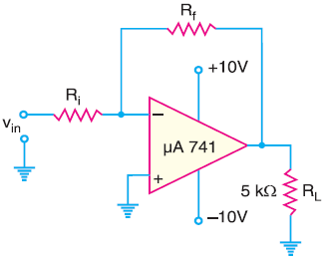

*Figure8*

1. Determine the output voltage for the summing amplifier shown in Figure 10. **5mks**

**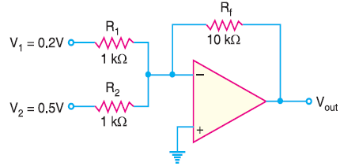***Figure9*

1. The differential amplifier shown in Figure 12 has a differential voltage gain of 2500 and a CMRR of 30,000. A single-ended input signal of 500 μVr.m.s. is applied. At the same time, 1V, 50 Hz interference signal appears on both inputs as a result of radiated pick-up from the a.c. power system.

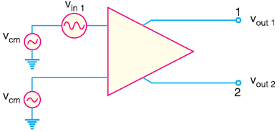

*Figure 10*

1. Determine the common-mode gain. **10mks**
2. Express the CMRR in dB.
3. Determine the r.m.s. output signal.
4. Determine the r.m.s. interference voltage on the output.