KENYA TECHNICAL TRAINERS COLLEGE DEPARTMENT OF COMPUTER STUDIES
CS1005 OPERATING SYSTEMS
CAT 1 TERM 1 2018 2017cscs3C
Time Allowed: 1 Hour

Instructions: Attempt ALL Questions.

Question 1
Process management is an integral part of any modern day operating system (OS). The OS must allocate resources to processes, enable processes to share and exchange information, protect the resources of each process from other processes and enable synchronization among processes.
In class we discussed the five-state process model depicted in Figure 1 below.
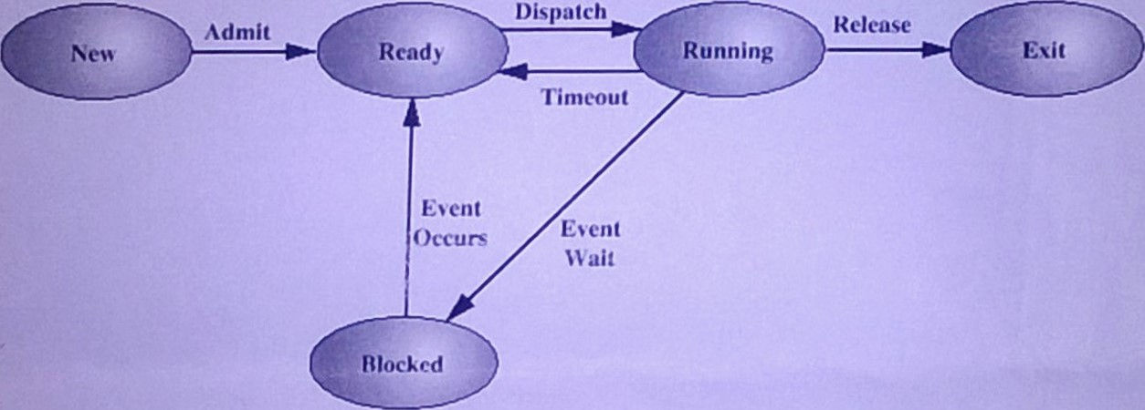
You are required to complete the following table 17 marks]
Process state | State description (1 or two sentences | What can initiate/trigger transition to this state | What can initiate/trigger transition from this state
New
Read
Running
Blocked
Exit |  |  | N/A
1
Question 2
- Suppose that the following processes arrive for execution at the times indicated. Each process will run for the amount of time listed. In answering the questions, use non preemptive scheduling, and base all decisions on the information you have at the time the decision must be made.
Process | Arrival Time | Burst Time
P1 | 0.0 | 8
P2 | 0.4 | 4
P3 | 1.0 | 1
  - What is the average turnaround time for these processes with the FCFS scheduling algorithm? (6 marks)
  - What is the average turnaround time for these processes with the SJF scheduling algorithm? (6 marks)
  - The SJF algorithm is supposed to improve performance, but notice that we chose to run process PI at time 0 because we did not know that two shorter processes would arrive soon. Compute what the average turnaround time will be if the CPU is left idle for the first 1 unit and then SJF scheduling is used. Remember that processes PI and P2 are waiting during this idle time. so their waiting time may increase. This algorithn1GÜITbÜGÄfuture-knowledge scheduling.
- Many CPU-scheduling algorithms are parameterized. For example, the RR algorithm requires a parameter to indicate the time slice. Multilevel feedback queues require parameters to define the number of queues, the scheduling algorithms for each queue, the criteria used to move processes between queues, and so on. These algorithms are thus really sets of algorithms (for example, the set of RR algorithms for all time slices, and so on). One set of algorithms may include another (for example, the FCFS algorithm is the RR algorithm with an infinite time quantum). What (if any) relation holds between the following pairs of algorithm sets? (8 marks)
    - Priority and SJF
    - Multilevel feedback queues and FCFS
    - Priority and FCFS
    - RR and SJF

