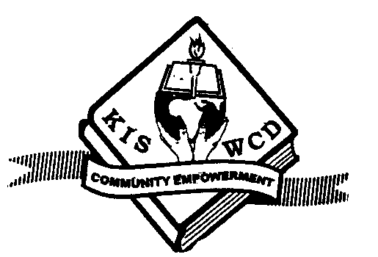KENYA INSTITUTE OF SOCIAL WORK AND COMMUNITY DEVELOPMENT

MODULE THREE
LEVEL: DIPLOMA
COURSE: DSW/GIWEP/DPPM/DMM/DMN
CODE: 1219/1519/1319/1419/2619
UNIT: SOCIAL POLICY AND ADMINISTRATION
DATE: 8.12.16
TIME: 2:30 – 5: 00PM

Instruction: Answer question ONE and any other FOUR questions

- a. Looking at the aims of Social Policy, explain each aim giving specific examples of its applicability (10 marks).
c. There are various emerging trends in social policy and administration. Discuss five emerging trends you know (10 marks).

- As a social policy student discuss various groups and arms of government that play a vital role in policy administration at different levels (20 marks).

- a. Discuss the three main models of social policy and give a specific example of organizations using each model (10 marks).
b. Discuss four challenges experienced in policy administration at county
government (10 marks).

- Policy making process can be influenced by many factors. Giving clear examples, discuss these factors (20 marks).
- a. Explain how bills became law by narrating a case of any bill that has been recentry passed (15 marks).
b. state at least three bills that have been passed for the last three years (3 marks).

c. State any bill that was passed recently but did not get presidential assent to become a law and state the reasons for this (2 marks).

- Social policy is very important in development work. Discuss this statement looking at the role of social policy in social development work in your community (20 marks)

- Explain six steps followed in the process of policy analysis (20 marks)
- As a community developer and with a case in mind;
a) Explain the steps you will go through in decision making giving very specific illustrations (10 marks).

b)Show Cleary some of the models you may use (10 marks).

KENYA INSTITUTE OF SOCIAL WORK AND COMMUNITY DEVELOPMENT

Nacico Plaza, 6th Floor, Landhies Road, P.O. Box 57961, Tel.248637 Fax: 247539 Nairobi, Kenya E-mail: kiswcd@kenyaweb.com

LEVEL: CERTIFICATE

MODE: FT/DLP

UNIT: SOCIAL POLICY AND ADMINISTRATION

- A) Define the following terminologies (4 marks)
- Policy administration
- Policy formulation
B) Briefly explain the factors that influence policy and in each category give specific examples (6 marks)

- A) State various functions of social policy in the society today (5 marks).
B) State the aims of social policy (5 marks)

- As a social policy student briefly explain various groups and arms of government that play a vital role in policy administration at different levels (10 marks).

- A) Highlight five evaluation techniques you would use to evaluate you project (7 marks).
- State three determinants of effectiveness of a project (3 marks).

- Clearly highlight stages involved in policy-making process

- A) State the stages involved in policy formulation process (5 marks)
B) Mention various groups and arms of government involved in policy administration (5 marks)
7. A) Briefly explain two types of evaluation (6 marks)
B) State four reasons why programs may be ineffective (4 marks)

8. A) Which are some of the agencies involved in policy implementation (4 marks)
B) Highlight models used in social policy and clearly give an example of organizations employing each model (6 marks)

9. A) State four policies of an organization of your choice (4 marks)
B) Mention at least three bills that have been passed for the last three years (3 marks)
C) State three examples of pressure groups/interested groups (2 marks)
D) Mention a policy offered by KISWCD (1 mark)

10. Citing a project of your choice explain the factors that may affect its success and its failure and give your comments (10 marks).

