**LIMITS AND CONTINUITY**

1. For the graphs shown below state the value of for which: (i) does not exist.

ii)  is not continous. (iii)  has a removable discontinuity. (iv)  has a jump discontinuity. (v)has an asymptote. (1 mark)



**LIMITS FROM A SKETCH**

1. Below is the graph of  For each of the given points, determine the value of and. If any of the quantities do not exist, clearly explain why.
2. .
3. .
4. .
5. .

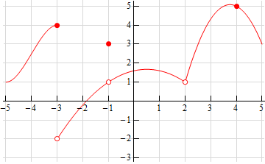

1. Below is the graph of  For each of the given points, determine the value of and. If any of the quantities do not exist, clearly explain why.
2. .
3. .

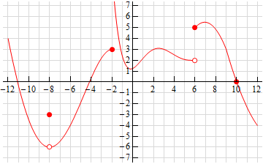

1. .
2. .
3. .

**LIMITS N CONTINUITY FOR PIECEWISE DEFINED FNS**

Given the function  ,

1. Sketch the graph. (2 marks)
2. Find . (1 mark)
3. At what points if any is  not continuous. Give reasons for

your answer and state the type of discontinuity at stated point. (3 marks)

1. Given the function  ,
2. Sketch the graph. (2 marks)
3. Find . (1 mark)
4. At what points if any is  not continuous. Give reasons for

your answer and state the type of discontinuity at stated point. (3 marks)

1. Given the function  ,
2. Sketch the graph. (2 marks)
3. Find . (1 mark)
4. At what points if any is  not continuous. Give reasons for

your answer and state the type of discontinuity at stated point. (3 marks)

1. Find all the real numbers for which  is undefined. 2 marks.
2. For what values of *x* is the function continuous ? 3 marks
3. Determine if the following functions are continous at the stated point.
   * 1. 
     2. 
     3. 
     4. 
     5. 
     6. 
     7. 
     8. 
     9. 
     10. 
     11. 
     12. at x = 1, and x = 3.
4. Find all values  of that guarantee that exists for the function



1. Determine where the following function is discontinuous: . 3 marks