JOMO KENYATTA UNIVERSITY OF AGRICULTURE AND TECHNOLOGY
UNIVERSITY EXAMINATIONS 2017/2018
EXAMINATION FOR THE DEGREE OF BACHELOR OF MEDICINE AND SURGERY,SCIENCE IN PUBLIC HEALTH, SCIENCE IN PHYSIOTHERAPY, SCIENCE IN OCCUPATIONAL THERAPY
ICS 2100: INTRODUCTION TO COMPUTER SYSTEMS
DATE: JANUARY 2018 TIME: 2 HOURS
INSTRUCTIONS:
Answer Question ONE and any other TWO questions.
Question 1
- Differentiate between the following. [4 marks]
- Hardware and software.
- Digital computers and analog computers
- Explain the following modes of processing. [6 marks]
- Batch processing
- Interactive processing
- Multiprocessing
- Explain two different ways of opening MS Excel. [2 marks]
- Explain any four functions of an operating system. [4 marks]
- Illustrate two different ways of doing each of the following:- [8 marks]
- Insert a column in a worksheet.
- Add a new worksheet
- Rename a worksheet
- Delete a worksheet
- The buttons below are found in the Microsoft word ribbon. Explain the function of each of the labeled parts. 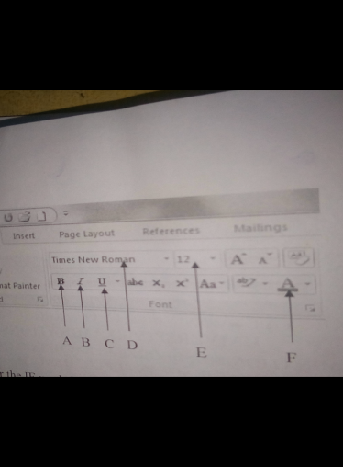[6marks]
Question 2
- Give the proper syntax for the IF worksheet function and explain each of the arguments. [4marks]
- The data displayed in a certain cell H5 is the result of a formula i.e = H3+H4. Explain how Alice would copy the value and paste it in cell J5 without copying the formula [2 marks]

- Define the term calculation operator as used in Microsoft excel. [2 marks]
- Using examples explain the four different types of calculation operators [4 marks]

- State the importance of protecting a file using a password. [2 marks]
- Briefly explain how you would save your workbook with a password to open. [2 marks]
- Explain any four views one can display a word document in. [4 marks]
Question 3
- Explain the main purpose of an operating system.
- Explain the steps you would follow to do each of the following:-
- Hold rows 1 to 3 constant so that they don’t scroll off the screen as you move around the worksheet. [3 marks]
- Print only a certain section of the data in your worksheet. [3 marks]
- Copy the format H3 to F2 without affecting the value in F2. [2 marks]
- Include column and row heading in your print out. [2 marks]
- Assume that cell B4 contains the name Karen and cell B5 contains the name Campus. Write a formula to be attached to the cell C5 to display the two names combined. i.e Karen Campus. [3 marks]
- Differentiate between SUM and SUMIF worksheet functions. [2 marks]
- Give the proper syntax for SUMIF and explain the argument used. [3 marks]
Question 4
- Distinguish between the following:- [6 marks]
- COUNT and COUNTIF worksheet functions.
- Absolute and relative Cell Referencing.
- Sorting and filtering.
- MS-Excel provides different method of achieving the same result. Using examples, briefly explain three different methods you can use to add up values in a given range. [6 marks]
- Explain two advantages and two disadvantages of electronic spreadsheets. [4 marks]
- At Kangemi Light Industries data is stored in Microsoft Excel and reports are prepared using Microsoft word. As a result, if there is a change to be made, it has to be made in both MS-Excel and MS-Word which is tiring and sometimes leads to inconsistencies. Explain how the staff can copy a section of the Excel worksheet to a word document so that when changes are made in Excel, they are automatically reflected in the word document. [4 marks]

