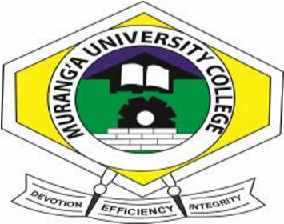

MURANG’A UNIVERSITY COLLEGE
(A constituent College of Jomo Kenyatta of Agriculture & Technology)
SCHOOL OF BUSINESS AND ECONOMICS

DEPARTMENT OF COMMERCE

MAIN CAMPUS

2015/2016 ACADEMIC YEAR
EXAM: END OF SEMESTER 2EXAM
DIPLOMA IN BUSINESS MANAGEMENT
UNIT CODE : DAB 1121
UNIT NAME : COST ACCOUNTING
SUPPLEMENTARY EXAMINATION
INSTRUCTIONS TO CANDIDATES TIME: 2HOURS
Answer question one and any other two questions

Q1a) Explain advantages of performing inventory method (6marks) b) Highlight Four sections into which cost accounting is divided (8marks)
C) Briefly explain Five classifications of costs (8marks) d) What are the advantages of standard costing (8marks)
Total 30marks
Q2a) Describe factors you would consider in choice of a costing system (10marks)
b) The following is provided to you relating to ABC co.ltd
Sales for the year | 275,000
Opening stock of finished good | 7000
WIP | 4000
Purchasing materials for the year | 110,000
Opening stock of raw materials | 3000
Closing stock of raw materials | 4000
Direct labour | 6500
Factory oils | 21000
Other expenses
Selling expenses 10% sales
Administrative expenses 50% of sales
Required: prepare statement of cost (10marks)

Total 20marks

Q3) What are the advantages of centralized purchasing (10marks) b) Explain the procedure in purchasing (10marks)
Total 20marks
Q4a) Cost A buys annual requirements of 36000 units of an installment ordering cost is Ksh 25, inventory carrying cost 20% of unit value which is Ksh 640
Calculate EOQ (4 marks)
b)Write short notes on
i. Standard costing (4marks) ii. Historical costing (4marks) iii. Job costing (4marks) iv. Contract cost (4marks)

Total 20marks

