EDUCATION

SECTION A (60marks)
Answer ALL the questions in this section.

  - Explain three domains of learning according to bloom’s taxonomy. (6marks)
- Cognitive domain-This deals with the intellectual type of learning i.e. mental operations or thinking.
- Psychomotor domain-This deals with coordination of movement
- Affective domain-It deals with emotions and values.

- Give five considerations a teacher should make when using group teaching approach for effective learning. (5marks)
- Divide the learners into manageable groups.
- Consider the objectives of the lessons/nature of topic/subtopic.
- Availability of teaching-learning resources.
- Availability of space/number of pupils.
- Time&criteria for grouping e.g. ability of learners, interest of learners’ gender. e.t.c.

- Propose six ways in which a school can promote development of learners’ potential abilities. (6marks)
- Provide a conducive learning environment.i.e a relaxed learning atmosphere/healthy teacher-pupil relationship.
- Provide opportunity for self initiated learning/relevant resources.
- Use learner centered methods of teaching to encourage participation e.g. project/demonstration.
- Encourage learners to ask questions and express their ideas.
- Encourage learners to participate in decision-making/Responsibility.
- Provide opportunities where learners can apply the learnt principles e.g. creative writing, music, drama, artwork & application.
- Provide learning opportunities that enable learners to acquire skills of literacy, writing, good speech, reading and numeracy.
- Motivate learners’ initiatives and boost morale.
- Acknowledge unusual questions and ideas and help them to fill gaps.
- For gifted/talented learners, give more challenging work.

- Identify six offences a teacher may commit that could result in disciplinary action by the Teachers Service Commission (TSC). (6 marks).
- Chronic absenteeism.
- Desertion.
- Insubordination/professional misconduct/negligence.
- Incitement.
- Immoral behaviour.
- Political activities.
- Infamous conduct e.g drunkenness, fighting.
- Forgery/impersonation.
- Criminal cases.

- Give six reasons why a scheme of work is important to a teacher.(6marks).
- Helps a teacher to put into consideration the available resources.
- Helps the teacher to take into consideration the learner’s ability, background and previous experience.
- Helps the teacher to plan for appropriate teaching-learning methods, learning experiences and modes of assessment.
- Helps in teaching the topics in a logical sequence.
- Promotes uniformity in teaching especially amongst teachers teaching the same subject but different streams.
- Helps the teacher to cover the topics in each subject within the time allocated.
- Helps the teacher to break the syllabus into teachable units.
- Helps the school administration to ensure that the teachers follow the official syllabus.

  - Regina, one of your colleagues who is expecting her first baby comes to you for advice. Which four factors will you advice her to take into considerations in order to deliver a healthy baby.(4mrks).
- Maternal diet.
- Exposure to radiations/X-rays.
- Rhesus factor incompatibility.
- Age of mother.
- Prolonged labour.
- Emotional state of mother.
- Drugs taken during pregnancy/alcohol.
- Exposure to chemicals.

  - Explain five reasons that led to initial resistance to western education by the Africans.(5mrks).
- A lot of demand was put on learners especially those in boarding schools e.g harassment by Europeans in the way of hard labour.
- Africans felt that the education was interfering with their socio-economic state.
- They were against agriculture and industrial kind of educational/vocational educational/practical education.
- They looked at the policy of education as intended to make them peasants in a modern economy and distinct Europeans and Asians.
- African children received different education from the whites’/racial segregation.
- The missionaries were known to preach against African cultures such as female circumcision which was not welcome by the Africans.
- Missionaries also contributed to land grievances.
- Africans were against the conversion to Christianity which was tied to education.
  - Explain five ways in which National Youth Service (NYS) contributes to national development.(5marks).
- Provides technical knowledge, vocational skills and attitude necessary for human resource development.
- Produce skilled artisan, craftsmen, technicals and technologists both for the formal and informal sector.
- Provide increased opportunities for school learners that will enable them to be self reliant.
- Develop desirable skills, values attitudes and that will enable school leavers earn a living.
- Helps to conserve Kenya’s natural resources.
- Promote national unity.
- Offers opportunities for further education and training.
- Inculcate in the youth good citizenship/provide opportunity to contribute to social economic development of the country.

  - Outline six signs that may lead a teacher to conclude that a learner in class is experiencing frustration.(6 marks).
- Emotional outburst.
- Blaming others for his/ her own failure.
- Expression of rudeness to teachers and other learners.
- Aggressive behaviour / crying.
- Absentmindedness in class/drop in performance.
- Restlessness/anxiety/fearful/depression/fidgeting.
- Regressive behaviour such as thumb sucking, nail biting.

  - a) Distinguish between a specimen and a model as teaching-learning resources. (2 marks)

Specimen; It’s a whole thing taken as a representation of its groups or class.e.g a collection of grasshoppers, plants and soil samples, e.t.c.

Model; A model is a recognizable three dimensional representation of a real thing.

b) Give two advantages of using a specimen and two advantages of using a model as teaching-learning resources.

Specimen:
- It allows learners to observe study and manipulate the objects.
- Makes the learning situation more real/interesting/enhances retention/involving.
- Specimens can be preserved and stored for later use.
- Specimens are portable.
- Can be collected from distances and be made available.
- They can be used for longtime if well preserved.
Model:
- The model gives the feeling of depth and substance like the real thing /capture attention.
- The model can be used to reduce large object or to enlarge small ones to a size that can be manipulated and observed.
- It promotes learning through the sense of sight and touch/enhance retention.
- Can be used to demonstrate the interior structure of with fine details without resorting to the damage of the real thing.
- Models can be used to represent a very highly complex situation or process/critical thinking.

  - You have been posted as a guidance and counseling teacher in a primary school which does not have guidance and counseling services. Mention five factors that you would consider when establishing these services. (5marks).
- Needs of the learners.
- Select personnel with desirable qualities for effective guidance and counseling.
- Develop a data processing system.
- Identify relevant professionals for referral cases.
- Ensure continuous evaluation of the guidance and counseling services.
- In-servicing of selected guidance and counseling personnel.
- Prepare schedule for guidance and counseling.
- Clarify the functions and goals of guidance and counseling.

SECTION B (40marks)
Answer any TWO questions from this section. Write your answers in the spaces provided after question number 15.

  - (a) Identify five factors a teacher should consider when planning a lesson for multi-grade class.(10marks)
- Decide what topic or theme is common to teach the grades involved.
- State the objectives considering the different grades.
- Determine the content that is suitable for each grade.
- Develop clear lesson plans that cater for age levels.
- Select relevant teaching-learning resources.
- Select learning activities based on the grades of the learners.
- Select and brief leaders on their roles.
- Select relevant teaching/learning methods.

(b) Examine five challenges that the teacher may face in dealing with multi-grade class. (10marks)
- Making teaching learning resources appropriate for different grades.
- Deciding when and how to teach topics and themes that are not common to all grades.
- It is time consuming in planning for various grade levels.
- Difficult to maintain discipline due to a wide range of learners’ interest and growth needs.
- Meeting the individual learners’ needs.
- Identifying the common topics and themes that are suitable for the varied ages.
- Marking learners’ work is difficult especially when the class is large.
- Coping with increased amount of work at the planning stage.
- Planning for a variety of lessons.

  - Explain how the following documents are used for effective school management.
(a) School master time table.
- Ensures activities around the school are orderly to reduce conflict.
- Indicates the subject /activity a class is doing at a particular time.
- Indicates in which class the teacher is at given time.
- Facilitates supervision of teachers/learners.
- Shows the curriculum followed in a school.
- Allows for effective use of available resources.
- Enables head teacher to assign responsibilities to members of staff to supervise various activities.

(b) Examination records.
- Provide a quick and accurate reference to a learner’s performance and give feed back to parents.
- They are used to assess capability and weaknesses of individual learners.
- Can be used to write testimonials and recommendations on both performance of teachers and learners.
- Can be used for future reference in case of loss of certificates and academic documents.
- Promotion to the next level.
- Gauge learners that are in need of remedial teaching.

(c) Log book.
- Shows daily occurrences in the school.
- Shows unusual happenings in the school.
- Gives detailed history of the school.
- Can be used to evaluate school programmes and make adjustments.
- Can be used to plan school programmes.
- Shows when important personalities visited the school (DEO, MP, PDE and other stakeholders).
- Shows when teachers and head teacher were absent.
- Shows when the school participated in games, tours, prize-giving day and public holidays.
- Gives information about materials, tools and equipment purchased.
- Shows experiments and innovations tried in the school.

(d)Correspondence files.
- Shows communication with members of the school community, ministry of education and other stakeholders.
- Contains policy guidelines such as circulars from MOE, KNUT, TSC, DEO, PDE that give information about management of the education system by term dates.
- Shows records of discipline cases which help in management of learners with behavioral problems.
- Contains information on best performing students which help in their motivation and giving awards.
- Contains appointments for teaching and non-teaching staff which help in knowing their academic levels for promotional purposes.
- Contains invitation letters for various meetings to the school to discuss school development matters.
- Contains confidential letters that can be used for staff appraisal/commendation/demotion.

  - (a) Define the following types of tests:
Diagnostic test
- It is an in-depth test used to identify specific needs/abilities/talents and trait in learners.
Aptitude test
- This is a test of a person’s ability to learn a task or potential ability to perform a task.

Achievement test
- This is a test designed to measure a learner’s knowledge, skills and attitudes in a given area of learning.

(b) Suggest seven ways in which a teacher can enhance the effectiveness of essay tests. (14marks).
- Avoid vague terms that can elicit contradictory responses from the learners.
- Avoid long wordy questions, instead use shorter questions.
- Moderate the test items.
- Write answers to the set questions to remove ambiguity.
- Follow the working scheme strictly.
- Mark when mind is still fresh.
- Allocate enough time for writing the exam/setting.
- Read over a sample of candidates’ papers to obtain a general idea of the quality of answers that may be expected and include relevant answers provided by candidates that were not in the initial marking scheme.
- Mark blind to avoid overscoring underscoring.
- Ensure that the objectives of the topic area the essay test questions are derived from are best achieved through an essay test.

  - (a) Explain any five goals of education in Kenya.
    - Fostering, nationalism and patriotism to promote national unity-Kenya has diverse ethnic groups and races/religion but they should be able to live together as Kenyans. Education should therefore foster nationalism, mutual respect and patriotism for development of the nation.
    - Promote social, economic, technological and industrial needs for national development
-Education should prepare learners for changes in attitudes and relationships.
-Education should help learners to acquire skills, knowledge, expertise and personal qualities to support a rapidly developing economy.
-Education should prepare the youth for global technological and industrial development.
- Promote social equality and responsibity.-Education should provide equal educational opportunities for all.
- Promote individual development and self-fulfillment-Education should provide learners to develop their potential interests, abilities and talents to the fullest.
- Promote respect for and develop Kenya’s rich and varied culture-Education should instill in the youth an understanding of our varied cultural values.
- Promote international consciousness and foster positive attitudes towards other nations-Kenya is a member of the international community. Education should therefore lead the youth to accept membership in this international community.
- Promote sound moral and religious values-Education should develop in learners moral values to help them grow into self disciplined, self reliant and integrated citizens.
- Promote positive attitudes towards good health and environmental protection-Education should lead the youth to appreciate the need for physical health and to live in a healthy environment.

(b). Discuss five ways in which schools can enhance good health and environmental protection. (10 marks)
- Teaching of environmental and health education.
- Involving learners tree planting exercises.
- Involving learners in public health cleaning activities.
- Forming clubs of environmental, health and 4k clubs.
- Inviting speakers on health and environmental matters.
- Organizing seminars, workshops and talks within the school on good health and environmental protection.
- Involving learners in soil conservation activities such as building of gabions.
- Working in consultation with other organizations, institutions and companies involved in the promotion of good health and environmental protection e.g Green belt movement,NEMA,ministry of education/ministry of public health /Trips/fieldwork excursion.
- Providing a balanced diet/feeding.

1021/1 ENGLISH PAPER 1

SECTION A (40 MARKS)

Answer two questions. Question 1 is compulsory. In question 2 select one of the options given.

- You are the head teacher of Missionet Primary Schoolwhich is situated in a semi-arid area. The school is experiencing an acute food shortage. A local Non-Govermental Organisation (NGO) has written to you proposing to offer a feding program to the pupils.
Write a letter to the NGO accepting he offer and thanking them for the initiative. In addition, provide information on your school and make suggestions on how the programme can be run in your school. (20 marks)

ANS:
Layout Items
- Sender’s address
- Date
- Reference (file) number
- Receiver’s address
- Salutation
- Subject heading
- Complimentary close
- Signature
- Name
- Designation

Introduction:
Statement of appreciation, refer to NGO’s
Letter- date, reference number, subject

Body:
- Statement on magnitude of the problem e.g. pupils are malnourished; fail to come to school, school dropout.
- Statement on number of pupils who need the programme
- Statement on how you will run the programme e.g. facilities required
- Statement on the total budget
- Statement on meals to be offered e.g lunch, super
- Appropriate conclusion e.g. looking forward to…

- Choose one of the following topics and write a composition of not more than 350 words on it. (20 marks)

Either

- Write a composition that illustrates the saying: “Do not put all your eggs in one basket”

Or

(b) Describe the efforts the government is making to alleviate the employment of the youth in Kenya

SECTION B (20 MARKS)

- Read the passage below and then answer the questions that follow:

My parents could never have entertained so many guests and visitors in our home, on the meager salary of a church minister, had they not made big gardens for growing food. My mother made soap, which she gave to those who helped with digging and weeding. Ten miles away they grew rice in a riverbed and not far from Lubwa they cultivated a large area of land. Their generous hospitality became famous and their home was known everywhere as Galilee- the place of rest and peace.

After my father’s death, my mother expected every one of her children to help her in keeping house and home together. Though I was a boy, I was made to do every type of work around the house and in the gardens. I learnt to carry water from the well two miles away – we were never allowed to make any excuse for not washing because there was no water – and my mother insisted on us stripping for a bath everyday. I learnt to kneel bt the gardening stone and grind the millet for the evening meal. I learnt to sweep and clean the cooking pots and wash my own clothes and iron them as well. There was firewood to be gathered from the forest and always work to be done carrying poles to build build the grain bins and the chicken houses.

The land in the Northern Province is very poor and the only way of getting a crop of any kind is by the system of chitememe. In the dry season, the men go out with their axes into the forest and, climbing the trees, they lop off the branches. These are then stacked in long piles and burnt before the coming of the rains. The BaBemba are the most expert tree climbers in Northen Rhodesia and there is a great art in the way the branches are stacked before burning, for if they do not burn slowly and burn away completely, the soil beneath the fires is not sterilised and, when the seeds are planted in the ash, the weeds grow up and choke the millet. Only in this way has it been found possible to get a crop from the ground. There was noo shortage of land to cultivate in the Northern Province and we did not kill the trees by lopping off the branches. Over the years, the bush regenerated and could be cultivated again.

My people, through long ages of trial and error, had learnt to live with nature and win a living from the infertile soil.

(Adapted from English for communication: by Burford Harry, The College Press, 1987.)
(a) How did the writer’s parents manage to entertain many guests? (2 marks)

ANS:
- Food from big gardens
- Mother made soap
- Grew rice in river bed
- Cultivated a large area of land near Lumbwa

- State domestic chores that the children were exxppected to do by their mother (3 marks)

ANS:
- Carrying water
- Grinding
- Sweeping
- Cleaning cooking pots
- Washing and ironing own clothes
- Gathering firewood
- Carrying poles

- Identify and explain one figure of speech used in the passage. (2 marks)

ANS:
“as Galilee” – imagery- simile ie the place of peace
weeds choke the millet – personification of the weeds

- Was the Chitememe system friendly to the environment? Explain (2 marks)

ANS:
Yes because it did not kill the trees and after a while the bush regenerated

  - Describe the character of the writer’s mother (3 marks)

ANS:
Hospitable/generous- home, a place of rest, entertained many guests.
Strict/displinarian- taught all the children domestic chores/ensured children had a bath everyday
Hardworking/industrious- used to make soap

- Describe the writer’s attitude towards the mother. (2 marks)

ANS:
Admiration/ appretiation
Viewed the mother as a role.

- Give the meaning of the following words and phrases as used in the passage (4 marks)
- meagre- Not enough/insufficient
- Lop off- cut off, separate, remove
- Sterilized- kill the weeds/ destroy harmfull effects
- Regenerated- grew again/restored.

- Comment on the significance of the last sentense of this passage. (2 marks)

ANS:
The sentence emphasizes the community’s positive attitude towards work- they had learnt to earn a living from the infertile soil

SECTION C (20 MARKS)

- Read the passage and answer the questions that follow.

Purchasing is the procurement of needed materials, supplies services and equipment and is the responsibility of a designated officer in any organization. The procurement officer should adhere to certain important procedures. To begin with, the officer must make a purchasing order. The order issued is commonly referred to as Local Purchase Order (LPO). The LPO specifies the items wanted, the number, description and price. This is sent to the prospective supplier who signs a copy and returns it signifying acceptance and ability to supply. The supplier keeps one copy in his file and sends the third copy with the goods and the invoice to the buyer.

The buyer should then inspect all the goods once received to ensure that they are the right item and to confirm their quality, quantity and price. If everything delivered is according to the order, the buyer should make payment for the goods and services as per the agreed terms. If the delivery is unacceptable, the buyer should return the goods with a letter explaining why they cannot be accepted.

The buyer should always keep a purchase record. All transaction documents should beproperly kept to show the terms and prices. This also helps in keeping control of purchases and may indicate a need for extra funds. Keeping records also helps in making follow up on delayed deliveries as well as determining reliable suppliers.

A business should not keep too much stock in hand since this can be costly because of insurance, likely theft and rent for physical space taken up. There are several advantages of stock control, which include: saving on carrying costs and balancing of stock in relation to sales. It also includes giving attention ti the fast moving and most profitable items as well as determining optimum stock turn over rate for each item.
There are two methods to determine the quantity of stock. There is the physical count method, which is mostly used by small businesses. It involves simply couting the inventory on hand periodically. It may be tidious, but it is the simplest method of determining what is in the store. The other is the perpetual stock method. This is, more sophisticated and involves keeping a continuous record of everything that has ben sold. As a result, the number in the stock book should be the actual amounts on hand.

In about 80 words summarise the procedure that a Procurement Officer should follow in making and completing a purchase transaction. (12 marks)

ANS:
- Raise a Local Purchase Order
- Send a Local Purchase Order to the prospective supplier
- Receive signed copy confirming supplier is ready
- Receive and veryfy goods
- Accept the goods and add them to stock
- Arrange for payment.

(b) Make notes on the importance of keeping records in a business (8 marks)

ANS:

- To show terms and prices
- Keep control of purchases
- Indicate need for extra funds
- Make follow up on delayed deliveries
- Determine reliable suppliers
- Stock control
- Balancing stock in relation to sales.
- Noting fast moving and most profitable items.
- Determining stock turn over rate

SECTION D (20 marks)

- Below is a part of a composition written by a pupil. Underline ALL the mistakes of language, punctuation and spelling. Above each mistake, write the correction where necessary. An example has been given. Half a mark will be deducted from each miscorrection. (10 marks)

  - I start (started) saving money when I was five year’s (years) old. One day my mother came with a box that had a whole (hole) and gave me some money. She asked me to drop the money on (in) the box. She adviced (advised) me to be saving a shilling regularlly (regularlly). Every evening, I will (would) drop the money in the box. When I was seven (add a comma) my mother take (took) me to the bank. She open (opened) a bank account for me. I begun (began) to save my money in my bank account.

(b) Complete the passage below by filling the blanks with the correct alternative from the choices given in the brackets. (5 marks)

Every adult has passed (past/passed) through the teenage stage. During this stage, a lot (a lot/a lot) of biological changes take place The teenagers go (go/goes) through emotional experiences, which lead (leads/lead) to mood swings. Parents should talk to their children more often during this (this/these) stage.

(c) Rewrite the following sentences according to the instructions given after each without changing the meaning. (5 marks)
- The driver told the passengers to break the glass incase of an accident.
(Use direct speech)
ANS:
“Break the glass incase of an accident”, the driver told the passengers.

- My door is not as strong as yours. (use stronger)

ANS:
Your door is stronger than mine

- If you do not work hard you will fail the examination. (Use Either)

ANS:
You either work hard or you will fail the examination

- It was surprising that the student had not done the assignment even after she had been punished by the teacher. (begin: Surprisingly)

ANS:
Surprisingly, the student had not done the assignment even after she had been punished.
OR
Surprisingly, even after being punished by the teacher, the student hadn’t done the assignment

- The protesting workers carried these placards (write in passive voice)

ANS:
These placards were carried by the protesting workers.

1021/1 ENGLISH PAPER 1
SECTION A (45Marks)

Answer three questions from this section. Question one is compulsory. Answer two other questions: One from either ‘The novel’ or ‘The short stories’, the other from ‘The play’.

  - Compulsory.
(a) The different kinds of people mentioned are:
Watchmen
Twilight girls
Might travelers
Travelers from upcountry
The drunks/ drunkards.

(b)Give one example of stylistic devices used in the poem.(3marks)
i) Paradox- “Twilight girls assessing their gains, counting their losses”
The possibility that the twight girls have gotten both same gain (payments/gifts, drinks) and also contracted STD’s, lost chastity

ii) Personification-“dying embers of fires”
Embers are personified as if they were living or had life.

iii. Alliteration-Horizon hidden

(c) Explain the meaning of the following word and phrase as used in the poem.
(2 marks)
i) Clutching at the vanishing darkness

ANS:
Anxious that night would only last a little longer/unhappy that day is fast approaching.

ii) Stuffed

ANS:
Filled beyond carrying capacity

(d) Explain the significance of the last two lines of this poem (3 marks)

ANS:
The last two lines imply that the people named in the poem are only comfortable at the city at night.
Approach of day causes them anxieties as their activities can only be done at night.
Their activities can only be done at night and can only continue for a little while since morning is approaching.

(e) Describe the mood of the poem (3 marks)

ANS:
Hopelessness
Gloom
Disillusionment
Sad

(f) How appropriate is the title of the poem (2 marks)

ANS:
The title is appropriate; it depicts the true picture of what happens in the city towards dawn. The morning (approach of) brings to a close the activities of the night.

  - a) The Novel: Scarlet song, Marriama Ba.

(i) Briefly explain the escapade that is referred to in this excerpt (2 marks)

ANS:
The escapade:
She married a black man Ousmane against her parents wish.
She left France/ran away from France and stayed with her husband in Africa

(ii) What do we learn about Mireille’s Father from this except (3 marks)

ANS:
He is a sadist, he is happy that Mireille is suffering, delighting in his own victory.
He is unforgiving; he has not forgiven Mireille from marrying a Blackman: “You see what happens when you disregard traditions of dignity?”
He is hot tempered, Mireille could imagine her father ranting and raving
He is merciless/arrogant,”Ah, ha! Your daughter!”
He is a racist, “So the Negro ran off with a Negress”

(iii) Explain how Mirreille has been treated like a common object (4 marks)

ANS:
She has been abandoned by her husband for another woman.
She feels treat unfairly because she has sacrificed a lot to get married to Ousmane.
She feels betrayed because she still loves Ousmane who no longer seems to love her.
Mirreille got a letter in her peg ion-hole at school revealing her husband’s marriage to a Senegalese wife, Ouleymatou(a former girl friend)
Yaye mistreated her.
Ousmane’s cronies looked down upon her.
Ousmane depleting the joint bank account.

(iv) What are the traditions of dignity referred to in this except (2 marks)
ANS:
Whites look down upon the blacks’ culture
The French culture is supposed to be superior to the African primitive culture

(v) Identify and explain any two features of style used in this excerpt. (4marks)
Contrast:e.g father’s ranting and raving as compared to mother’s mute distress.
Sarcasm:e.g.the negro ran off with a negress.
Simile:e.g like a common object.
Metaphor:e.g the rebellious bird.
Use of short sentences/sentence structures~this brings out the intensity of mireille’s emotions.
Omniscient narrator: The author tells us what is going on in Mireille’s mind.

Or
(b) Short stories An anthology of east African short stories by Valerie Kibera.

Why is Amri annoyed with his son? (2marks)
  - He has learnt that the son has applied to stay in an Umoja Ujamaa village,the very place that he Amri hates.
  - His son is not convinced that the way to success is through Umoja/Ujamaa and wants his father to accept it.
  - His son is not going to give him a better future of becoming wealthy as he had anticipated.

(ii) State your understanding of the concept of Umoja Ujamaa Village from the story, Transition. (4 marks)

From president Nyerere- people coming together to start villages where they work together, for the benefit of all/socialism.

(c) What is Tumaini’s dilemma (2 MARKS)
Not rewarding his father/parent but the society.
His father had expected Tumaini to make him richwealthy but Tumaini wants to help the masses by joining Umoja Ujamaa village
He had infact enrolled with one and had hoped that his father would join him.
He is caught between his father’s dreams and wishes and the principles he cherished.i.e. reality vs ideology.

(d) Identify and explain one character trait of Amri as revealed in this excerpt. (3 marks)

Uncompromising /selfish/conservative/adamant/determined
He is the one to make suggestions and plans but never his son.

(e) Identify two features of style used in this excerpt and give an example of each (4 marks)
- Rhetorical questions-e.g. ”Was there any alternative?”
- Simile/sarcasm-e.g. “like an ungrateful cow with stomach full”
- Personification-“growing cold”
- -Direct speech –“To push me….”
- -Repetition-“To,…..
- Symbolism: Dying embers symbolizing dying hopes.

  - The Play: David Mulwa: Redemption
Either

- “You will start climbing the tree from the branches.”
Comment on the statement in the light of what happens in the play Redemption

INTRODUCTION
Ironical
While Elton thinks that the son Antoninous can climb the tree from the branches, the son thinks he needs to climb his own tree from the ground
Trees are climbed from the ground not from the branches.

FATHER ELTON
- Elton had done everything including forming a church to make money for the family.
- Elton having been poor never wanted the son to miss anything in life including buying for Antoninous (the son) a sports car.
- Elton despised Antoninous’ girlfriend Rebecca because she came from a poor background and her father was also his enemy.
- He had built a house for his son Antoninous so he would start climbing from the branches.
- He paid his workers very little money in order to save for his son/took people’s land and paid very little.

THE SON (ANTONINOUS)
- He had always lived under his father’s shadow, and had everything done for him.
- He had in moments of decision and false pride, deceived the girlfriend and impregnated her. He later realizes his mistakes especially when Rebbeca has been thrown out of home by her father.
- Antoninous realized that his destiny is with Rebbeca and the unborn child.
- The two reconcile, forgive each other and get married.
- Antoninous realized he has to stand on his feet, make his own decisions and not run away from his mistakes.

(b) (i) Explain the significant event that has just happened. (3marks)
- The singing women from the church want Mutema to relax his rules so that the congregation can come back to church.
- Among the singers is a woman carrying a child who is sick and thirsty.
- Rebbeca thinks that the child should have been given food and water.
- The father is furious.

(ii)Why is Rebbeca stunned? (2marks)
- The father would rather have this people crushed since they do not want to follow Christ
- Infact the father does not even let her daughter complete her request.

(iii)Discuss Pastor Mutema’s mode of preaching as opposed to that of Archbishop Muthemba’s.

ARCHBISHOP MUTHEMBA
- Archbishop Muthemba knows what he wants from the people.
- He allowed people to practice witchcraft as long as they would come to church.
- He also allows singing and dancing and paying offering.
- He’s able to use their plight to get funds from overseas and enrich himself.
- He does not care for the people at all.
- He rarely prays.

PASTOR MUTEMA
- Every Sunday it was thunder and brimstone and the hard narrow path rumbling to the pulpit.
- There was no two way about Christianity.
- Old-fashioned preaching-no dancing, no speaking in tongues, no women to be preachers.
- Did not relax church rules like Archbishop Muthemba.
- Sees sinners as earmarked for eternal fire.
- Follows Bishop Hardestein’s preaching to the latter.
- Prays all the time.

SECTION B: METHODOLOGY (55 marks)
Answer all the questions in this section.
  - (a) List down the four language skills in the order in which they are learnt. (2marks)
(i) Listening
(ii) Speaking
(iii) Reading
(iv) Writing

(b) Mention three ways in which learning of a second language can be made easy in Primary schools. (3marks)
(i) Increase exposure e.g within the classroom.
(ii) Motivation e.g use of attractive materials.
(iii )Reduce formality,use informal encouraging approaches.
(iv) Intense practice,reinforcement from the other subjects.
(v) Exploit learning from peers and group work.
(vi) Good role models.

(c) Give four reasons why English is the medium of instruction in upper primary classes.(3mks)
(i) Consolidates English used in textbooks.
(ii) Helps learners to get access into information found in reading materials.
(iii) International importance/language.
(iv) Official medium of instruction/Language policy.
(v) Official language of communication in Kenya.
(vi) English is used in teaching other subjects.
(vii) Exams are done in English except Kiswahili.

  - (a) A pupil has been pronouncing the following words as follows:
(i) Asked as ‘axed’
(ii) Hair as ‘air’
(iii) Gate as ‘get’
(iv) Milk as ‘miliki’
Give a possible reason for each of the mispronunciation. (4marks)
- asked as ‘axed’-consonant displacement.
- Hair as ‘air’-omission of the glottal sound ‘h’
- Gate as ‘get’-oversimplification of diphthongs.
- Milk as ‘miliki’-insertion of vowels.

(b) State three characteristics of a successful oral lesson presentation. (3marks)
- Practice should be thorough.
- Have variety/use of media.
- Be meaningful.
- Use of relevant contextual examples.
- Exposure to controlled structures language control.
(c) (i) Words that can be used to practice /k/ and /g/ sounds. (4marks)
/k/ /g/
Came game
Coat goat
Coal goal
Call gall
Cap gap
Cape gape
(ii)Briefly describe three activities you would use to practice the sounds above.
(3marks)
    - Say the word, pupils repeat.
    - ‘stop me game’
    - Show a picture or a model as you say the word.
    - Explain point and manner of articulation.
    - Using minimal pairs.
    - Use of tongue twisters.
    - Dialogue
    - Songs
    - Poems.
  - (a) How would you introduce the reading of a new word to your Standard Two class using the look and see method? (1mark)
Pupils are taught to associate the spoken sound with the written word and the object.

(b)Give a reason for using each of the following methods to introduce new reading items at lower primary. (2marks)
(i) Phonic method
- Suitable for regularly spelt words.
- Gives pupils some independence in reading.
- Can read forgotten words/new words.
(ii)Look and say
- Necessary for long, difficult and irregularly spelt words.
- Pupils read meaningful material/many words.
(c) You have discovered that some pupils in your class can read faster than others. List two types of reading material you would use to occupy these fast readers in a reading comprehension lesson. (2marks)
- Supplementary readers/storybooks.
- Teacher made reading materials.
- Articles written by other pupils.
- Newspaper cuttings.
- Books from other subject areas.

(d) Mention three qualities you would look for when selecting reading materials for upper primary classes.
- Relevance to pupils’ interest.
- Relevance to content to be taught.
- Appropriate language level.
- Humorous, exciting.
- Conformity with national goals of education.
- Durable
- Appropriate print size
- Illustrations
  - (a) Mention five ways that a teacher may use to provide assistance to the pupils with the content for a compost ion topic. (5marks)
(i) Guiding questions to bring out appropriate information.
(ii) Use of pictures.
(iii)Give main points in notes form.
(iv) Use of substitution tables.
(v)Paragraph beginnings
(vi)Sentences to be completed
(b) What should a teacher advise the pupils to do once they have finished writing a composition? (1 mark)
To proofread the work.

(c) A standard six teacher introduced a writing exercise by saying: “Open your books at page 12.I want you to do exercise 5.”Then the teacher sat at the table to mark some previous work. At the end of the lesson, the teacher collected the pupils’ exercise books.
State four ways in which you could improve on this procedure. (4marks)

(i)Discuss exercise, make pupils understand instructions.
(ii)Discuss the sentence patterns
(iii)Build content through question and answer method and wrote points on the board
(iv)Provide useful tips on spelling and organization
(v)Review the previous lesson giving apt examples
(vi)Assist individual pupils while writing

  - (a) State three ways in which story telling contributes to learning (3marks)
- Improves listening skills
- Exposes learners to more vocabulary
- Exposes learners to more sentence patterns
- Improves speaking skills/oral frequency
- Improves creativity in learners
- Motivates learners
(b) (i) Give four reasons why visual aids are essential in the teaching of English in primary schools. (4marks)
- Help to relate language to real life situations
- Retention is facilitated/memory
- Reinforcing langue already acquired
- Enhancing interests
- Facilitates teaching
- Makes teaching pupil centered
- Enhances meaning

(ii) Name any three types of visual aids you could use in an English lesson. (3marks)
- Pictures/photographs
- Real items/realia
- Films
- Drawings
- Charts
- Maps
- Flash cards
- MODELS

(c) Suggest four methods you would use to integrate the message on the importance of conserving forests in the teaching of English language. (5marks)
- Use this sentence patterns
- When introducing new vocabulary
- In a composition exercise
- Give related materials e.g comprehension
- Poetry
- Drama
- Debates/discussions
- Story-telling

KISWAHILI
Karatasi 1

SEHEMU YA KWANZA:INSHA (Alama 20)

  - Andika insha isiyo pungua maneno 350 kuhusu mojawapo ya mada zifuatazo:

- Wewe ni naibu wa mkuu wa shule. Andika mazungumzo kati yako na mzazi kuhusu maendeleo ya mwanawe shuleni.

JIBU:
Mazungumzo- muundo uwe ni wa mazungumzo
k.m. Mzazi:…………………
Mwalimu:…………….
AU
Mwalimu:…………….
Mzazi:……………….
Kuanza –Salamu
Mazungumzo yahusu maendeleo au matatizo ya mwanafunzi na matarajio yao.
Kumalizia Kwa maagano, k.m. Elimu, Nidhamu, Michezo, Mahadhurio, Afya, Ushauri, Maagano.

- Umuhimu wa kuwaelimisha wanajamii kuhusu njia mwafaka za kusuluhisha migogoro.

JIBU:
Hoja nzito kuhusu umuhimu wa kuwaelimisha wanajamii kuhusu njia mwafaka za kusuluhishia migogoro k.m.
-Kuishi kwa amani kama ndugu ilikuimarisha uchumi/maedeleo
-Kusameheana ili wapunguze dukuduku ili kuimarisha maendeleo, amani, rasli mali, ujenzi wa taifa, umoja, upendo, uhusiano mwema, heshima n.k.

- Mkulima ni mmoja walaji ni wengi.

JIBU:
Insha ionyeshe vile ambavyo mtu mmoja anafanya kazi lakini faida nyingi husaidia wengine pia.

- Malizia kwa:
Sikuamini kwamba alikuwa amebadilika kiasi hicho.

JIBU:
Maelezo yaonyeshe mabadiliko ya hali na tabia au moja wapo.
SEHEMU YA PILI: UFAHAMU (alamu 20)

  - Soma habari ifuatayo kisha ujibu maswali.

Hii ilikua ndiyo siku ya siku. Ingekuwa siku ya janguo kwa wengine na kwa baadhi ingekuwa siku ya kuuma vidole. Mizani ya haki ingeamua bivu na bichi.

Mbabe alikuwa akimtupia shemeji Dhilifu jicho la kebehi na kujisemea mwenyewe, “Hivi kwa nini shemeji amenileta huku? Hajui kwamba mume hapaswi kupelekwa mahakamani? Lini atatambua himaya yangu katika aila hii? Ngoja leo atavuna alichopanda!” Dhilifu naye alikuwa tuli, anajiwazia. “Hivi kwa nini nilijitia kisimani?” Huyu shemeji nitamweza kweli? Tayari ameshawadanganya wanangu mpaka wakaniona kuwa mimi si chochote si lolote. Isitoshe, huyu bwana amehonga sana. Mimi sipati kitu hapa.” Akaanza kutokwa na machozi.

Mbabe alipomwona Dhilifu akilia alifurahia sana. Akaanza kunong’onezana na wenzake na kucheka akijua kuwa kweli Dhilifu hataambua chochote. Dhilifu alikuwa na mwanawe mmoja tu upande wake. Mtoto huyualikataa katakata kushiriki katika njama za ami yake. Hakuamini uongo ambao ami alikuwa anauzua kila wakati.

Ami huyo alisingizia kwamba Dhilifu alikuwa mbaya kwa wengi. Watoto wawili wa Dhilifu walidanganywa, wakaiba hati-milii za mali ya wazazi na kumpa ami yao ambaye alikuwa amewaahidi mengi mema. Aliwaambia wangoje kesi iishe ndipo wangepewa fungu lao. Wakawa wanangoja siku hii kwa hamu na ghamu.

Hauchi hauchi unakucha. Hakimu aliingia na kesi ikaanza. Mbabe alipewa nafasi ya kutetea madai yake. Akasimama kwa madaha na kuanza hivi, “Mheshimiwa hakimu, marehemu ndugu yangu alisha kunirithisha mashamba, nyumba, biashara, mke na watoto kabla ya kufa. Alinipa mamlaka ya kuitunza familia na mali yake; yote yako chini yangu. Nimekwisha kukupa nakala zote za hati-miliki. Ninashangaa tumejia nini hapa. Kwanza kabisa, kulingana na mila, mimi ndiye mrithi hata kama pasingekuwa na hizo hati za kisasa. Pili, mwanamke hawezi kumpeleka mumewe kortini. Zaidi ya hayo, ukoo mzima umeniunga mkono katika suala hili. Ni hayo tu niliyo mheshimiwa.”

Dhilifu naye alipewa nafasi ya kuingia kizimbani, Mchozi yaliendelea kumbubujika kwani alidhani kuwa yeye hakuwa na chake. Moyo wake ulimwambia kuwa mikono ya majaji ilikuwa imevimbishwa na shemej yake kitambo. Yeye angefanyaje? Dhilifu alihofia isije ikawa dau la mnyonge haliendi joshi. Mwishowe akaamua kupiga moyo konde, akasema “Liwe liwalo. Binadamu hufa siku moja tu.” Baada ya kupiga haidhuru, Dhilifu alifuta machozi, akasimama kidete na kutoa dukuduku lake.
“Mheshimiwa hakimu, mimi nataka kuyakanusha yote yaliyosemwa na mdai, ambaye ni shemeji yangu. Nataka kueleza mahakama hii kuwa yote yaliyosemwa ni uongo mtupu. Mimi na marehemu mume wangu tuliitafuta pamoja mali hiyo. Huyu shemeji hakuchangia kwa namna yoyote. Mara nyingi huyu shemeji alikuwa akitupangia njama za kutuangamiza. Baada ya kifo cha kutatanisha cha mwenzangu, shemeji alianza kuwadanganya watoto wangu, akachukua kitambulisho cha marehemu na stakabadhi za mirayhi. Nina taarifa kuwa amezibatilisha stakabadhi hizo. Sina uwezo wa kuchukua chochote benki, amezuia kila kitu. Watoto wametatizika vyuoni. Hawana karo.
Shemeji anasema ati kwambavmwanamke hawezi kumshtaki mume wake. Hiyo ni imani iliyopitwa na wakati. Mwanamke ana haki kama mwanamume. Kufikiria kuwa mke akifiwa na mumewe lazima arithiwe au lazima mali iende kwa nduguze mumewe si haki. Mjane anaweza kuwakimu wanawe sawasawa bila kudhibitiwa na shemejize. Isitoshe, mali tulichuma pamoja na mume wangu, kwa nini ninyang’anywe? Mheshimiwa, naomba uyachunguze malilio yangu. Mimi ndiye mzazi aliyebakia na ninataka kukidhi mahitaji ya wanangu ipasavyo. Sina mengine Bwana Hakimu. Naomba haki itimizwe.”
Baada ya hakimu kutia na kutoa kwa muda, alifikia uamuzi. Dhilifu alirudishiwa mali yake yote. Kumhusu Mbabe, sheria iliachwa kuchukua mkondo wake.

- Kulingana na kifungu, kulia kwa Dhilifu kulisababishwa na nini? Toa hoja nne.
(alama 4)
JIBU:
- Aliona kuwa hangeshinda kesi.
- Mbabe alikuwa amewavuta watoto wawili wa watoto wake.
- Ukoo ulikuwa upande wa Mbabe
- Mbabe alikuwa amehongana.
- Mbabe alikuwa amebatilisha hatimiliki.

- Fafanua nafasi ya mwanamume katika jamii hii kwa mujibu wa taarifa. (alama 5)

JIBU:
- Ndiye mrithi wa mali.
- Ndiye mrithi wa mke
- Ndiye anayekimu familia.
- Hapaswi kushtakiwa na mke
- Ni chombo cha kutenga familia – Mbabe anamtenga Dhilifu na wanawe.
- Mrithi wa watoto
- Ndiye kiongozi

(c) Kuna ushahidi gani kuwa Dhilifu anaweza kuiendeleza familia? (alama 3)

JIBU:
(i) Alitetea haki ya familia yake mahakamani.
(ii) Alichuma na mumewe.
(iii) Ana akiba benki.
(iv) Angeendelea kuwasomesha wanawe.

(d) ‘Mbabe alikuwa fisadi.’ Toa hoja tatu kuthibitisha kauli hii. (alama 3)

JIBU:
(i) Anadanganya hakimu kuwa amerithishwa
(ii) Alibadilisha hatimiliki
(iii) Kupanga maangamizi ya familia ya Dhilifu
(iv) Alifarakanisha Dhilifu na watoto wake
(e) “Methali, ‘Dua la mnyonge haliendi joshi’ imebatilishwa katika kifungu hiki.”
Thibitiisha. (alama 3)

JIBU:
(i) Mbabe kwa kujihisi kuwa mwenye nguvu alitaraji kushinda kesi lakini hakushinda
(ii) Hakimu alikuwa na uwezo wa kudhulumu Dhilifu lakini alimpa Dhilifu haki
(iii) Dhilifu hakutarajia kushinda kesi lakini alishinda.

(f) Eleza maana ya manene yafuatayo kama yalivyotumika katika kifungu. (alama 2) (i) bivu na bichi
JIBU:
Ukweli/uongo, Haki/huruma, Mshindi/mshindwa

(ii) Kuwakimu
JIBU:
Kuwalea, kuwatunza, kuwatimizia mahitaji.

SEHEMU YA TAU: MATUMIZI YA LUGHA (alama 50)
Jibu maswali yote katika sehemu hii.

  - (a) Andika tofauti mbili kati a sauti zifuatazo, [b] na [v]. (alama 4)

JIBU:
[b]-kipasuo
-ya midomoni
[v]-kikwamizo/kikwaruzo
-ya mdomo na meno

(b) Maneno haya yako katika ngeli gani? (alama 2)
(i) Wema …
JIBU:
u…u
(ii) Mbao
JIBU:
U…zi

(c) Tambua aina za maneno yaliyopigiwa mistari katika sentensi hii. (alama 2)
Hee! Mwalimu wetu alipongezwa juzi.

JIBU: Hee! Kihisishi/kiingizi/kishangao.
Juzi…kielezi.

(d) Tunga sentensi moja uonyeshe matumizi ya kitenzi kisaidizi. (alama 2)

JIBU:
Mfano: wanafunzi wangali wanacheza Watoto walikuwa wakicheza.
- Akifisha kifungu hiki.
otweri amehamia hospitali kuu ya kenyatta tangu januari alikuwa akifanya kazi nakuru.

JIBU:
Otweri amehamia hospitali kuu ya Kenyatta tangu Januari, alikuwa akifanya kazi Nakuru.

- Tumia kiambishi –a- cha wakati katika sentensi kuonyesha hali mbili tofauti.
(alama 2)
JIBU:
Mazoea- jua la choma mashariki
Hali isiyodhihirika-asoma
Wakati uliopo-twala

- Unda sentensi ambatano kwa kuunganisha sentensi hizi: (alama 2)
Baba alikuwa mgonjwa. Baba amepona.

JIBU:
Baba alikuwa mgonjwa lakini amepona
Au
Baba alikuwa mgonjwa na amepona.

- Nyumbua vitenzi hivi katika kauli ya kutendeshaea. (alama 2)
(i) iga
JIBU:
Igizia/kuigizia.
(ii) nywa
JIBU:
Nyweshea/kunyweshea/nywishia

- Tumia mzizi-pole katika sentensi kama: (alama 4)
(i) Nomino..

JIBU:
Pole/Upole/polepole

(ii) Kivumishi..

JIBU:
Mpole

- Tunga sentensi kubainisha: (alama 4)
(i) Kihusishi cha wakati

JIBU:
MFANO: baada ya, kabla ya, hadi, tangu, mpaka.

(ii) Kiunganishi cha masharti

JIBU:
Maadamu, Kama, lau, ikiwa, iwapo, lazima, sharti.

(k) Tunga sentensi moja kutofautisha maana ya kaba na kapa (alama 2)

JIBU:
Kaba… bana kwa nguvbu/shikilia mtu afanye jambo kikamilifu/kitambaa kilichoshonewa shingoni na mabegani.
Kapa…Mchezo wa karata/sehemu ya pwani inayoota mikoko na yenye tope/kizibao/kipimo cha nguo,(enda kapa-nahau)

(l) Andika katika msemo halisi: (alama 2)
Mwalimu alishangaa ni kwa nini Juma hakuwa amebeba mkoba wake siku hiyo.

JIBU:
“Juma kwa nini hukuubeba mkoba wako leo!” Mwalimu akashangaa

- (a). Sikio ni kwa kusikiliza; figo ni kwa (alama1)

JIBU:
Kuchuja, kusafisha damu.

(b) Kapu la kubebea matunda huitwa (alama 1)

JIBU:
Pakacha

(c) …………… ni aina ya ndege ambaye hunyakua vifaranga. (alama 1)

JIBU:
Mwewe/kipanga

(d) Mnazi huzaa nazi na mgomba huzaa………. (alama 1)

JIBU:
Ndizi

- Kitalu cha maua huitwa pia…………. (alama 1)

JIBU:
Bustani/kitaru

- Kidani huvaliwa wapi mwilini…………(alama 1)

JIBU:
Shingono

- Mtoto wa simba ni shibli na mtoto wa nyuki ni………(alama 1)
JIBU:
Zana/jana/ chana

- Arbuni ni malipo gani…(alama 1)
JIBU:
Sehemu ya bei ya kitu anayotoa mnunuzi ili kitu kisiuzwe /adarasi/kishanzu

- Alama inayobaki mwilini baada ya jeraha kupona huitwa……(alama 1)

JIBU:
Kovu

- …………ni sehemu kati ya paja na kiuno (alama1)

JIBU:
Nyonga

- Tegua kiotendawili kifuatacho
Ng’ombe wangu hali hadi nimshike mkia…(alama 1)

JIBU:
Jembe/shoka/ufagio

- Mshenga amemwoa Salam. Mshenga ni mtoto wa Kuloba.

  - Salama atamwitaje dadake Mshenga?………..(alama 1)

JIBU:
Wifi
(ii) Kuloba atawaitaje wawaxi wa Salama………(alama 1)
JIBU:
Vivyele

- Andika tarakimu 11 111 101 kwa maneno… (alama 2)

JIBU:
Milioni kumi na moja, mia kumi na moja elfu, mia moja na moja

(o) Andika kinyume cha sentensi hii. (alama 2)
Mzee mrefu mwembamba amelala

JIBU:
Kijana mfupi mnene ameamka
- Andika methali nyingine yenye maana sawa na: (alama 2)
Mzigo uko kichwani kwapa lakutokeani jasho?

JIBU:
Pilipili usiyoila inakuashiani?
Mavi usiyoyala wayawingiani kuku?
Jivu usilolilalia walifukuziani paka?

SEHEMU YA NNE: SAJILI ZA LUGHA. (alama 10)

- Fafanua mambo matano ambayo husababisha kuzuka kwa sajili.

JIBU:
Sajili huzuka kutokana na kuwapo na miktadha tofauti ya matumizi ya lugha kama vili:-
- Mahali- upo mtindo maalum wa lugha ya mahali mahususi, k.v lugha ya sokoni, mahakamani n.k.
- Taaluma/kazi- sajili ya kisheria, sajili ya kimatibabu. Kila taaluma huwa na istiali zake. Kwa mfano sajili ya majibabuhutumia msamiati wa kisayansi
- Mada- wazungumzaji wa lugha huteua lugha kulingana mada kwa mfano, mada ya kisayansi hutumia istilahi za kisayansi.
- Umri- watu wa umri sawa hutumia lugha kwa mtindo sawa. K.M.vijana huwa na matumizi yao ya lugha ambayo ni tofauti na ya wazee.
- Matilaba/lengo- watu hutumia lugha kwa namna tofautikulingana na haja/lengo. K.M.lugha ya tahadhari, huwa kali, luha ya kuelekeza huwa angavu, ya moja kwa moja.
- Njia ya mawasiliano- kwa mfano sajili ya simu ni tofauti na sajili ya mazungumzo ya kawaida.
- Uana/jinsia- wanawake wana mtindo wao wav mazungumzo ambayo ni toauti na ya wanaume.
- Hali- watu hutumia lugha kulingana na hali wanamajikuta. K.M.sajili ya matangani/maombolezi.
- Cheo- watu wa cheo sawa hutumia lugha kwa namna mahususi. Watu wa cheo tofauti kwa kawaida hudumisha urasmi.
- Kiwango cha elimu- yapo matumizi ya lugha ambayoyanahusishwa na wasomi.
- Uhusiano- marafiki/ ndugu hutumia lugha kwa njia mahsusi. Ndugu wana mazoea ya kutaniana. Watu ambao uhusiano wao ni rasmi hudumisha urasmi katika lugha n.k.
- Tabaka
- Imani/utamaduni

KISWAHILI
Karatasi 2

USHAIRI
Jibu swali la kwanza au la pili.

- Soma shairi hili kisha ujibu maswali

S.A MOHAMED. Sikate Tamaa.

Jicho, tavumiliaje, kwa hayo uyaonayo?
Kicho, utasubirije, maonevu yapitayo?
Kwacho, lijalo nalije, nimechoka vumiliyo
Naandika!

Moyo, unao timbuko, maudhi tusikiayo
Nayo, visa na mauko, wanyonge yawakutayo
Kwayo, sina zuiliko, natoa niyahisiyo
Naandika!

Hawa, wanotulimiya, dhiki wavumiliayo
Hawa, mamiya mamiya, na mali wazalishayo
Hawa, ndo wanoumiya, na maafa wakutayo
Naandika!

Hwa, sioni wengine, kwao liko angamiyo
Hawa, huwapa unene, watukufu wenye nayo
Hawa, bado ni wavune, kwa shida waikutayo
Naandika!

- Kwa nini mshairi amechoka? Toa sababu nne. (alama 4)

JIBU:
- Maonevu ayaonayo
- Vifo vya wanyonge
- Maskini wengi, hawafaidi mali wanayozalisha
- Pupa tamaa ya kupata mali zaidi
- Tofauti kubwa ya matajiri na maskini

- Andika bahari zinazojitokeza katika shairi hili ukizingata: (alama 3)
- Mishororo
JIBU:
Tarbia (mishororo minee) unne

(ii)Vipande
JIBU:
Ukawafi (vipande vitatu)

(iii)Kibwagizio
JIBU: Msuko (kimefupishwa)

- Toa mifano ya aina mbili za uhuru wa kishairi uliotumika katika shairi. (alama 2)
JIBU:
Inkisari- tavumiliaje
Bananga sarufi- kwako sin zuiliko
Lahaja- wanotulimiya
Tabdila- wanoumiya

(d) Andika ubeti wa tatu kwa lugha ya nathari (alama 4)
JIBU:
Watu wanaotufanyia kazi kama vile kulima hukumbwa na kuvumilia shida
Watu hawa ambao ndio wengi hushiriki katika kuzalisha mali
Licha ya mchango huo wao huendelea kukumbwa na shida za kila aina
Hali hii ndiyo imenisukuma kuandika

(e) Eleza maana za manene yafuatayo kama yalivyotumika kwenye shairi (alama 2)
- Mauko
JIBU
Hali ya kupoteza uhai, vifo, mauti

- Wavune
JIBU:
Watu waliochoka/wenye maumivu ya uchovu.

- Soma shairi lifuatalo kisha ujibu maswali

KING’EI NA AMATA: Taaluma ya Ushairi.

Kupenda mno ukwasi, naona nitapotea,
Mali ina wasiwasi, sikai nikatulia,
Mali huzaa maasi, mtu yakampotoa.

Mwenye mali huzuzuka, kheri akaziambaa,
Na heshi kubabaika, kushukushuku jamaa,
Na huko kufilisiki, akuhofu kila saa.

Maadui wa mkwasi, ni wengi kupindukia,
Rafikize si halisi, ghalibu humdowea,
Wamchomoe fulusi, kisha wamtete pia.

Kheri nikidhiwe haja, shida zikinifikia,
Nile kadiri ya haja, na nione njaa pia,
Na niipate faraja, dhiki zikinitokea.
Ee Mola wangu Bwana, Jalla wa ala Jalia,
Ufukara Maulana, nakuomba nepushia,
Nipe riziki mwanana, haja kunitoshelea.

Ukinipa utajiri, nipe na elimu pia,
Mali zangu niajiri, ziwafalie insia,
Nikushukuru Qahari, vile kunifadhilia.
(a) Kwa kutoa mifano mitano fafanua mtazamo wa mshairi kuhusu mali (alama 5)

JIBU:
- Mali inapotosha
- Inaleta wasiwasi
- Huzua maasi
- Huzuzua
- Hufanya watu kuwashuku wenzao
- Huleta hofu ya kufilisika
- Huleta uadui
- Huleta marafiki walaghai/wanafiki
- Afadhali kupata mali fa kutosha kukidhia haja
- Utajiri/uandamana na elimu
- Mali itumiwe kuwasaidia wengine

(b) Eleza muundo wa shairi hili (alama 4)

JIBU:
- Mishororo mitatu kila ubeti- tathlitha
- Vipande viwili kila mshororo-mathnawi
- Vina vya utao vinafanana (-a) vya ukwapi vinabadilia-badilika-ukara
- Mizani ni 16 (8,8) kila mshororo
- Kila ubeti una kimalizio chake

- Toa mifano ya matumizi ya mbinu zifuatozo za lugha kwenye shairi.
- Tashihisi
JIBU
Mali ina wasiwasi, mali zangu niziajiri, mali huzua maasi

- Takriri
JIBU
Neno mali kurudiwarudiwa, Jalla wa ala Jalia

- Inskisari
JIBU
Heshi-haishi,
Rafikize-rafiki zake
Nepushie-niepushie

- Kufinyanga sarufi
JIBU:
Ufukara maulana na kuomba nepushia- nakuomba maulana uniepushie ufukara

- Eleza maana za maneno yafuatayo kama yalivyotumika kwenye shairi. (alama 2)

- Yakampotoa

JIBU
Yakamharibu, kumtoa kwenye njia za sawa, yakampoteza

- Ghalibu
JIBU:
Kwa kawaida, mara nyingi, aghalabu

TAMTHILIA
JIBU SWALI LA TATU AU LA NNE

- K.W WAMITILA: Pango

(a)…..”Raha hasa hii; nundu ya maisha hii! Wanajua kuandika kabisa hawa! Ehh…Si neno, hiyo elim sina…lakini? Kwani elimu ni nini humu mwetu? Ehh…”

(I) Eleza muktadha wa dondoo hili. (alama 4)
JIBU:
- Maneno ya Ngwese
- Anajisemea
- Yumo chumbani mwake akisoma gazeti
- Ameona yaliyoandikwa kumhusu/kumsifu
- Ndipo anajisemea haya
- Mkewe- Sakina anaingia na kumuuliza kama haendi kazini
- Ngweseanampuuza na kumwonyesha gazeti
- Baada ya kuibuka mshindi

(II) Andika na kutolea mifano mbinu tatu za lugha zilizotumiwa katika dondoo hili (alama 3)

JIBU:
- Sitiari/jazanda-nundu ya maisha
- Mjadala nafsia/Uzungumzi nafsia anajisemea
- Nidaa-Ehh/siyahi
- Keleli- Kwani elimu ni nini humu mwetu-anadharau nafasi ya elimu
- Balagha-kwani elimu ni nini humu mwetu?
- Takriri- hii

(b) “Suala la utetezi wa haki ni mojawapo ya maudhui yaliyoshughulikiwa na mwandishi.”Thibitisha (alama 8)
JIBU
- Sakina anamsuta Ngwese kwa kutokwenda kazini
- Sakina anamwambia Ngwese kuwa angewaruhusu susa na sota kuchota maji
- Ngwese anatetea nasaba yake. Anasema uongozi ni wa nasaba yao.
- Katango anamkashifu Ngwese kwa kuwafukuza Sota na Susa.
- Katango anapigania uongozi/ulinzi wa pango.
- Katango anampinga babake anaposema kuwa mwanamke hapaswi kushika mata na mishale. Anaona hamna kosa, hii ni miti tu.
- Katango anasema kwamba asali ya pango (rasilmali) lazima iwafaidi wote.
- Katango anajitetea dhidi ya Mtu I na Mtu II wanapotaka kumhujumu kimapenzi- anampiga mtu II.
- Mama Katango analalamikia kunyanyaswa kwa mwanamke na mwanamume.
- Babu anamhimiza Katango kutokata tamaa katika kulikomboa pango n.k.
- Elimu kwa wote bila ubaguzi
- Elimu inastahili kuheshimiwa.

- KITHAKA WA MBERIA: Natala

“Chui halisi hawatangazi kucha zao…kwa heri Tila.”

(a) Fafanua muktadha wa dondoo hili. (alama 5)

JIBU:
- Haya ni maneno ya Natala anamwambia Tila.
- Nyumbani kwa Natala.
- Tila amekuja kumwomba chumvi
- Natala hapendezwi, anamkumbusha kuwa juzi tu alikuwa amekuja kumwomba sukari na mafuta taa
- Natala anampa Tila chumvi. Tila haridhiki.
- Tila andai kuwa yu kwa kaka ya mumewe.
- Natala anamwambia aondoke.
- Tila anamuuliza Natala kama yeye (Natala) hajui kwa nini Tila anaitwa kucha za chui ndipo Natala anasema haya.

(b) Eleza umuhimu wa mzungumzaji katika tamthilia. (alama 10)

JIBU:
- Natala ni kielelezo cha mwanamke mwadilifu- anapigana na mtunza maiti anapotaka kumhujumu kimapenzi, pia anaonyesha mapenzi ya dhati kwa mumewe.
- Anaendeleza maudhui ya malezi mema- anatetea urithi wa wanawe.
- Kupitia kwake tunaona ukosefu wa uajibikaji wa Tila. Tila anakuja kuomba vitu vidogo kama vile chumvi.
- Kupitia kwake, mwandishi anasawiri utamaduni kandamizi. Ukoo unaidhinisha kupokonywa kwa nyumba.
- Anatuonyesha kutowajibika kwa wakewe, (shamba, watoto).
- Ametumiwa kuonyesha uovu katika asasi za kijamii kama vile ufuo- mtunza maiti anataka hongo kutoka kwa Natala.
- Anaendeleza maudhui ya uongozi mbaya
- Anaonyesha ujasiri wa mwanamke kukabiliana na maisha.

RIWAYA
Jibu swali la tano au la sita.

- LAMIN H. OMAR: Dunia Mashaka Makuu.

“Msiba wa Dunia ulikuwa wa kujitakia.”Jadili. (alama 15)

JIBU:

- Kuaibika mbele ya pazia kunasababishwa na wepesi wake wa kudanganyika.
- Kupuuza mawaidha ya wazazi, walimu na Mjumbe akaacha masoma.
- Dunia anjitenga na familia kwa kuenda mjini.
- Dunia anashikwa kwa kuiba kwa hiari akiwa na Mpoto.
- Umaskini wake ulisababishwa na kukataa masomo.
- Matatizo yake mjini, kama vile kuibiwa na baadaye kufungwa kwa kupatikana akiwa uchi- yanasababishwa na kutoroka kwake nyumbani.
- Anakosa radhi ya baba (awali) kutoroka.
- Dunia anakatwa kwa kisu na mahabusu mwenzake kwa kumwambia hatampa chakula.
- Kutumia dawa za kulevya.
- Kipuuza ushauri wa askari jela na kumfuata Mpoto.

Baadhi ya matatizo hakujisababishia.
- Kutoroka kwake kunachochewa na ukali wa baba.
- Siye aliyesababisha ajali iliyoandamana na kuzaliwa kwake.
- Baba hakumpenda- alimpuuza.
- Baba hakumlipia karo.
- Kuja kwa dadake- Yasibu kulisababishwa na kosa la Yasibu.
- Inabidi kuwatunza wapwa zake na kupanga kuwarudisha nyumbani kibaoni baada ya ya Yasibu kutoroka.
- Ugonjwa wa Yasibu unambidi amtafutie daad yake matibabu.
- Kutoshauriwa na mama aliyetendekezwa.

- HABWE, J: Maisha Kitendawili.

  - “Wewe! Wewe! Wafikiria nini? Kama umeshindwa na Dunia si ufe. Ni nani aliyekwambia ukatae kusoma?”

(i) Eleza muktadha wa dondoo hili. (alama 3)
JIBU:
  - Ni maneno ya msukuma rukwama.
  - Anamwambia mwenzake mmoja aliyyekuwa amezubaa.
  - Kasu amesimama mbele ya mtumba wa nguo/mali yake.
  - Anawaa- bila kuvutwa makini na msukuma mkokoteni.
  - Kasu aliyasikia maneno haya.

(b) “Mwandishi ameshughulikia masuala ya kijamii kwa mtazamo unaokatisha tamaa.”
Thibitisha. (alama 12)

JIBU:
- Upungufu wa maadili- Farida, Rosr kushirikiana kimapenzi na wanaume.
- Suala la uyatima- Kasu na Farida wanafiwa na wazazi wakiwa wachanga.
- Elimu duni- Kasu anakataa kusoma.
- Malezi mabaya- Kasu anajisiwa na mjomba.
- Uhaba wa nafasi ya kazi- Farida, Peter, Rose- bada ya kuhitimu chuoni, wanakumbwa na uhaba wa nafai za kazi.
- Kusambaratika kwa familia- Kasu na Farida kutengana, Farida akiwa chuoni.
- Kuvunjika kwa asasi ya ndoa. - Rose anasema hatajifunga na ndoa.
- Uhumi duni- Kasu kufanya biashara ya kuuza mitumba n.k.
- Kifo- cha Kim, wazazi wa Kasu.
- Usaliti katika mapenzi- Kim anamsalii Farida.
- Maovu ya kijamii- wizi, ujambazi, Kim na Papi.
- Migomo choni badala ya kutaja suluhisho kwa njia chanya n.k.Ulaghai masomoni
- Ufisadi- kama humjui mtu hupati kazi.
- Dhiki na maradhi yasiyotibika mf. Bw. Omar.
- Umaskini- maisha ya Kasu na Yasmin, wazazi wa Kasu, mama Josii.
- Utajiri usioleta furaha- Juliet

SEHEMU YA PILI:
MBINU ZA KUFUNDISHA (ALAMA 55)
Jibu maswali yote.

- Eleza jinsi utakavyo funza somo la ufahamu katika darasa la tano. (alama 17)

JIBU:
- Teua kifungu chenye mada pewa.
- Kisome na kupima kam kinaafiki kiwango/darasa hili.
- Pigia mstari sehemu zinazohitajika kufafanuliwa zaizi Mfano.anwani
- Tunga maswali ya ufahamu
- Yaandikie maswali majibu.
- Waongoze wanafnzi kusoma kifungu kwa sauti na kwa zamu.
- Waongoze kusoma kimya kimya.
- Rekebisha makosa ya matamshi na kasi katika usomaji.
- Rekebisha usomaji mbaya K>V kufuatizia kidole.
- Wanafunzi wapewe nafasi ya kueleza yaliyomo kwa muhtasari.
- Wanafunzi waelekezwe kusoma kwa sauti maana ya maneno mapya.
- Maneno magumu yadondolewe.
- Maneno magumu yaandikwe ubaoni.
- Washirikishe wanafunzi kuyaeleza maneno yaliyodondolewa.
- Mwalimu awafafanulie zaidi msamiati.
- Wanafunzi wazitungie sentensi maneno magumu.
- Waelekeze wanafunzi kujibu maswali kuhusu kifungu kwa kuwapa kielelezo.
- Wanafunzi wafanye zoezi, wajibu maswali daftarini.
- Sahihisha kazi za wanafnzi.
- Washirikishe kufanya marekebisho.
- Washughulikie wanafunzi wenye udhalifu.
- Wape zoezi la ziada.

- Fafanua jinsi nyenzo zifuatazo zinavyoweza kufanikisha ufunzaji katika darasa la saba. (alama 20)
  - Kamusi

JIBU:
- Maana za maneno na semi
- Maendelezo
- Ngeli
- Aina za maneno.
- Visawe na vinyume
- Minyambuliko
- Asili za maneno.

  - Redio
JIBU:
- Matamshi
- Kuibua mvuto kwa wanafunzi/usikivu
- Kiimbo na mkazo
- Kibadala cha mwalimu hivyo kuondoa ukinaifu
- Mada kuweza kurudiwa wakati mwengine
- Hutoa mtazamo tofauti kuhusu mada husika
- Kujaliza na kuimarisha ufunzaji wa mwalimu.
- Husawazisha ufunzaji

  - Vifaa halisi
JIBU:
Kutambua umbo- katika kufunza maumbo.
Kusaidia katika kuhifadhi na kukumbuka dhana
Kuonyesha uhalisia wa jambo/kitu
Kusaidia kupambanua maneno kama bie vitawe
Kusaidia katika kufunza mada kama udogo na ukubwa, vivumishi
Kuendeleza ubunifu
Kushirikisha hisia mbali mbali K.V kushika na kuona
Huondoa muda wa kueleza.

  - Maktaba
JIBU:
- Vitabu vya rejea kwa mwalimu na mwanafunzi
- Kukuza mazoea ya kujisomea
- Kuimarisha nidhamu
- Kuwezesha utafiti kufanyika
- Kuimarisha kusoma kwa mapana
- Kujaliza mwalimu- nyongeza
- Kupunguza gharama ya kunua vitabu
- Kuimariisha utunzaji wa vitabu
- Kuimarisha msamiati na sarufi
- Kuchochea ubunifu

- Eleza malengo ya kijumla ya kufundisha mdahalo/mjadala katika darasa la saba
(alama 18)
JIBU:
- Kuimarisha stadi ya kusikiliza
- Kuimarisha stadi ya kuzungumza/kuongea/kusoma
- Kukuza matamshi bora
- Kukuza stadi ya kujieleza kwa ufasaha (ulumbi)
- Kukuza ukakamavu/ ujasiri wa kuzungumza hadharani
- Kuimarisha uwezo wa kujieleza kwa maandishi
- Kuhimiza matumizi ya lugha yenye adabu
- Kukuza maadili ya unyenyekevu hasa mjadala unapofanywa kama mashindano
- Kuimarisha utangamano miongoni mwa wanafunzi, kutambua na kuzikubali tofauti zao na za wengine
- Kukuza ushirikiano- wanapotetea upande mojawapo.
- Kumpa mwalimu nafasi ya kurekebisha makosa ya lafudhi, matamshi na sarufi.
- Kukuza na kuimarisha kipawa cha uongozi
- Kuchangamsha kwa kuhusisha mwanafunzi katika ujifunzaji
- Kukuza uwezo wa kudondoa hoja muhimu na zisizo muhimu

PHYSICAL EDUCATION

SECTION A: (60 marks)
Answer ALL the questions in this section in the spaces provided.

- (a) State three cognitive benefits that partiicipants may derive from physical activities.
(3 marks)
ANS:
Creates harmony in the way the body and mind works
Efficient learning of skills/skill acquisition
Mental relaxation/recreation/stress free
It aids in decision-making
Analysing skills/strategies/concept

(b) (i) Describe the stages followed in breaking a tie in high jump competition. (4 marks)
ANS:
- Athlete with the lowest number of jumps at the height of tie gets a superior position
- Athlete with the least total number of failures throughtout the competition including the last height cleared gets a superior position
- If the tie doesn’t position 1 it remains
- For position 1, a jump off is awarded where the bar is raised or lowered untill the tie is broken
- If they are unable to clear the bar, it shall be lowered by two centimeters.

(ii) Cite five instances when the red flag may be used at a change over zone during a relay race in athletics. (5 marks)
ANS:
- When member of a team runs out of his/ her lane
- When incoming athlete throws the baton to his outgoing runner
- Athlete receives or passes the baton outside the change over zone.
- Obstraction is commited by a member of the opposing team
- Outgoing athlete picks up a baton dropped by the incoming athlete
- Restraining an opponent by pushing, holding, pulling

- (a) Outline six benefits of gymnastic displays to a primary school learner. (6 marks)
ANS:
Skill acquisition
Promotes good health and well-being/impproved sleep
Promotes leadership and responsibility
A means of social interaction/socialisation
Production of growth hormone increases
Self esteem
Confidence
Discovery of talents
Background for career opportunity
Emotional controll
Improved digestion
Self-expression

(b) Identify three types of dances. (3 marks)
ANS:
  - Traditional/folk songs
  - Educationa/creative
  - Modern/Ball room

(c) State the abilities that a beginner would develop by performing the following activities during swimming:

- Touching toes under water;
ANS:
Water confidence

- Collecting objects on the floor of the pool

ANS:
Ability to breathe under water

- (a) (i) Highlight four responsibilities of a First Aider (4 marks)
ANS:
- To assess a situation quickly, safely and call for an appropriate help and to protect casualties and others at the scene from any possible danger.
- To identify as far as possible the injury or nature of illeness affecting the casuality.
- To give prompt and appropriate help, treating the most serious conditions first.
- Reasure the casualty/croud
- To arrange for the casualty’s transger to hospital, into the care of the doctor, or his/her home
- Ensure availability of a first aid kit
- Compile for a medical report

(ii) Give two common injuries to the joints. (2 marks)

ANS:
  - Sprain
  - Dislocation
  - Tendonitities

(b) (i) Define the term “simple carbohydrates” as applied in Physical Education. (2 marks)
ANS:
Carbohydrates that require little digestion that are quick enery reserviours

(ii) Analyse the type of meal suitable for an athlete before a competition. (5 marks)

ANS:
  - Simple carbohydrates are eaten one hour and complex carbohydrates eaten 3-4 hours before competition/easily digestable foods.
  - Foods rich in carbohydrates for glycogen stores
  - Carbohydrates should be accompanied with lots of fluids.
  - Foods low in fats and protein since digestion takes a long time and not the main source of enery/less gas
- (a) Cite an instance when the following techniques are applied during the game of rounders
  - Over arm

ANS:
Used for throwing balls for long distances

  - Under arm

ANS
  - Bowling
  - Giving accurate pass
  - Used for throwing balls for shorter distances
  - In giving low pass

(b) Highlight three situations when “Fair ball” may be called for, during a game of Softball (3 marks)
ANS:
  - When a batted ball settles in the fair territory between home and first base and home and third base
  - When a battled ball rolls over a base into fair territory.
  - When ball drops into fair territory beyond the field
  - When a batted ball hits a runner

(c). Outline the points of emphasis when teaching right side step skill in the game of rugby. (3 marks)
ANS:
  - Approach opponent on a straight line
  - Transfer body weight to the right leg, then drive to the left taking the opponent with you.
  - Place left foot firmly on the ground; then drive back to the right, leaving the opponent running to the opposite direction
  - Ball tugged under left armpit.

(d) What is the advantage of usingshort rhythm when ‘pulling’ during a Tug-of-war contest? (1 mark)
ANS:
  - Opposing team has no time to pull back

(e) State the significance of a ‘Team march past’ during a school’s sport’s day (3 marks)
ANS:
  - Creates order
  - Psych competition/motivation
  - Gives an overview of the teams present
  - Entertainment/fun
  - Adds colour to oppening and closing ceremony
  - Brings participants close together

- Explain the factors to be considered when planning for the application stage of a Physical Education lesson. (12 marks)
ANS:

- Size of class- assist in determining the number of teams or competitions. If the class is small, the teams are fewer, if teams are large, the more sets of teams are realised
- Equipment/apparatus- the teacher’s instruction on team composition
- Supervision/feedback- teacher to supervise/refer. If teams are many, teacher to appoint some students to officiate the games/competitions.
- Weather- teacher should be ready with alternative activites in case of unfavourable situations
- Skill-relevant, the skill of the day should be applied in a game situation
- Learner’s involvement- all learner’s to be actively involved
- Space- should be adequate, clear enough vto accommodate all learners
- Rules of the game- teacher should explain the rules of the game clearly before the competion
- Level of enjoyment- the/ competions should be desinged in such a way that it is exciting to the learners/ enjoyable/ intresting
- Safety – clear instruction on safety precautions and teacher ensures that they are observed
- Verdict – teacher to anounce official result or outcome(s) of the game or competion

SECTION B: (40 marks)
- (a) (i) When would it be necessary to dribble a game of basketball. (4 marks)

ANS:
  - Move the ball cover /distance / advance
  - Move past the defending player/ cldge
  - Escape from a touch and tight defence/ free one self
  - Get a better passing angle / shooting angle
  - Control the ball

(ii) Explain the following terms as explained in the game of basketball:
- Free throw;
  - Is the priviledge awarded to a fouled player to score one point by a hindered attempt for the goal from a position directly behind the free throw line

- Held ball
  - Is a situation whe two oponents have one or both hands firmly on the ball that neither can gain sole possession without undue roughness.

(b) (i) Give reasons fo the popularity of soccer in kenya.
  - Earliest game to be introdused in kenya
  - Contains simple rules which c an be learnt easily
  - Can be played in any appropriate space available
  - The standard soccer stadia can accommodate many supporters / cheerers / spectators
  - Can be played with minimal adaptations by people of all ages
  - Equipment can easily be improvised e.g balls, goal post.
  - Soccer receives a lot of publicity by mass media
  - Attracts many scholarships
  - Chances of players getting into proffessional game are higher than other games / sports.
  - Availlability of role models in soccer
  - Simle skills
  - Played by both men and women

(ii) Outline the factors to consider when deciding on a system of play in agame of soccer
  - Strength and weakness of a team/ability
  - Skill level of opponents.
  - Objective / purpose of competion
  - Style / systems of opponent / opposing teams

  - Identify two situations when an offside player may not be penalized for an offence in a game of soccer.

  - He / she receiving the ball directly from the goal kick
  - When an offside player is not interfering with the play / passive

- (a) (i) state four functions of the Kenya netball association.

Ans:
  - Organise netball tournament
  - Promote the game of net ball
  - Organice clinics for umpires / coaches
  - Select regional competition.
  - Implement rules of the game
  - To discipline errant members of the team / offficials

(ii) State the teaching point for shooting skill in a game of netball (4 marks)
ANS:
  - Raise the ball slightly ahead in front of the face
  - Eyes focu on the ring
  - The knees bent
  - The non-shooting hand supports the ball
  - For accuracy backspin the ball
  - Use a higher release to avoid possibility of interception
  - Observe the footwork rule
  - Always follow through after shooting

- Highlight the significance of the following features on a netball court:
  - Centre circle

ANS:
When centre pass is taken at the beginning of a match, after a score, after break
Area within which the centre taking the centre pass stand
Area outside which the opposing centre shold not entre during centre pass
  - Goal line
ANS:
It holds goal post
Indicates the ball out play
A line demarcating the goal third from the centre third pass

  - Give the dimensions of the following features on a Hocky pitch
- Shooting circle

ANS:
14.63 metres/16 yards

- Penalty spot

Ans:
6.40 metres/7 yards

- Sideline
ANS:
91.40 metres/100 yards

- Goal mouth
ANS:
3.66 metres/4 yards

  - Study the diagram below and answer the questions that follow

(i) Name the skill in the diagram (1 mark)
ANS:
Scoop/Dodge

(ii) Cite an instance when the skill in c (i) may be applied (1 mark)
ANS:
When faced by an opponent
Dodging an opponent
It is also suitable for scoring

(iii) Apart from the skill named in c (i) identify two other skills usd in the game of Hockey. (2 marks)
ANS:
- Dribbling
- Flick
- Push
- Hit
- Scoop
- Shooting

(iv) When is a goal considered to be valid during a game of Hockey (2 marks)
ANS:
  - The ball must wholly pass over the goal-line, between the posts annd under the cross bar

- (a) (i) State the teaching points for goal keeping in a game of handeball (5 marks)
ANS:
  - Arms spread and bent at elbow
  - Legs together with knees flexed
  - Move towards te side the ball has been shot to
  - Narrow the shooting angle by moving slightly out of the goal mouth
  - Punch the ball

(ii) Describe the position of players in a 4-2 defense system during a game of Hande ball
(5 marks)
ANS:
  - Four defenders are positioned at the goal line
  - The four defenders move sideways as a block to prevent any ball from passing to goal area
  - Two defenders are positioned at the free throw line (9 m line)
  - The two defenders intercept any pass from the attackers
  - The two deffenders hassle the attackers with the ball ensuring that he/she doesn’t get easy access to the goal area
  - The two defenders also cover the central area between the four defenders and the attackers

(b) (i) state the factors to be emphasized o when training a volleyball player for the ‘dig skill’ skill (5 marks)
  - Eyes focused on the ball
  - Contact made with fleshy parts of the hands/forearm
  - Position on path/direction of the ball
  - Feet slightly apart
  - Knees slightly bent
  - Aim at target
  - Rise with ball at contact as you straighten knees
  - Follow through
  - Interlock the hands together with elbows stretched
  - Slaken the arms to absorb shock

(ii) What are the qualities of an effective spiker in a game of volleyball (5 marks)
ANS:
  - Fast
  - Strong
  - Knowledgeable
  - Good in jumping
  - Good sense of timing/accuracy
  - Reaction time
  - Skillfull

MATHEMATICS
SECTION A (60 marks)
Answer ALL the questions in this section in the spaces provided.

- Evaluate 3²(-5 + -4²) + 15 (2marks)
2³ + -3(-6 - -8)
9(-5-16)+ 15
8 – 3(-6 + 8)

-189 + 15
8 – 9
-174
2
-87
- What is the difference in the value between the smallest 8-digit number and the largest 6-digit number? (2marks)
Smallest 8-digit number = 10000000
Largest 6-digit number = 999999
10000000-999999= 9000001

- Find the value of x + y if x = 2.4 x 10⁻³ and y =5 x 10⁻⁵. Give your answer in standard form.
(2marks)
x = 0.0024
y = 0.00005
Therefore x + y = 0.0024+ 0.00005
= 0.00245
= 2.45 x 10⁻³
- What is the value obtained when the L.C.M. of the numbers 24, 30 and 54 is divided by the G.C.D of the same numbers? (2marks)
LCM = 2 x 3 x 5 =1080
GCD = 2 x 3 = 6
LCM ÷ GCD = 1080 ÷6
= 180
- Solve the inequality: ^{y}/₄ – ^{y}/₅ – 1 > 2+y (2marks)
4
5y-4y-20>10+5y
Y-20>10 + 5y
-4y>30
y<30/-4
y<-7½
- The population of a town is 694560. The number of women is 7824 more than the number of men. The total number of men and women is three times the number of children. How many women are there? (4marks)
Let m be number of men.
M+7824-women
1/3(2m+7824)-children
M+m+7824+1/3(2m+7824)=694560
M=256548
Women=256548+7824
=264372
- In the figure below, lines AD and BC are parallel, and lines DC and OC are equal. Angle DAC=32degrees and angle DBC=56 degrees.
D

A C

B
Giving reasons, calculate the size of angle DCO. (3marks)
Alt angle 32 or 56
Base angles DOC and ODC = 88
<DCO= 180-2x88 degrees
=4 degrees

- A square of side 20 cm has each of its sides increased by 20%. Determine the percentage increase in the area of the square. (3marks)
Side of new square=20 x ¹²⁰/₁₀₀
=24cm
New area =24 x 24=576cm²
Increase in area =576-400
=176
% increase in area =¹⁷⁶/₄₀₀x100%
=44%
- A father shared a third of his piece of land among his three children, Muli, Saunya and Ndege. Muli received ½ of the part while Saunya received ¼ of the remainder. The rest of the part shared was given to Ndege. Find the fraction of the piece of land that Ndege got. (3marks)
Muli’s share ½ x ¹/₃ =¹/₆
Saunya’s share ¹/₄ 0f ½ of ¹/₃ =¹/₂₄
Ndege’s share ¹/₃-(¹/₆+¹/₂₄) =¹/₈
- The length of a rectangular plot is (x+3) metres. The width of the plot is 5 metres less than the length. If the area of the plot is 84m2, calculate the width of the plot. (4marks)

Width = (x – 2)
(x + 3)(x – 2) = 84
x² + x – 6 = 84
x² + x – 90 = 0
x = -10 or x = 9
Width = 7m
- A cylindrical block of metal has a diameter of 28cm and a height of 12cm. The block is melted and recast into a rectangular block 32cm long and 15cm wide. Calculate the height of the block. Take pi=22/7 (3marks)

32 x 15 x h=²²/₇ x 14 x14 x 12
h =22 x 2 x 14 x 12
32 x 15
=15.4cm
- Using a ruler and a pair of compasses only, construct triangle XYZ such that XY =5.5cm, YZ=7cm and angle XYZ=120degrees. Construct a circle that touches the sides of the triangle. Find the radius of the circle. (4marks)
Correct triangle XYZ
Bisecting two angles to obtain the centres
Complete correct circle
Radius =1.4cm+- 0.1
- By selling an article of sh.170 a shopkeeper made a loss. Had the shopkeeper sold the article for sh.220, she would have made a 10% profit. Determine the percentage loss. (3marks)
Buying price =220 x ¹⁰⁰/₁₁₀ =200
%loss=200-170 x 100%
200
=15%
- The table below shows international postal charges for air parcels.

Weight steps | Africa | Europe/Near East | The rest of the world
1st 200g or part thereof  Each additional 200g or part thereof upto 31.5kg | Sh Cts  880 00  70 00 | Sh Cts  890 00  95 00 | Sh Cts  890 00  110 00

Asha sent a parcel of 2kg to Nigeria and another of 1½ kg to Japan. Calculate the amount of money altogether Asha paid for the postage. (3marks)

Charges for 2kg to Nigeria
880 + ¹⁸⁰⁰/ x 70 = sh.1510
Charges for 1½ kg to Japan
890+¹/₇ x 110=1660
Total amount paid=1510+1665
=sh.3170
- The pie-chart below shows the number of vehicles that passed near a school in five days of a week. The number that passed on Friday was 15. Calculate the mean number of vehicles that passed near the school each day. (4marks)

Frid Mon

Thur Wed Tue
Measuring the angles:
Monday = 110 Tuesday=60 Wednesday=55
Thursday=60 Friday=75
Number of vehicles each day
22, 12,11,12,15

22+12+11+12+15
5
=14 ²/₅

- A train left station A at 8.00p.m. and arrived at station B, 570 km away at 0530h. Find its average speed for the journey. (2marks)
Time taken =9½
Speed= 570 ÷ 9½ = 60km/h

- The figure below represents a trapezoidal plot of land in which angle EDG and angle DGF are right angles. Calculate the area of the plot in hectares. (4marks)
D 42m

15m 17m

G F

GF = 42 + 17 - 15
= 42 + 8
=50
Area = ½ x 15(50+42)
=690m²
Area in hectares=⁶⁹⁰/₁₀₀₀₀
=0.069ha
- Mutuku bought a cupboard on hire purchase terms by paying a deposit of sh.4500 and 18 monthly installments of sh.1200 each.
Akinyi bought similar cupboard and was allowed a 20% discount on the hire purchase price for paying cash. How much more than Akinyi did Mutuku pay for the cupboard? (4marks)

H.P price = 4500+1200x18
=26100
Cash price =26100x80/100
=20880
Difference in price
Sh.26100-sh.20880
=sh.5220
- The area of a piece of land on a map whose scale is 1: 100 000 is 3.7cm2. Calculate the area of the same piece of land on a map whose scale is 1:50 000. (3marks)

Linear scale factor 10000/50000
Area scale factor= 4:1
Area of the piece of land on the new map=3.7x 4/1
=14.8cm²
- In one year a school had 750 pupils. The ratio of girls to boys was 7:8. In the following year, the number of girls increased in the ratio 11:10 while the number of boys decreased in the ratio 19:20. Determine the total number of pupils that year. (3marks)
Number of girls =750x7/15x11/10
=385
Number of boys =750x8/15x19/20
=380
Total number of pupils =385+380
=765

SECTION B (40marks)
Answer any FIVE questions in this section in the spaces provided.

- Mati is x years old, while his son is y years old. Four years ago Mati’s age was twice that of his son while in 10 years time his age will be 20 years more than the son’s age.

a) Form two equations in x and y. (4marks)
Mati’s age is x years. Son’s age is y years.
4 years ago:
Mati’s age wasx-4
Son’s age was y-4

Relation x-4=2(y-4)
x -2y=-4

In 10 years time:
Mati’s age will be x+10
Son’s age will be y+10+20
Relation x+10=y+10+20
x -y=20
b) Solve the equations to determine the values of x and y. (4marks)
Actual ages of Mati and his son.
x-2y=-4
x-y=20
y=24

X-y=20
x=20+y
=20+24
=44
- A cylindrical tank of internal diameter 2.8m and height 1.8m is filled with water.
a) Calculate the capacity in litres of the water in the tank. (3marks) Capacity of water in litres
1.4x1.4x22/7x1.8x1000
=11.088litres
b) Water was drawn from the tank through a pipe of radius 0.7cm. The speed of the water through the pipe is 54cm/sec.
Calculate the time in hours taken to empty the tank. (5marks)

Volume of water flowing per sec
54 x 0.7 x 0. 7x ²²/₇cm3
=83.16
Amount of water in the tank in cm3
11.088x1000=11088000cm3
Time taken to empty the tank in home
1108800/83.16x3600
=37.04hrs

- Use a ruler and a pair of compasses only to construct triangle ABC in which AB=5cm, AC =10cm and angle BAC=371/2. Construct a perpendicular from point C and let it meet line AB extended at P. Determine the area of triangle ABC. (8marks)
Construction 75 degrees
Bisector of 75 to get 37½
Line AB=5cm
LineAC=10cm
Triangle ABC drawn
Construction of perpendicular CP
CP=6.0cm
Area of triangle ABC:
1/2x5x6cm2
=15cm₂
- A factory had two machines A and B. On a certain day machine A packed 10000kg of maize flour into 1 kg and 2kg packets in the ratio 2:3. On the same day machine B packed 600, two packets. This was 3/20 of the flour packed by machine B. The rest of the flour was packed in 1kg packets. The factory then packed the flour into bales of twenty four 1kg packets and twelve 2 kg packets. Each bale was sold for sh.720. Calculate the amount of money realized from the sale of the flour. (8marks)

Machine A:
No. of 1kg packets=²/₅ x 10000=4000
1
No. of 2kg packets=³/₅ x 10000=3000
2
Machine B:
Amount packed in 1kg packets
¹⁷/₃ x 600 x 2kg
=6800
No. of packets packed in 1kg packets=6800
Bales for 2kg packets 3000 + 600 = 300
12
Bales for 1kg packets 4000 + 6800 = 450
24
Amount of money realized
Sh. 720x (300 + 450)
=sh.540,000

- Members of a certain company required to elect a chairman. Out of 1728 registered members 128 of them did not cast their votes. There were no spoilt ballots. Three members Atu, Begu and chode vied for the seat. Atu got 45% of the votes cast while Chode got 60% of the number of votes that Atu got. Begu got the remaining number of votes cast.
Determine the ratio of the number of votes Chode got to the number of votes Begu got. (8marks)
No. of votes cast 1728-128=1600
Atu’s votes =⁴⁵/₁₀₀ x 1600 = 720
Chode’s votes = ⁶⁰/₁₀₀ x 720 = 432
Begu’s votes =1600-(720 + 432) =448
Ratio Chodes votes: Begu’s votes
432:448=27:28

26. On a certain day Emu left town K at 7.00a.m and drove to town L a distance of 120km at 60km/h. She stopped at town M at 8.00 a.m. for 30 minutes. She then continued with the journey at the same speed and reached town L at 9.15 a.m.
On the same day Kiwi left town L at 8.30 a.m. He reached town K at 10.00 a.m.
a) On the grid provided and using the same scale, represent the journeys of the two motorists. (6marks)

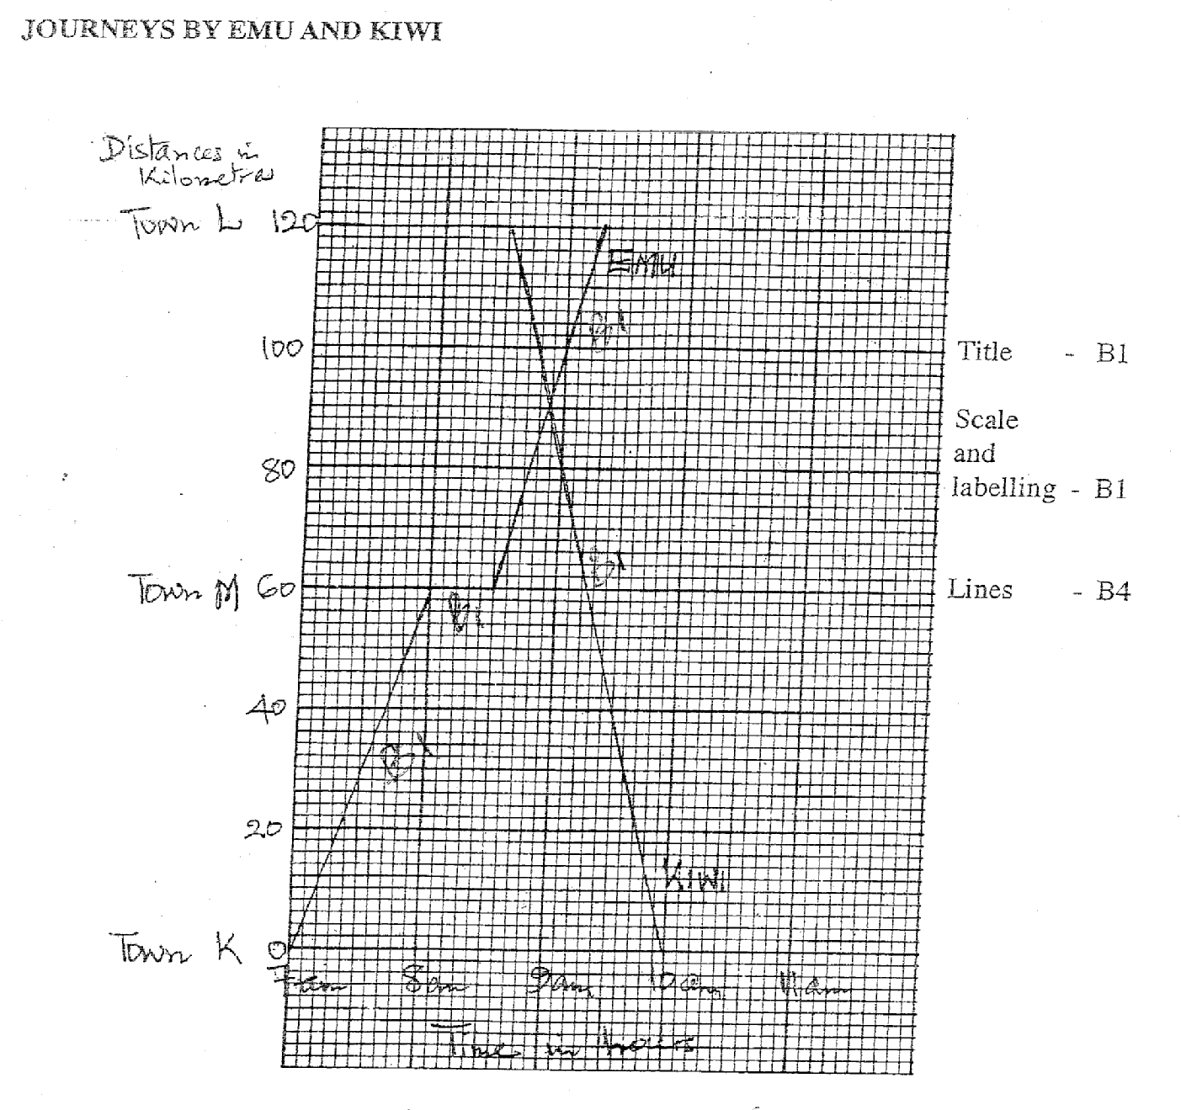

b) How far from town L and at what time did the motorists meet?
The motorists met 30±5 kilometres from town L at 8.54 a.m.

MATHEMATICS
Paper 2

Methodology described in answering questions in this paper need not necessarily be that of any textbook in any current use in school. Any effective method may be described to answer the questions.

SECTION A (60 marks)
Answer ALL the questions from this section in the spaces provided.

- Describe how you would use a teaching/learning aid to introduce the concept of the number four and its symbol. (4marks)

  - Use of T.A. (concrete objects such as counters)
- Make groups of objects (4) by identifying groups of four
- Introducing the symbol 4

- You intend to introduce to your class how to find the G.C.D of 12, 16 and 20. List down the steps you would use. (3 marks)
- List the divisors of each number as:
12-1, 2, 3, 4,6,12
16-1, 2, 4,8,16
20-1, 2,4,5,10,20
- Identify the common divisors as:
{1, 2, 4}
- Choose/pick the Greatest Common Divisor which is 4
- Accept equivalent

- State an error that the pupils are likely to make when expressing a distance of 90m to a length of 30cm in ratio form. (2marks)
- Writing 90m to 30cm without converting metres into cm.

- (a) Describe a practical activity you would involve your in before teaching them conservations of capacity.
- Teaching Aid.
- Containers of different shapes and sizes.
- Water/sand/soil
- Direct comparison explanation:
- Fill a container with water /sand/soil and transfer all the contents into another container. Lead learners to note the containers that hold more/less/equal amounts.

(b) Explain how you would then proceed to show tem conservation of capacity. (1mark)
- Conservation explanation:
Fill a container with sand/soil/water and empty it into another of a different shape. Lead learners to realize that the amount of water/sand/soil remains the same by transferring the same content to the previous container.

- You intend to use place value tins in the teaching of addition of numbers.
Describe how you would prepare the teaching aids needed for this lesson. (3marks)
- Collection tins and sticks
- Label the tins in ONES, TENS and HUNDREDS.
- Tie some sticks in bundles of tens and hundreds.
- Accept one sticks in tens and in hundreds to represent bundles.

- List the steps you would follow to show your class how to construct triangle MNP in which angle MNP=60, line MN= 5cm and line NP= 8cm. (4marks)
- Draw line NP=8cm with centre N construct angle MNP=60 mark NM=5cm
- Join MP

- Pupils in your class have learnt the idea of giving/receiving change in buying and selling. Write a word problem that you would use to test idea of giving/receiving change.(2 marks)
- Any word problem that tests the idea of giving/getting change.
Example
Hamisi had 3 notes of sh.500, 12 notes of sh.200 and 7 notes of sh.100. He changed all the money to sh. 50. How many sh. 50 notes did he receive?

- A teacher gave his pupils the question below:
There is enough food for 6 cows to last 8 days. How long would 3 such cows take on the same feed?
One pupil worked out as follows:
6 cows take 8 days.
3 cows take 8x3 days
6
=4 days
What would you stress in your remedial teaching to enable the pupil realize the error made. (2marks)
One cow takes (6x8) days.
3 cows take more days than the 6 cows.

- Pupils were asked to work out the question below:
The average speed of a bus is 60km/h while that of a car is 80km/h. What is the ratio of the time taken by the bus to that by the car for equal distance?

Write down two key questions you would ask to guide pupils in working out the question. (2marks)
- How long would the bus take to cover a given distance?
- How long would the car take to cover the same distance?

- You intend to teach your class how to convert percentages to fractions. Show the chalkboard layout of this conversation using 60% as an example. (2marks)
- Correct chalkboard layout.

- The table below shows the cost of milk sold in a kiosk.

Milk in litres | 0.5 | 1.0 | 1.5 | 2.0 | 3.0
Cost of milk in shillings | 30 | 60 | 90 | 120 | 180

You intend to show your class how to draw a line graph using the information in the table. List the steps you would follow to do this. (4 marks)
- Draw and label the axes
-Vertical axis- amount in shillings.
-Horizontal axis- capacity in litres.
- Choose an appropriate scale and record the values starting from zero.
- Plot the points.
- Draw a line to join the points.

- You intend to lead your class to construct a perpendicular from a point P to the line AB. Explain the steps you would use. (4marks)
- Draw line AB and make a point P outside the line.
- With centre P and any convenient radius draw an arc that cuts AB at Q and R.
- With centres Q and R and using same radius draw intersecting arcs.
- Join the point of intersection with point P.

- You intend to explain the working of the following problem to your class:
Musa borrowed sh. 20000 for a period of two years. He repaid all the money borrowed plus the compound interest charged at a rate of 10% per year. How much money did he pay altogether?
List the steps you would use in your explanation. (4marks)
- Calculate the interest earned in the 1st year.
- Add the interest earned in the 1st year to the money borrowed to get the principal for 2nd year.
- Calculate the interest earned in the 2nd year.
- Add the interest earned to the principal 2nd year.

- Describe a practical activity you would use in your class to show that the area of a triangle ABC below is half the area of the rectangle BCDE.

E A D

B C

- Draw/trace rectangle BCDE and mark triangle ABC.
- Cut out triangles CDA and BAE.
- Fix the two triangles cut onto triangle ABC.
- Conclude that since triangles CDA and BAE form triangle ABC then the area of triangle ABC is half of the rectangle.

- Pupils were asked to plot a bar graph using the information in the table below:

Ages of pupils in a class
Age in years | 11 | 12 | 13 | 14
Number of pupils | 7 | 13 | 16 | 4

Write down the steps you would follow to lead learners draw the bar graph. (4marks)
- Mark pupils ages (11-14) on horizontal axis at equal intervals.
- Mark number of pupils on vertical axis at equal intervals from zero (0) to 16 or more.
- Draw even bars corresponding to the number of pupils for each age marked.
- Label the axis and write the title for the bar graph.

- A pupil worked out the value of 23.439+418.62 and obtained 65.291 as the answer.
State the error the pupil made. (2marks)
- Nonalignment of digits according to place value.

- You want to teach your class to calculate percentage discount using the example below.
The marked price of an article in a shop was sh. 700. Sigei bought the article for sh. 650. What was the percentage discount?
Explain how you would use this example to lead learners calculate percentage discount. (3marks)
- Calculate the discount by subtracting the buying price from the marked price.sh. (700-650)= sh. 50
- Express the discount as a fraction of the marked price,⁵⁰/₇₀₀
- Multiply the fraction by 100%.
⁵⁰/₇₀₀ x 100% = 7¹/₇%

- Describe an activity you would involve your pupils in to introduce ordinal numbers from first to fifth. (3marks)
- Involve some learners in a race competition.
- Lead learners to identify the order in which to finish up to the fifth position.
- Assign the numbers first, second, third, fourth, fifth.

- Describe how you would lead your pupils to simplify the algebraic expression. (3marks)
¹/₃(9a+12b-15c) +3a+5c
Remove the brackets to get:
3a+4b-5c+4a+5c
- Collect the like terms
3a+4a+4b+5c-5c
- Add/subtract
7a + 4b

- A teacher used questioning techniques to help her class solve the following problem:
Ouma left his home at 8.a.m. and traveled at a speed of 80km/h for 1 hour. He rested for half an hour and then continued with his journey at the same speed. He reached his destination at noon. What was the total distance traveled?

Below is a set of questions she asked.
- What distance did Ouma travel after the rest?
- How much time did Ouma take to travel after the rest?
- What distance did Ouma travel before he rested?
- At what time after the did Ouma continue with the journey?
- What total distance did Ouma travel?

By writing letters (a) to (e) in the boxes below arrange these questions in the order they should be asked. (2marks)

c | d | b | a | e

SECTION B (40 marks)

Answer any FOUR questions in this section in the spaces provided.
- You intend to teach your class how to convert improper fractions into mixed numbers.
- Write down the specific objective for this lesson. (1mark)
  - By the end of the lesson the learner should be able to convert improper fractions into mixed numbers.

- Write down a teaching/learning aid that you would use in this lesson. (1mark)
- Any relevant teaching/learning aid.

c) State the previous knowledge on fractions you would expect the pupils to have. (3marks)
- Meaning/recognition of fractions.(fraction part of a whole/group)
- Equivalent/comparison of fraction, different names for one.
- Operations of fraction (+,-, x). Simplifying fractions by canceling.

d) Explain the steps you would follow to lead the pupils convert 11/3 into mixed number. (5marks)
- Fold/cut the cutouts into thirds.
- Count 11 thirds to show 11/3
- Group 3 thirds to form one whole. Count the number of 3 thirds up to 11 thirds, 9 thirds make 3 wholes , 2 thirds remain.
- Conclude that 11 thirds make 3 wholes and 2 thirds. i.e. 11/3=3and 2/3

- Project is one of the learner centred methods in teaching Mathematics.
(a) State two essential learning characteristics of the project method. (2marks)
- It is a problem solving activity.
- It develops critical thinking in learner.
- It helps learners to use and acquire a variety of skills.

(b) Identify any one project related to Mathematics you would carry out with your pupils. (1mark)
- Any one project related to Mathematics.

(c) State seven activities that you would do before carrying out the project. (7 marks)
- Choose the title of the project.
- State the problem to be investigated.
- Decide on the study area.
- Choose the target group.
- State the objective/purpose of the study.
- Choose the methods of collecting the information.
- Decide on how information would be presented and analyzed.

- The teaching of subtraction of whole numbers involves three main stages.
State the three stages and using an example and an appropriate teaching aid explain how you would introduce each stage.

STAGE 1: Subtraction involving basic addition facts. e.g.17-9
- Take 17 counters. Remove 9 counters from the group. Count how many remain.

STAGE 2: Subtraction without borrowing .e.g. 67-26
- Place 6 bundles of ten sticks in TENS tin and seven loose ones in the ONES tin.
- Remove 6 loose sticks from ONES tin and 2 bundles of ten sticks from TENS tin.
- Count how many remained.

STAGE 3: Subtraction involving borrowing. e.g. 41-16
- Place 4 bundles of 10 sticks in the TENS tin and one stick in the ONES tin.
- Explain that it is not possible to take away 6 sticks from ONES tin since there is only one stick.
- Remove one bundle of ten sticks from the TENS tin to remain with three bundles.
- Untie this bundle and place the sticks in the ONES tin to make eleven sticks.
- Take away six sticks from the eleven sticks.
- Take away one bundle of ten sticks from the TENS tin.
- Count the number of bundles and loose sticks that have remained.

- You intend to test pupils understanding of surface area of an open cylinder.
(a) What should the learners consider in order to calculate the surface area? (2marks)
- An open cylinder has:
- One circular face
- A curved surface that forms a rectangle

(b) The following is a stem of a multiple choice item:
An open cylindrical tin has a diameter of 3.5cm and a height of 7cm. What is the total surface area of the tin? Take =22/7
Determine:
- The key; 86.625 (2marks)
- Three distractors and show how each was obtained. (6marks)
Any three distactors + explanation such as

- 2r  dh 2 x 22 x 3.5 x 3.5 + 22 x 3.5 x 7 = 9.625
7 2 2 7

- d² + dh 22 x 3.5 x 3.5 + 22 x 3.5 x 7 = 115.5
7 7
- r²h 22 x 3.5 x 3.5 x 7 = 67.375
7 2 2

- You intend to teach your class the topic on percentage loss.
(a) How would you explain?
(i) Percentage profit; (2marks)
- The amount of money more than the buying price that one gets after selling an item called profit. Percentage profit is profit expressed as a percentage of the cost price.

(ii) Percentage loss? (1mark)
- The amount of money one looses after selling an item is called loss. Percentage loss is loss expressed as a percentage of the cost price.
(b) Using a word problem explain how you would show your class the calculation of percentage profit. (4marks)
- Any word problem that requires calculation of percentage profit.
- Explanation of the problem.
(c) Write down a word problem on everyday life situation that would test calculation of percentage loss. (2marks)
- A word problem testing calculation of percentage loss.
(d) State an error that pupils are likely to make when calculating percentage loss. (1 mark)
- Expressing the loss as a fraction of the selling price.

SCIENCE
P.T.E 2011

- A science teacher intend to teach standard III learners a lesson on the topic ‘Air in the soil’
(a) State one knowledge objective for this lesson. (1 mark)

By the end of the lesson the learner should be able to state/tell/mention/identify that there’s air in soil.

(b) Other than recording, name two skills learners will develop during this lesson (2marks)

Observation
Manipulation
Draw conclusion

(c) Name three materials required to carry out an experiment to show that there is air in the soil (3marks)

Large container
Small container
Dry soil
Water

(d) State three instructions a teacher that the teacher should give to the learners, so as to guide them to carry out an activity to show that there’s air in the soil (3 marks)

Put dry soil in a small container; carefully immerse/dip the small container in the water in the large container; observe what comes out from the soil.

(e) Draw a labeled diagram of the set up that could be included in the chalk board summary for this lesson. (2 marks)
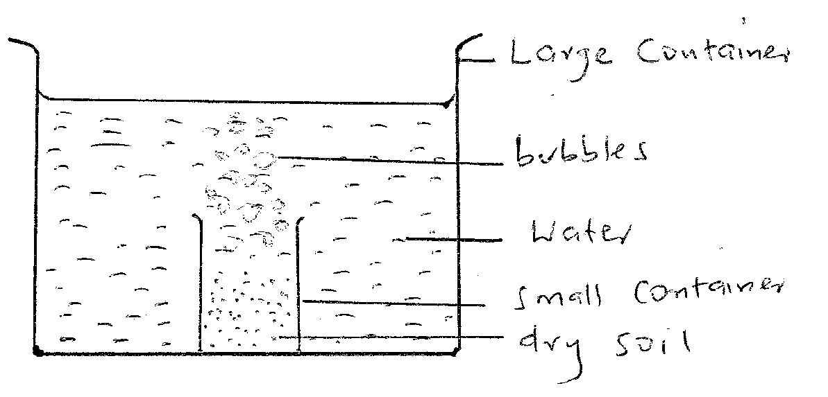

- During a science lesson on HIV/AIDS, a std VI learner asked the teacher the importance of testing for HIV/AIDS.
(a) Name one scientific attitude this learner had developed. (1 mark)

Interest/curiosity

(b) State four reasons why testing for HIV/AIDS is important. (4 marks)

So that they may stay without fear
So that if one is infected should avoid re-infection
So that one may plan for his future
So that one may seek medical intervention if infected
To avoid infecting others of infections

(c) State three reasons why it is sometime necessary for the teacher to redirect questions asked by learners in class back to them. (3 marks)

To enhance learners participation
To develop communication skills
To find out how much pupils know/entry behavior/feedback

(d) The teacher divided the class into groups to discuss the importance of testing HIV
(I) State one precaution the teacher should give to the learners before the discussion (1 mark)

To avoid personalizing the discussion;

(II) State one other suitable practical method of teaching this concept (1 mark)

Role play/dramatization
Field visit to a VCT centre/hospital/inviting a medical practitioner

- In an activity to investigate refraction of light, a teacher provided the materials listed below.
Transparent containers and 30 cm rulers

a) State two observations learners are expected to make during the investigations
(2 marks)

Ruler appear bent at the point where it touches the surface
The part of ruler inside the water appears shorter
The part of the ruler inside the water appears thicker
The bottom of the container appears raised

(b) Complete the ray diagram below to show the appare t position of the ruler in water (2marks)
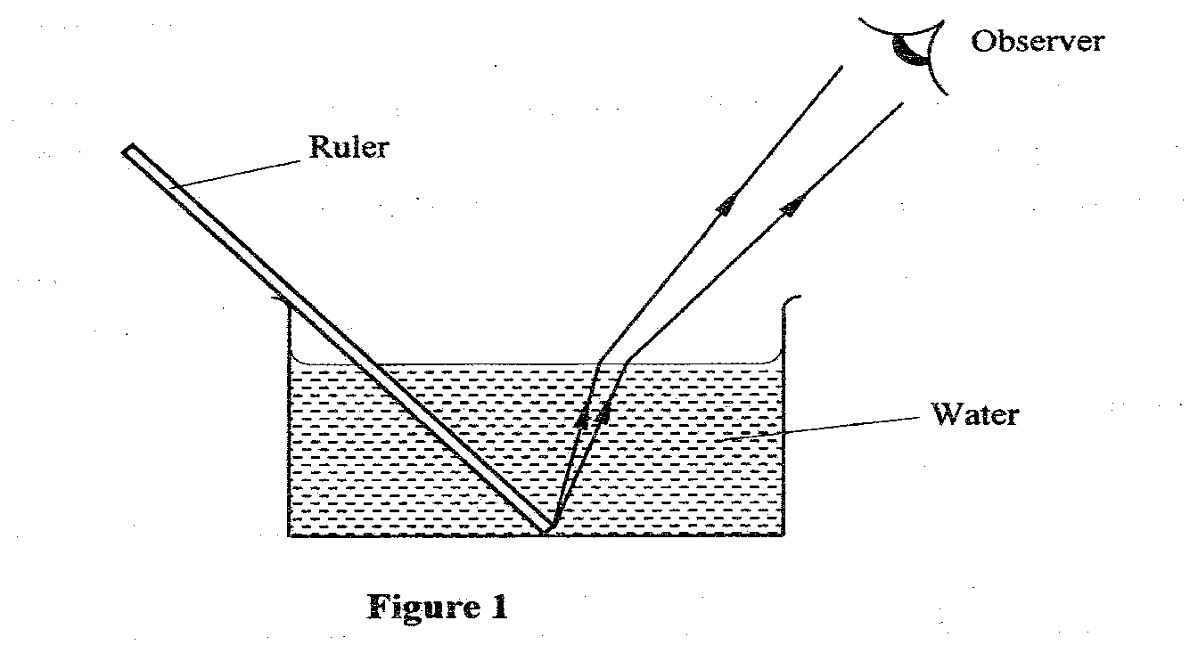
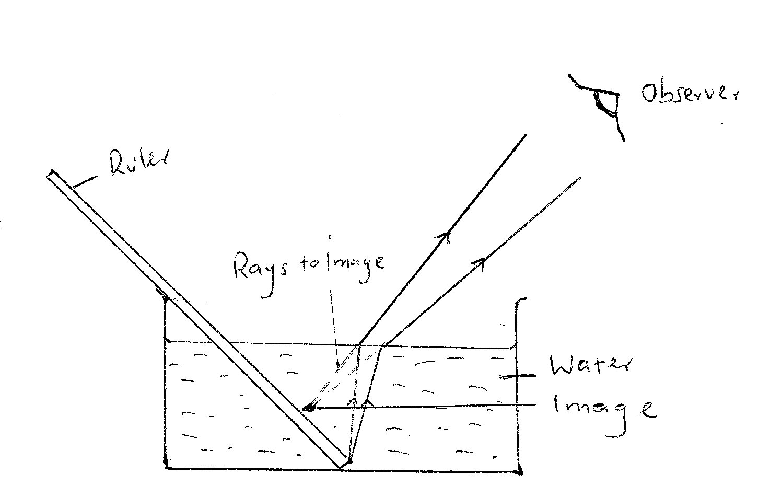

(c) Explain how ‘observation’s a method of assessment could objectively be used during this activity to assess the achievement of skill objective. (3 marks)

Develops criteria of awarding grade/marks ;(to avoid subjecting)move from group to group making direct observation; Award marks /grades according to the prepared criteria

(d) Explain how the teacher will use observation from this activity to explain how a swimming pool appears shallow than it actually is. (2 marks)

Rays of the light from the bed of the pool bends at the surface making the pool appear shallow than it actually is.

- a) State three reasons why continuous assessment in science is important to a learner
(3 marks)

For their teachers to be aware of their strength and weakness/self evaluation
To motivate learning/competition
To develop self confidence

(b) The multiple choices item shown below appeared in a KCPE paper.

‘When breathing in, the…………
A. diaphragm flattens
B.lungs shrink
C.diaphragm becomes dome shaped
D.volume of chest cavity decreases

State the key and the ability tested

Key:……A……………(1 mark)
Ability:……recall/memory/knowledge (1 mark)

(c) State two characteristics of two matching questions (3 marks)

The stem is clear on what is to be matched
The responses should be more than the items to reduce guess work
Instructions on how matching should be done

(d) State three difference between essay and objectives tests

Essay tests Objectives tests
Are easy to set Difficult to test
Difficult to mask Easy to mask
Covers narrow scope of content. Covers wide scope of content

- A teacher intended to write a scheme of work for std III science. Syllabus topics included sense of sight and gestures .Topic objectives in the syllabus are:

Learners are able to:

I Use sight to compare distance and size of objects
II compare the strength of eyes
III use gestures to communicate

(a) Give three reasons why it is necessary for a teacher to use topic objectives from the syllabus during preparation of the schemes of work. (3 marks)

They guide the teacher on;
- scope/depth/extensiveness/intensiveness
- Methods to be used
- Type of resource to be used
- Activities to involve the teacher in

(b) Explain why the ability of the learners is an important aspect to consider when scheming for this content (1 mark)

Decide on methods /activities to use
Influence the mode of assessment

(c) i) State two variables the teacher will consider while planning for an activity to achieve objective I (2 marks)

Distance at which objects are viewed
Size of objects

(ii) After a lesson to achieve objective ii, the teacher indicated in the lesson plan under self evaluation the remark ‘lesson taught as planned’ Explain shortcoming of such a remark. (2 marks)

- The remark does not identify weak areas that require improvement in the lesson
- It does not indicate the strong areas of the lesson

(d) Write two suitable activities that could be carried out in a lesson to achieve objective iii (2 marks)

Observe and interpret common gestures made by the teacher/learners
Learners communicate gestures using gestures

- The diagram below represents a set up that was used in an investigation

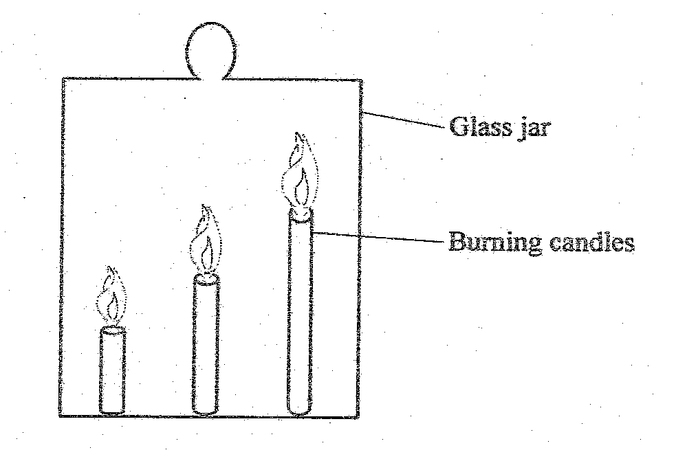

(a) Learners observed that candles went off.
(i) State the order in which the candles went off (1 mark)
The candles went off gradually starting from the tallest to the shortest

- Explain why the candles went off in the order you have stated in (i) above (3 marks)
During burning, hot air rises because it is less dense; the air that contains more carbon iv oxide coming from the burning candles; hence the tallest candle is the first one to be put off and the shortest is the one as carbon iv oxide concentration in the jar increase from the top down; accept depletion of oxygen from top

(b) State three ways in which a teacher could use dynamic approach during this investigation (3 marks)
Involve the learners in;
- Setting up the apparatus
- Making observation
- Drawing conclusion
- Recording information
(c) Explain how knowledge gained from this investigation could be used to rescue somebody from a burning house (2 marks)

Keep the head low low as possible to the ground as possible; to avoid inhaling carbon IV oxide

SECTION B (40 marks)
Answer all questions in this section in the spaces provided
- The table below shows the average height in cm of a man, taken after every three years over a period of 24years
Age (Years) | 0 | 3 | 6 | 9 | 12 | 15 | 18 | 21 | 24
Height (cm) | 50 | 92 | 106 | 120 | 142 | 163 | 169 | 170 | 170

(a) On the grid provided, draw the graph of height (y-axis) against age (4 marks)

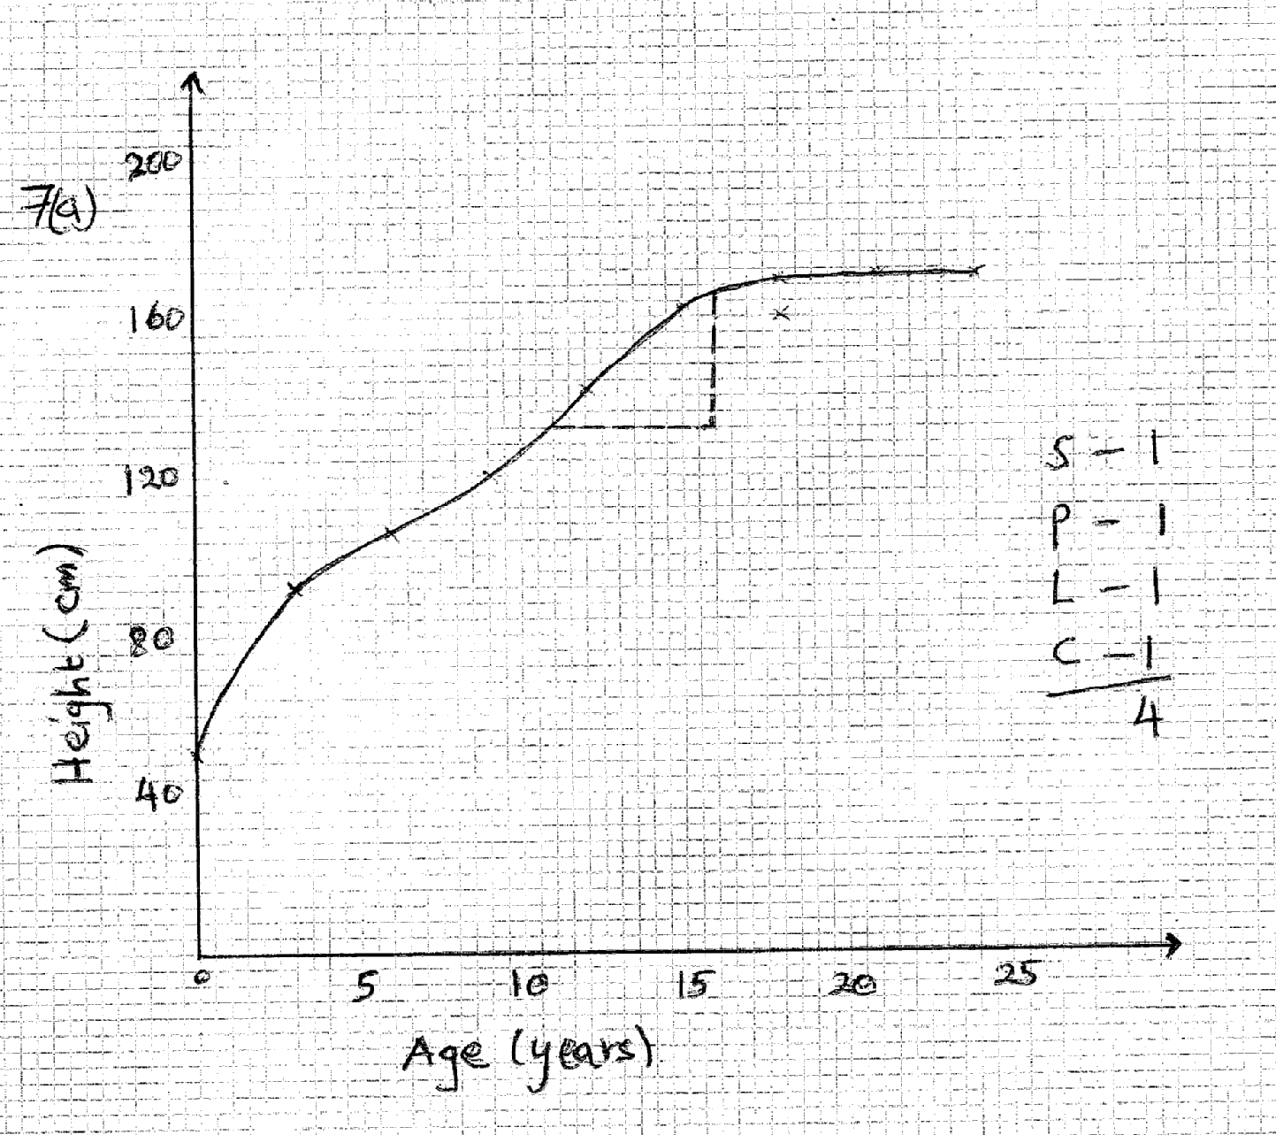
(b) Use a graph to state a 5 year period during which the growth rate was fastest
(1 mark)
0 – 5

(c) Determine the annual growth rate between the eleventh and the sixteenth year
(2 marks)
166 – 132
16 – 11

34 = 6.8 ±0.1 cm/year
5
(d) Explain the shape of the curve between the 15th and 24th year (1 mark)
Growth rate slows down and then stops-reaches optimum rate/height

- a) The flow chart below represents energy transformation that occurs in a system.
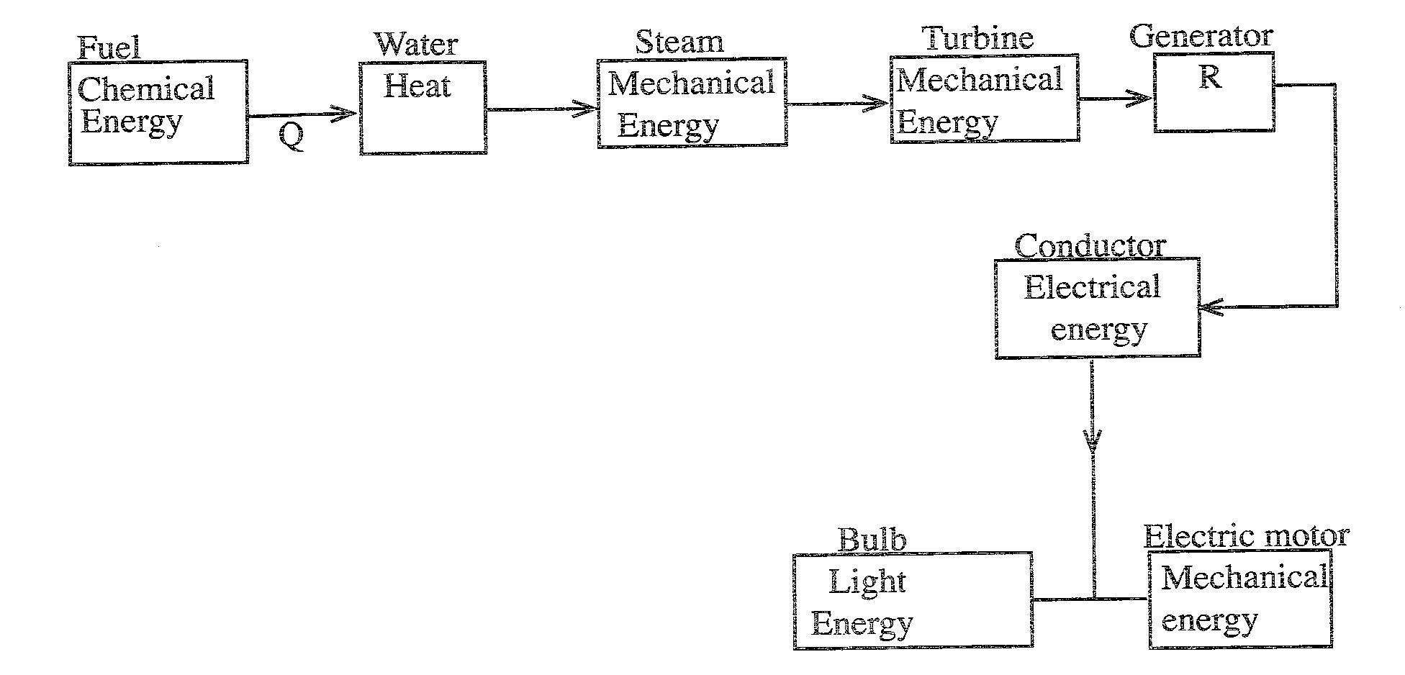

(i) State the process involved at the point represented by the letter Q
Combustion/burning

(ii) Name the form of energy represented by letter R
Electrical energy

(b) Explain why energy transformation is important in every day life(2 marks)

Energy is the ability to do work; work is done when energy is transformed from one form to another; chemical-heat-light

- In a monohybrid inheritance, a pure breed for round seed (RR) was crossed with a pure breed for wrinkled seeds (rr)
(a) Using genetic crosses work out the F1 generation (2 marks)

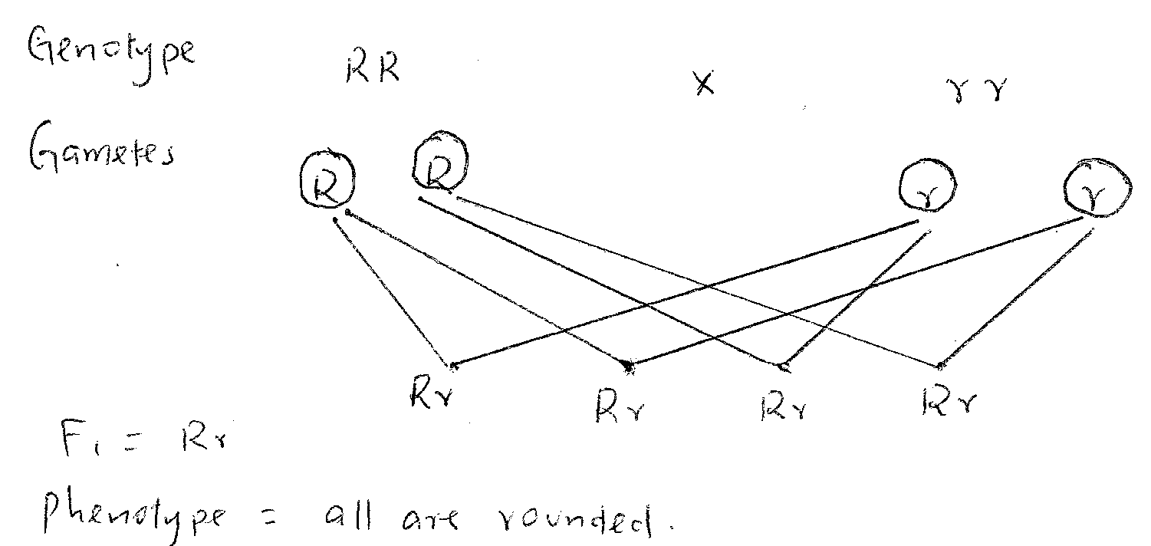

(b) Determine the phenotypic ratio of F2 generation if F1generation was selfed
(2 marks)
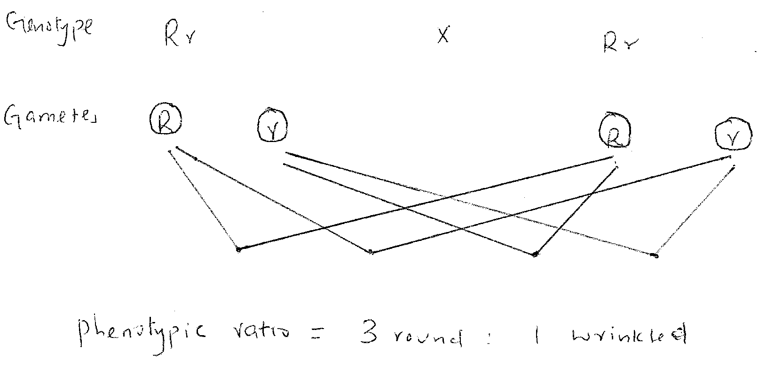

- Polythene materials waste is a nuisance as far as environmental management is concerned

(a) State why polythene wastes are environmental pollutants (1 mark)
Polythene is non biodegradeable; cannot decompose/rot

(b) State three ways of managing polythene waste so as to avoid the environmental pollution (3 marks)

Reduce use any other alternatives
Recycle
Burn in incinerators

- The diagram below represents a weather measuring instrument
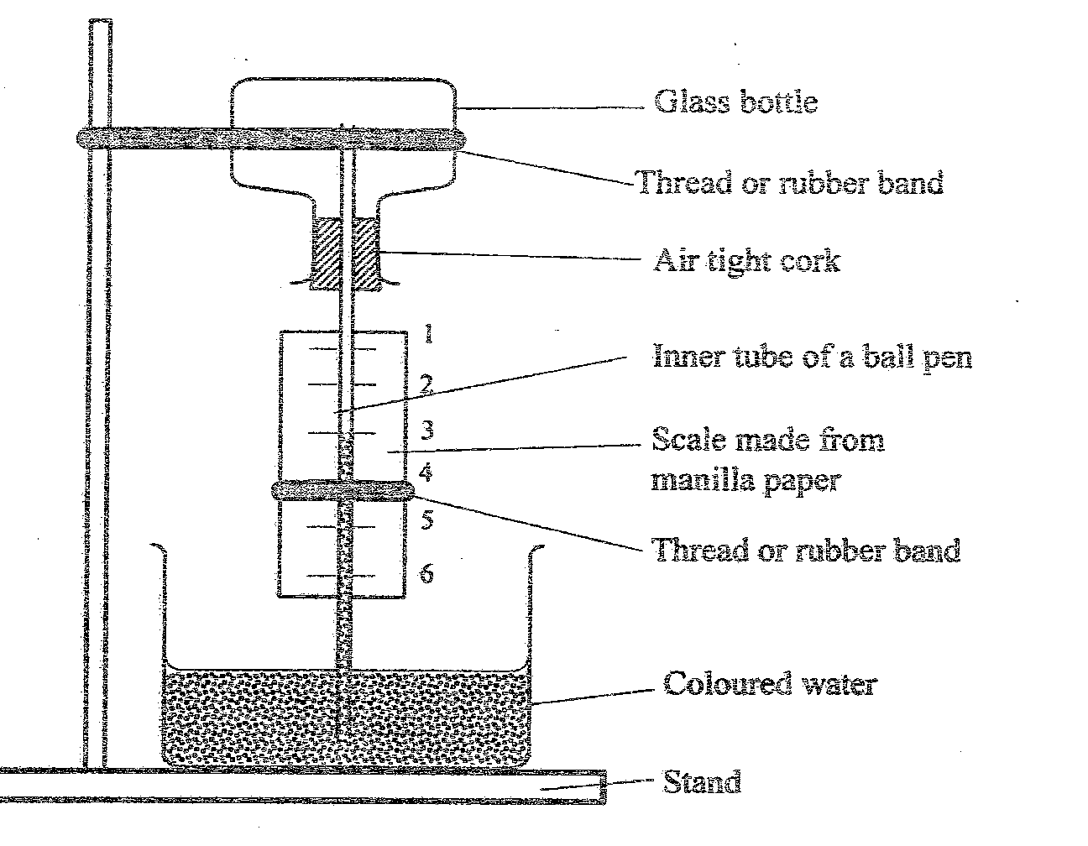

(a) Name the instrument
Air thermometer
(b) Explain how the instrument works (3 marks)

When the temperature raises air in the upper bottle expands pushing down the level of liquid column showing higher reading on scale;
When the temperature falls air in the upper bottle contracts allowing the volume of the liquid column to rise showing a lower reading on the scale

- a) State two chemical properties of an acid (2 marks)
  - An acid reacts with metals to give hydrogen and salt;
  - Acids reacts with carbonates and hydrogen carbonates to give salt, CO₂ and water
  - Acids react with bases to give salt and water as the only products

(b) Explain why melting of a candle wax is a physical change (2 marks)

Because no new substance is formed; it’s reversible; no change in mass; no heat absorbed or emitted

- (a) The diagram below (not drawn on scale) represents a simple machine that was used to raise a load.
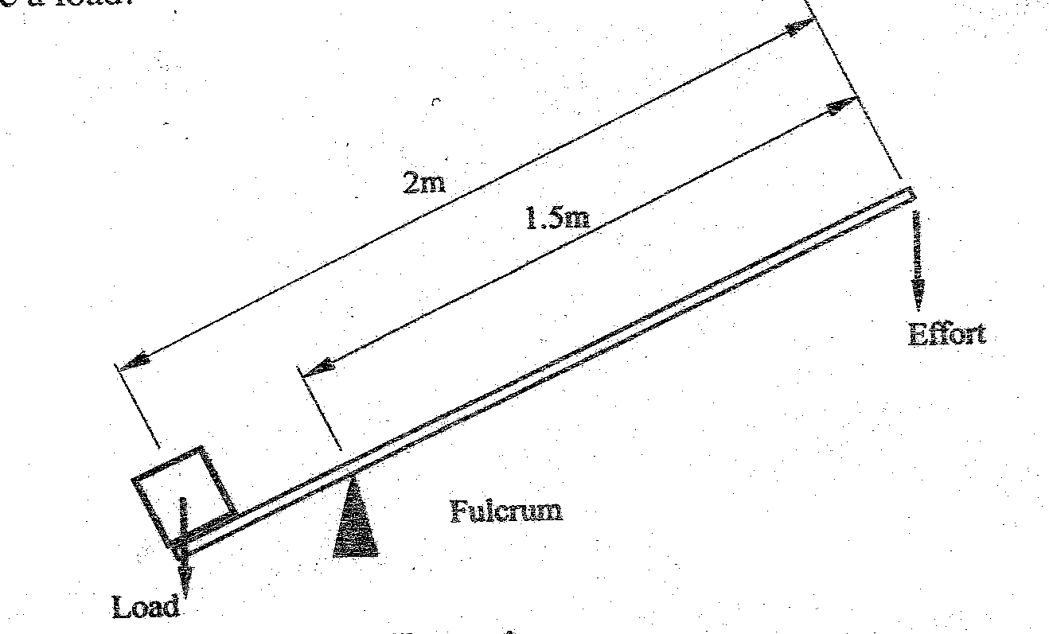

Calculate the velocity ratio of the machine (2 marks)

Effort arm = 1.5 = 30
Load arm 0.5

(b) State two properties of oil that make it suitable as a lubricant (2marks)
High viscosity
High heat capacity/high boiling point

- a) Explain one property of components of a mixture that enable their separation by winnowing(2 marks)
Some of the components should be dense enough to remain; while others should be less dense such that they can be blown away

b) State one advantage and one disadvantage of boiling as a method of obtaining clean water for drinking (2 marks)

Advantage
It kills harmful microorganisms
Disadvantage
Does not remove harmful solid impurities

- a) The diagrams below represent certain underground plant structures used in vegetative propagation

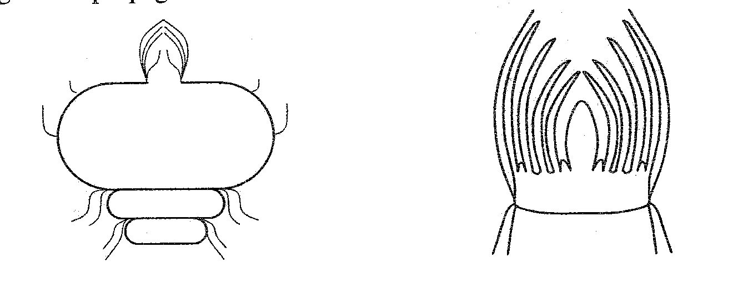

Figure 5(i) Figure 5(ii)
Structure I structure II

(i) Identify the structures i and ii
Structure i
Cosm
Structure ii
Bulb

(ii) State one advantage and disadvantage of vegetative propagation to the plant
(2 marks)

Advantage
Good traits are perpetuated; bad traits are perpetuated
Disadvantage
Leads to overcrowding of the same plant
Propagation of diseases

(b) Describe the habitat for a moss plant
Damp (shady)

AGRICULTURE
P.T.E 2011

SECTION A (30MARKS)
Answer ALL the questions in this section

  - A teacher is planning to carry out a crop production project with pupils.
(a) State eight factors that the teacher should consider before starting the project.(4marks)
- availability of adequate land
- availability of tools and equipment
- availability of inputs
- security of the project
- mode of produce disposal
- level of pupils
- care for the projecting during holidays
- government policy/regulations
- mode of evaluation
- mode of ownership

(b) Give eight aspects of the project that the teacher would consider when evaluating the project. (4marks)
- participation /interest/attitude
- creativity /originality in carrying out the activities
- seedbed preparation
- crop establishment
- field management practices
- harvesting procedure
- yield obtained
- record keeping/analysis
- Profitability of the project.

  - (a) State four factors that a teacher should consider when designing learning activities in a scheme of work. (2marks)
- requirements of the objectives to be achieved
- content to be taught
- available teaching/learning resources
- level of the pupils
- time available

(b) Give four qualities of a good lesson objective in a scheme of work. (4marks)
- Stated in behavioural change/performance the learner should display.
- clear and precisely stated
- should be achievable
- time bound/show time limit
- specify conditions under which the learners will show the achievement of the objective
- should be realistic

  - A teacher intends to take learners through an experiment to determine soil composition using fresh garden soil, water and measuring cylinder.
(a) State two preparations that the teacher would make for the lesson.(2marks)
- make a lesson plan
- identify/prepare suitable site for practical
- assemble apparatus for the lesson
- Read more about the content/topic area.

(b) Give the appropriate procedure the teacher can use to demonstrate the above experiment to learners. (4marks)
- put the fresh garden soil into the measuring cylinder
- add water
- observe what happens
- record your observations

(c)Apart from the demonstration, state three other roles of the teacher during the lesson. (3marks)
- giving instructions
- asking leading questions
- maintaining class discipline/control
- arranging pupils into convenient groups/with a leader
- assisting them to carry out experiment
- Ensure apparatus are available and in good working conditions.
- answering questions

(d) Give three ways in which the teacher would ensure participation of all learners during the lesson. (3marks)
- ensure adequate apparatus/materials for the experiment
- assign tasks to the pupils
- provide proper instructions/procedure to the pupils
- supervise the pupils activities during the lesson/class control
- ask/allow questions on various aspects of this experiment

  - State four characteristics of a good test in science. (4marks)
- valid/assess all topics/syllabus in a balanced manner
- test all assessment domains/proportionately
- language appropriate to this level of the learners
- Should cater for all learners/equity/free from geographical/gender/religious/cultural bias.
- fair/appropriate level of difficult
- should match learning objectives stated in the syllabus
- should be reliable

SECTION B (40MARKS)

Answer ALL the questions in this section in the spaces provided.

  - (a) State four factors a teacher would consider when planning for a new school farm as a teaching resource (2marks)
- physical plan of the farm
- site for the school farm
- budget for the school farm/availability of funds
- possible farm activities/enterprises
- appropriate authorities to set up plan
- Resource persons to assist.

(b) Give two benefits of a crop museum in the teaching of science (1mark)
- for practical
- source of teaching/learning materials
- For demonstration lessons.

  - (a)Why is light essential in crop growth?(1mark)
Provides energy required for photosynthesis

(b)Name three aspects of light that are essential in crop growth.(1 ½ marks)
- light intensity
- light duration
- light wavelength

  - Explain two ways in which temperature influences soil formation (2marks)
- optimum temperatures speed up the rate of chemical reactions thereby accelerating soil formation
- optimum temperatures increase the activities of soil organisms thereby accelerating soil formation
- Sudden increase/decrease in temperatures causes rapid expansion/contraction of rocks resulting in weathering.

  - State four characteristics of the top soil layer in a soil profile.(2marks)
- dark in colour
- high humus content/rich in plants nutrients
- well aerated/drained
- rich in soil micro-organisms
- Most plant roots are found in this layer.
- High content of un-decomposing materials.

  - Name the appropriate tool/equipment for carrying out each of the following practices:
(a) lifting vegetable seedlings during transplanting ;(1/2 mark)
- garden towel
(b) trimming hedges ;(1/2 mark)
- pruning shears
(c) clipping fleece from sheep;(1/2 mark)
- wool shears
(d) injecting animals ;(1/2 mark)
- syringe and needle
(e) filing rough wood surfaces ;(1/2 mark)
- wood file/rasp
(f) Hitting wood chisel in carpentry. (1/2 mark)
- mallet

  - State three factors that determine the depth of cultivation during seedbed preparation.(1 ½ marks)
- type of crop to be grown
- type of soil
- implements available/used during cultivation
- soil moisture content/season
  - List four methods of fertilizer application in crop production.(2marks)
- broadcasting
- placement /row placement
- side dressing/ring dressing
- folia spraying
- drip application/fustigation

  - Name two methods of sampling soil from the field for analysis.(1mark)
- zigzag/random method
- traverse/diagonal method

  - State four advantages of row planting in crop production.(2marks)
- machine can be used easily between the rows
- easy to achieve optimum plant population
- lower seed rate is used
- easy to carry out cultural practices
- easy to calculate/estimate plant population

  - Explain how the following methods help to control weeds;
(a) Biological method; (1mark)
- Use of living organisms to feed on the weed suppresses and controls it.
(b) Legislative method (1mark).
- Enacting government laws that prohibit growing of noxious weeds/introduction of noxious weeds into the country /by imposing quarantine on any imported planting materials until its purity is determined.

  - State four advantages of deep litter system in poultry production.(2marks)
- requires low initial capital
- labour requirement is low
- house can be converted for breeding with ease
- fast manure accumulation
- allows higher stocking rate
- birds are safe from predators

- Give a reason for using a teaser ram in sheep management (1mark)
  - To induce/synchronize heat in ewes which accelerates ovulation and increases chances of twinning/to increase breeding efficiency.
  - To detect ewes on heat

- (a) Give two conditions that can necessitate feeding of bees.(1mark)
- maintain the colony/avoid absconding/swarming
- encourage fast multiplication of the colony
- supplement during dry season when flowers/forage and water is scarce

(b)Why is it advisable to harvest honey either early in the morning or late in the evening.(1/2mark)
- bees are less active and this reduces stinging

- Outline four external features that are considered when grading eggs for marketing.(2marks)
- size
- cleanliness
- shell colour
- shell texture/breakages/cracks
- egg shape

    - State four signs of heat that can be observed in rabbits.(2marks)
- doe becomes restless and excited
- reproductive organs become swollen/vulva
- doe tries to contact/peep at rabbits in the next pen
- doe throws herself on her side
- Doe rubs herself against the wall and food containers.

    - Give one reason for carrying out each of the following management practices on a fish pond.
(a) Liming; (1mark)
- sterilizes the pond/kills disease causing micro-organisms/raises PH of the pond
- Makes silt to settle at the bottom of the pond.
(b) Fertilization (1mark)
- Boosts growth of planktons which is the natural food for fish.

    - State two reasons for carrying out foot trimming in goat management.(1mark)
- control foot rot disease
- control/prevent lameness
- Facilitates mating.
    - Give two reasons for washing the udder of a cow before milking.(1mark)
- to remove dirt
- stimulates milk let down
    - State three harmful effects of ticks on cattle.(1 ½ marks)
- transmit diseases e.g E.C.F
- damage/lower quality of hides
- Suck blood which may result in anaemic condition.
- Cause irritation.
    - The graph below shows the quantity of potatoes supplied at different prices on a market.

(a) From the graph, determine the following:
(1)The quantity of potatoes supplied at a price of KSh.65 per kilogram.(1/2mark)
- 110kgs of potates.
(2)The price per kilogram when 80Kg of potatoes were supplied to the market.(1/2mark)
- Ksh.45 per kilogram

(b)Apart from the price , state four other factors that could have influenced the supply of potatoes on the market. (2MARKS)
- number of potato sellers in the market
- cost of production
- effects of weather changes
- level of technology
- price/supply of related goods
- transport and communication system
- time lag/period between production/season

    - Name four sources from which farmers can obtain loans for developing their farms . (2marks)
- Commercial banks.
- co-operative societies
- individual/private money lenders
- statutory bodies e.g AFC; marketing boards
- settlement trustee funds

SECTION C (30Marks)
Answer any THREE questions from this section in the spaces provided after question 29.

    - Explain the cultural practices that are carried out between planting and harvesting in crop production. (10marks)
- gapping –filling in planks/gaps
- controlling weeds-remove of unwanted plants
- ridging/earthing up-hipping soil around the plant base
- thinning-removal of excess seedlings
- pruning-removal of excess branches/sucks of plants
- application of fertilizers/manure
- crop rotation-planting different crops in the same piece of land in different seasons.
- mulching-covering the soil with organic or inorganic materials
- Stacking/training-proding of support to crops or plants.
- rogueing-removal and destruction of infected areas
- inter-cropping-planting more than one crop in the same piece of land
- application of pesticides/chemicals to control pests and diseases
- Flooding-allowing water to stay in the field.

    - (a) State five advantages of the Kenya Top Bar Hive in apiculture. (5marks)
- top bars can be removed and replaced to inspect combs/harvest honey
- Honey combs can be removed without disturbing the brood comb.
- High quality honey is harvested without brood combs.
- More wax is harvested because combs are not returned to the hive.
- Hive is easy to construct and repair.
- Queen excluder can be used at the centre of the hive to separate honey from the brood.
- Does not require expensive equipment to extract honey.

(b)Explain five factors that should be considered when sitting bee hives. (5marks)

- availability of water: near a reliable source of water
- Availability of flowers: near flowering plants to facilitate collection of nector and pollen.
- Shelter: well sheltered place for protection from strong sun and wind.
- Noise: should be free from noise and other disturbances.
- Safety for people and other livestock: away from homesteads, pastures and busy roads.
- Security: should be secure from predators and thieves.
- Accessibility: should be easily accessible to facilitate harvesting.
    - Explain the management practices for a dairy cow during the gestation period. (10marks)
Proper feeding on a balanced diet to facilitate foetus development
- Provide fresh clean water at libitum to ensure balanced osmotic pressure.
- deworming to control endoparasites
- dipping/spraying to control ectoparasites
- maintaining proper hygiene/cleanliness to reduce incidences of disease
- Dry-off the cow in the last 6-8 weeks of gestation to ensure regeneration of muscle energy/energy reserves for the next calf.
- Foot trimming to prevent incidence of foot rot disease and lameness.
- vaccination against diseases e.g brucellosis, anthrax, F.M.D, e.t.c
- dry cow therapy to control mastitis
- isolating and treating infected animals to control diseases
- Steaming-up in the last 6-8 weeks of gestation to build up energy reserves for the next calving and promote foetus development.
- regular milking of the cow until drying off is done

    - Describe the measures farmers can take to minimize risks and uncertainties in farming. (10marks)
- Diversification: several enterprises are set up and incase one fails, the farmer does not suffer a total loss.
- Selection of more certain enterprises:enterprises with a steady income are selected against those with high income variation to guard against losses.
- Contracting:farmer enters contract with consumers to supply at an agreed price over a given period of time.
- Insurance:farmers pay a premium to insurance companies which insures farm machinery,crops and livestock against loss.
- Flexibility in production methods:enterprises are designed to allow change from one enterprise to another with minimum expenses.
- Adopting modern/improved methods of production:they help reduce the amount of risk e.g spraying against pests and diseases enhances chances of high production.
- Keeping to proven production techniques:they enhance chances of producing the expected yields.
- Transforming the risk to consumers through price adjustments.
- Strategic storage/stock piling of produce and inputs to wait for favourable market prices and guard against shortages in future.
- Employing security measures to guard against theft /arsonists

