NAME…………………………………………… INDEX NUMBER ……………………………. DATE…………………………………………
443/1
AGRICULTURE MINI - MOCK 2017
PAPER 1
TIME: 2HOURS

INSTRUCTIONS TO CANDIDATES
- Write your name and index number in the spaces provided above.
- The paper consists of three sections A, B and C.
- Answer all questions in section A and B in the spaces provided
- Answer any two questions from section C on foolscaps provided

FOR EXAMINER’S USE ONLY
SECTION | QUESTION | MAXIMUM SCORE |  | CANDIDATE SCORE
A | 1- 18 | 30
B | 19 – 22 | 20
C | 23  24  25 | 40
 | TOTAL |  | 90

SECTION A (30MARKS)
ANSWER ALL QUESTIONS FROM THIS SECTION ON SPACES PROWDED

1. State two cultural measures that can be used to control couch grass. (1mark)
…………………………………………………………………………………………………………………………………………………………………………
2. Give three disadvantages of monocropping. . (1½ Marks)
…………………………………………………………………………………………………………………………………………………………………………
…………………………………………………………………………………………………………………………………………………………………………
3. State three reasons for inverting soil clods/furrow slices during land preparation. (1½ Marks).
…………………………………………………………………………………………………………………………………………………………………………
…………………………………………………………………………………………………………………………………………………………………………

4. State two disadvantages in vegetative propagation of pineapples. (1 mark)
…………………………………………………………………………………………………………………………………………………………………………
……………………………………………………………………………………
5. List two factors that favour blossom end rot in tomato crop. (1 mark.)
…………………………………………………………………………………………………………………………………………………………………………
…………………………………………………………………………………………………………………………………………………………………………
6. Give four qualities of mother pant from which tea stem cutting should be obtained.
(2marks)
…………………………………………………………………………………………………………………………………………………………………………
…………………………………………………………………………………………………………………………………………………………………………

7. State three methods of controlling the anthracnose disease in a bean crop. (1½ marks)
…………………………………………………………………………………………………………………………………………………………………………
…………………………………………………………………………………………………………………………………………………………………………
8. How does crop rotation control weeds? (1mark)
…………………………………………………………………………………………………………………………………………………………………………
……………………………………………………………………………………
9. Giving an example in each case differentiate between straight and compound fertilizers. (2 marks)
…………………………………………………………………………………………………………………………………………………………………………
…………………………………………………………………………………………………………………………………………………………………………
10. List three benefits of a farmer registering a parcel of land. (2 marks)
…………………………………………………………………………………………………………………………………………………………………………
…………………………………………………………………………………………………………………………………………………………………………
11. What two factors increase seed rate? (1 mark)
…………………………………………………………………………………………………………………………………………………………………………
12 a) Differentiate between a trash line and a stone line. (1 mark)
………………………………………………………………………………………………………………………………………………………………
b) How do cover crops control soil erosion? (2marks)
………………………………………………………………………………………………………………………………………………………………………………………………………………………………………………

13. Give two effects of liberalization to the Kenyan economy. (2marks)
…………………………………………………………………………………………………………………………………………………………………………
…………………………………………………………………………………………………………………………………………………………………………

14 a) List three sources of magnesium to crop land (1½ marks)
………………………………………………………………………………………………………………………………………………………………………………………………………………………………………………………………………………………………………………………………
b) Give three effects/ symptoms of excess Nitrogen in maize crop. (1½ marks)
………………………………………………………………………………………………………………………………………………………………………………………………………………………………………………………………………………………………………………………………
15. State four objectives of land redistribution. . (2marks)
…………………………………………………………………………………………………………………………………………………………………………………………………………………………………………………………………………………………………………………………………………………………………………………………………………………………………………
16. Outline two effects of herbicides on weeds. (2marks)
………………………………………………………………………………………………………………………………………………………………………………………………………………………………………………………………
17. Give two reasons for cutting the sugar cane at the ground level. (1 mark)

………………………………………………………………………………………………………………………………………………………………………………………………………………………………………………………………

18 a) Name two legume pastures grown at low altitude. (1mark)
………………………………………………………………………………………………………………………………………………………………………………………………………………………………………………
b) What is topping as used in forage management? (1mark)
………………………………………………………………………………………………………………………………………………………………………………………………………………………………………………

SECTION B (20 MARKS)
Answer ALL questions from this section on provided spaces

19. The diagram below represent a compost pit. Study it and answer the questions that follow
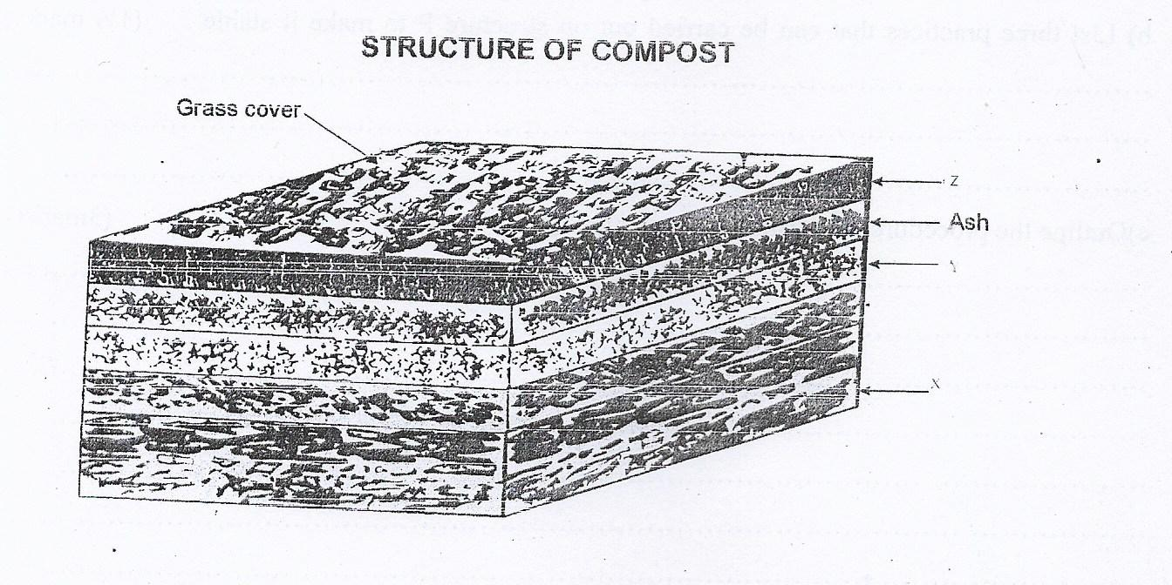

a) Specify the standard size of the pit (1mark)
………………………………………………………………………………………………………………………………………………………………………………………………………………………………………………
b) On the diagram identify materials in part labeled XYZ (1½ marks)
………………………………………………………………………………………………………………………………………………………………………………………………………………………………………………

c) State two reasons for addition of ash (1 mark)
………………………………………………………………………………………………………………………………………………………………………………………………………………………………………………
d) List two characteristics of a well decomposed manure (1 mark)
………………………………………………………………………………………………………………………………………………………………………………………………………………………………………………

20 a) Identify the soil and water conservation methods P and Q shown below (1mark)
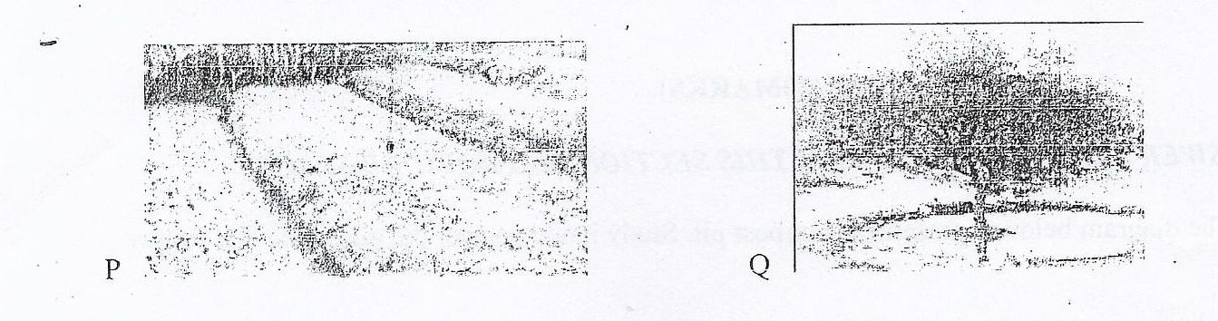
b) List three practices that can be carried out on structure P to make it stable
………………………………………………………………………………………………………………………………………………………………………………………………………………………………………………
(1½ marks)

c) Outline the procedure of constructing structure Q (3 marks)
………………………………………………………………………………………………………………………………………………………………………………………………………………………………………………

21. Study the crop storage structures shown below and then answer the questions that follow.
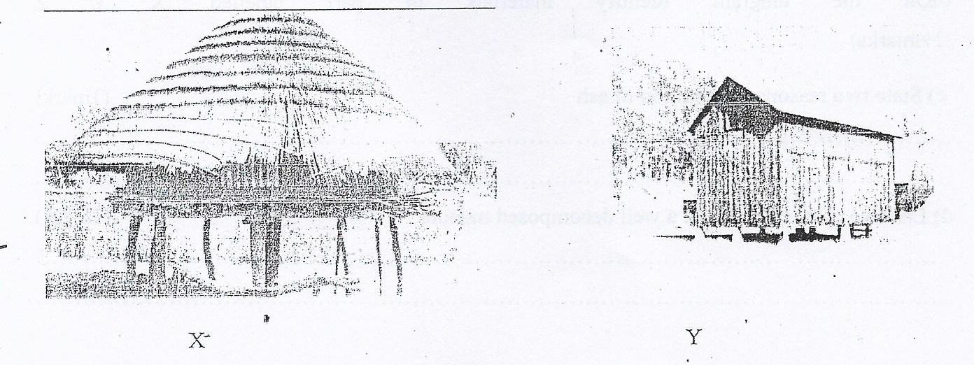
a) Identify four materials that the structures are made up of (2 marks)
…………………………………………………………………………………………………………………………………………………………………………
…………………………………………………………………………………………………………………………………………………………………………
b) Why is structure X raised above the ground? (½ mark)
……………………………………………………………………………………
…………………………………………………………………………………………………………………………………………………………………………

c) State two advantages of structure Y over X (2marks)
……………………………………………………………………………………
…………………………………………………………………………………………………………………………………………………………………………

d) Name two crop produce of different families that can be stored in X (1 mark)
……………………………………………………………………………………
…………………………………………………………………………………………………………………………………………………………………………

22 a) What do the photographs below represents


b) Give two effects of B on a crop. (1mark)
………………………………………………………………………………………………………………………………………………………………………………………………………………………………………………

c) Describe the non capping method of achieving practice A. (2marks)
………………………………………………………………………………………………………………………………………………………………………………………………………………………………………………
d) State two economic disadvantages of practice B. (1 mark)

………………………………………………………………………………………………………………………………………………………………………………………………………………………………………………

SECTION C: (40 MARKS )
ANSWER ANY TWO QUESTIONS FROM THIS SECTION ON FOOLSCAPS PROVIDED

23 a) Why is agriculture important in the economy of Kenya? (5marks)
b) Describe the factors that hastens rooting of cuttings. (5marks)
c) Outline the procedure of inoculating bean seeds (5 marks)
d) Describe production ?f Marigold crop under
i) Establishment and management ' (3marks)
ii) Utilization .(2marks)

24 a) Outline six harmful effects of pests on maize and give an example of pest for
each. (6marks)
b) Outline the importance of using certified seeds in crop production. (4marks)'
c) Describe the various methods of inorganic fertilizer application. (4marks)
d) Discuss mechanical methods of weed control. .. (6marks)

25 a) Describe kale production under the following sub headings
i) Ecological requirements (2marks)
ii) Nursery Established (4marks)
iii) Management practices (2marks)
iv) Harvesting . (2marks)
b) Describe the effects of mass wasting. (5 marks)
c) Describe the process of water treatment to remove the solid impurities. (5 marks)

