Name …………………………………………….……Class ………………………………………………...

231/ 1 Candidate’s Signature ………………….…...………..
BIOLOGY
Paper 1 Date …………………..
(Theory)
March/ April2017
2 hours

Kenya Certificate of Secondary Education (KCSE)
MINI-MOCK EXAMINATION

Instructions to candidates
- Write your name and class in the spaces provided above.
- Append your signature and write the date of examination in the spaces provided above.
- Spelling errors especially of Biological terms shall be penalized
- Answer ALL questions in the spaces provided.
- Candidates should check the question paper to ascertain that ALL the pages & questions are printed as indicated and that no questions are missing
FOR EXAMINER’S USE ONLY
Question | Maximum Score | Candidate’s Score
1 – 38 | 80

Attempt ALL the questions in the spaces provided only.

- Name the apparatus shown below……………………………………….….(1 mark)
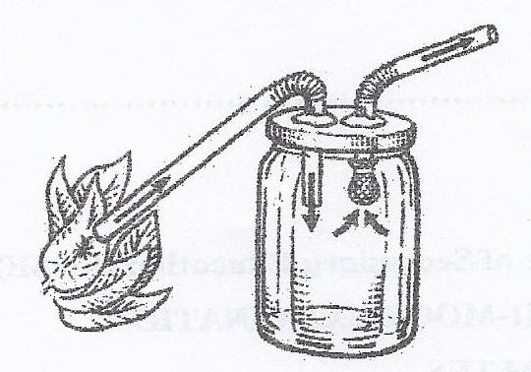
- The Photograph below represents a certain member of the kingdom Animalia
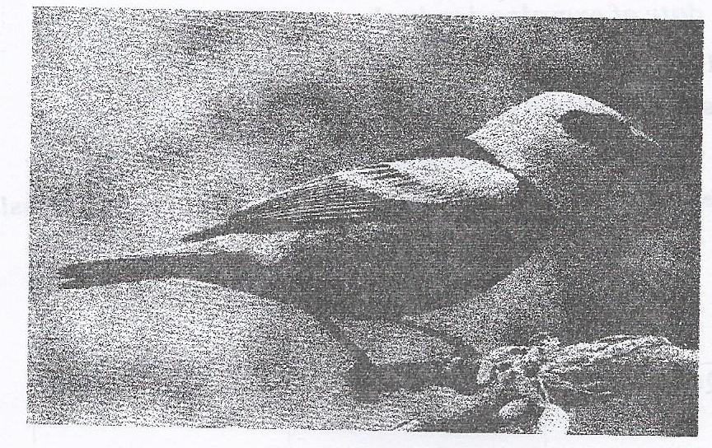
a) Name the taxonomic class t o which the animal belongs (1 mark)
b) On the diagram, label three features in which are characteristics of organisms in the class named in (a) above. (3 marks)

3. Plant cells contains both a cell wall and a cell membrane. What is the composition of
the cell wall, and where is it located in relation to the cell membrane? (2marks)

Composition……………………………………………………………………………
Location ……………………………………………………………………………….

4. (a) Identify the photograph below…………………………………… (1 mark)

(b) Outline in two steps how to use the apparatus shown in the photograph
(2marks)

5. For each of ceil organdies state ONE function and how it is ONE adaptation to carrying out the function.

(a). Ribosomes. (2 marks)
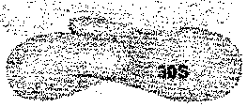

Function………………………………………………………………………

Adaptation…………………………………………………………………

b) Lysosomes (2 marks)
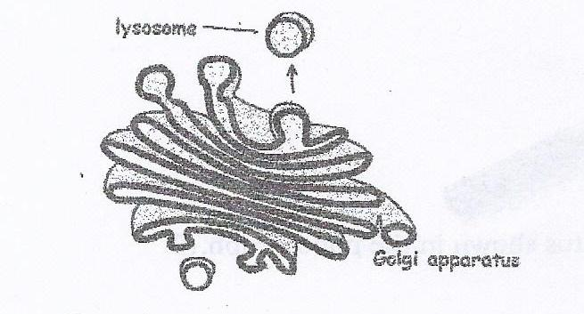
Function……………………………………………………………………………

Adaptation………………………………………………………………………...

6. For the specialized plant cells shown below identify the cell, state the function and how it is adapted to carrying out the function. (3 marks)
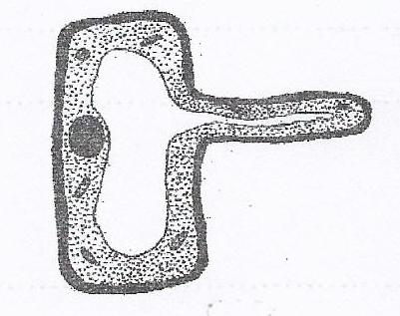
Name………………………………………………………………….…………………...

Function…………………………………………………………………………………...

Adaptation. …………………………………………………..…………………………...

7. A nursing infant is able to obtain disease-fighting antibodies, which are large
protein molecules, from its mother's milk. These molecules probably enter the cells lining the baby's digestive tract via (1 mark)
………………………………………………………………………………………………………………………………………………………………………………………………
8. A manufacturing company dumps its wastes into a nearby pond. One of the wastes is found to paralyze the contractile vacuoles of certain protists. A biologist looking at these organisms would find that these protists. (2 marks)
………………………………………………………………………………………………………………………………………………………………………………………………
9. Use the human digestive diagram and your knowledge of the living environment to answer questions below.
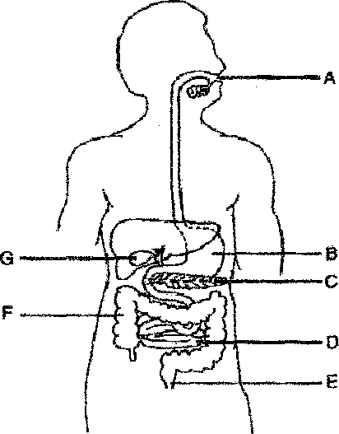
a) A painful condition resulting from the formation of small stone-like deposits of cholesterol may be treated by surgically removing structure labeled. (1 mark)
………………………………………………………………………………………………………………………………………………………………………………
b) Which letter indicates the organ that secretes hydrochloric acid and a protease enzyme? (1 mark)
………………………………………………………………………………………………………………………………………………………………………………
c) Which substance is normally absorbed by structure labelled F? (1 mark)

………………………………………………………………………………………

10. Name the hormone that is responsible for the development of a. deep voice in humans. (1 mark)
……………………………………………………………………………………………..

11 The type of relationship between fungi and algae in lichen is best described as: (1 mark)
……………………………………………………………………………………………..
12 Name the group of bacteria found in the root nodules of leguminous plants. (1 mark)
…………………………………………………………………………………………….

13 Name the site of the cell that does each of die following processes take place?
(2 marks)
Glycolysis:
………………………………………………………………………………………
Krebs cycle:
………………………………………………………………………………………
14. Name the structure used for excretion in fresh water Amoeba histolytica, (1 mark)
…………………………………………………………………………………………….
15. Mention four mechanisms of excretion in terrestrial green plants. (4 marks)
……………………………………………………………………………………………..
…………………………………………………………………………………………..…

16. Name the gamete cell that are produced by ovaries, (1 mark)
………………………………………………………………………………………

17. List four abiotic factors in a soil ecosystem. (4 marks)
………………………………………………………………………………………………………………………………………………………………………………………………………………………………………………………………………………………………
18. What is a facultative anaerobe? (1 mark)
………………………………………………………………………………………
19. What is meant by single circulatory system? (1 mark)
………………………………………………………………………………………
20. What is a test cross in genetics? (2 marks)
………………………………………………………………………………………………………………………………………………………………………………………………
21. Give the scientific name of the bacterium that causes tuberculosis in humans. (1 mark)
………………………………………………………………………………………………………………………………………………………………………………………………
22. (a) Name assimilated substances that undergo no digestion. (2 marks)
………………………………………………………………………………………………………………………………………………………………………………………………………………………………………………………………………
(b) Explain why the substances named in (a) above undergo no digestion. (1 mark)
………………………………………………………………………………………………………………………………………………………………………………………………………………………………………………………………………
23. Which part of the ovule forms the following structures after fertilization? (2 marks)
Endosperm
………………………………………………………………………………………………………………………………………………………………………………………………
Testa
………………………………………………………………………………………………………………………………………………………………………………………………

24. Distinguish between homologous and analogous structure. (1 mark)
………………………………………………………………………………………………………………………………………………………………………………………………
25. The process by which living organisms transfer oxygen into their bodies and release Carbon(VI) oxide into the environment is called? (1 mark)
………………………………………………………………………………………………………………………………………………………………………………………………

26. (a) Name requirements of a plant to carry out photosynthesis other than
water and carbon (IV) oxide. (1 mark)
………………………………………………………………………………………………………………………………………………………………………………
(b) Give the importance of mosaic leaf arrangement in photosynthesis.
(1 mark)
………………………………………………………………………………………………………………………………………………………………………………

27. State morphological features that a grasshopper, a crab and a spider have in common. (1 mark)
………………………………………………………………………………………………………………………………………………………………………………………………
28. State three ways of mechanically digesting a mandazima mammal. (3 marks)
………………………………………………………………………………………………………………………………………………………………………………………………

29. The Malpighian layer cells of a mammal contain 48,000 alleles in total. How many alleles would have been inherited from the organism's maternal parent? (1 mark)
………………………………………………………………………………………………………………………………………………………………………………………………

30. Other than direct drinking of water, name two other sources of water in nutrition
of man. (2 marks).
………………………………………………………………………………………………………………………………………………………………………………………………
31. State the role of the Pleural fluid of mammalian lungs. (1 mark)
………………………………………………………………………………………………………………………………………………………………………………………………
32. Give reasons why African Bush Elephants (Loxodonta africana) unlike garden peas (Pisum sativum), are not suitable subject for genetic studies. (1 mark)
………………………………………………………………………………………………………………………………………………………………………………………………
33. Identify each of the genetic disorders in man, characterized by the symptoms described below,
(a) Inability to distinguish between blue and green colour and various shades of red. (1 mark)
………………………………………………………………………………………………………………………………………………………………………………
(b) Lack of the protein dystrophin resulting in a progressive weakening of body muscles and uncoordinated body movement. (1 mark)
………………………………………………………………………………………………………………………………………………………………………………
34. (a) Biology students found that during germination of cowpea seeds, 9.00 cm³
of oxygen was used while 9.2 cm³ of carbon (IV) oxide was produced. Calculate the RQ. (2 marks)
………………………………………………………………………………………………………………………………………………………………………………………………………………………………………………………………………
(b) Identify the food substance that was metabolized in the cowpea seed. (l mark)
………………………………………………………………………………………………………………………………………………………………………………

35. Under what conditions is carboxyhaemoglobin formed in the human blood.
(1 mark)
………………………………………………………………………………………………………………………………………………………………………………………………
36. To estimate the population of Tilapia using the capture recapture method, 230 fish were captured marked and released. In the second capture, out of 112 fish, 10 had been marked. Calculate the estimated population of Tilapia, (Show your working). (2 marks)
………………………………………………………………………………………………………………………………………………………………………………………………
………………………………………………………………………………………………………………………………………………………………………………………………
………………………………………………………………………………………………………………………………………………………………………………………………

37. The photograph below shows a fruit specimen dispersed by a certain agent. Study the photograph carefully and then answer the questions that follow.
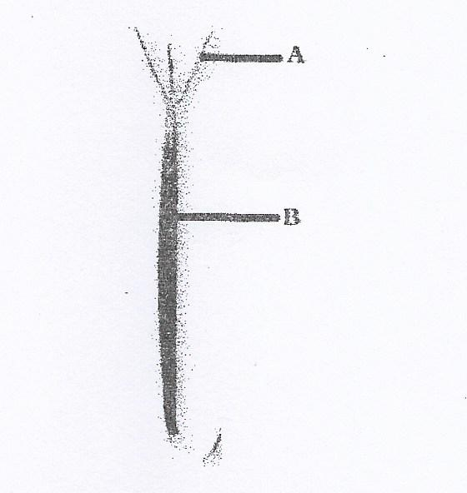

a) What type of fruit is represented by the photograph above? (1 mark)
………………………………………………………………………………………
………………………………………………………………………………………
b) On the photograph, name each of the parts labeled A & B. (l mark)

c) Name the agent of dispersal of the fruit. (1 mark)
………………………………………………………………………………………………………………………………………………………………………………
d) What is the economic value of the dispersal mentioned in (e) above. (1 mark)
………………………………………………………………………………………………………………………………………………………………………………
38. Albinism, lack of pigmentation in humans, results from an autosomal recessive allele designated ‘’a’’. Two parents with normal pigmentation have an albino child.
(a) What is the probability that their next child will be albino? (1 mark)
………………………………………………………………………………………………………………………………………………………………………………
(b) What is the probability that the next child will be an albino girl? (1 mark)
………………………………………………………………………………………………………………………………………………………………………………

