

**MAASAI MARA UNIVERSITY**

**UNIVERSITY EXAMINATIONS 2016/2017 (REGULAR)**

**SCHOOL OF SCIENCE AND INFORMATION SCIENCES**

**University EXAMINATIONS FOR THE DEGREE OF BACHELOR OF SCIENCE (INFORMATION SCIENCE)**

**THIRD YEAR FIRST SEMESTER EXAMINATION**

**COURSE CODE: COM 1103**

**COURSE TITLE: INTRODUCTION TO COMPUTERS AND COMPUTING**

**DATE: 2/2/2017 TIME: 8:30 A.M-10:30 A.M**

**INSTRUCTIONS**

1. Answer Question ONE and any other TWO Questions From Section II
2. Question 1 is compulsory.
3. Time 2HRS.
4. ***Mobile phones are not allowed in the exam room***.

SECTION A (Compulsory)

Question One (30marks)

1. Briefly explain the five basic functions/operations of a computer. (5marks)
2. What is the difference between data and information? Give an example of each. (4 marks)
3. Briefly describe what is known as the fifth generation of computers. (4marks))
4. Explain the two types of computer hardware. Give an example of each. ( 4marks)
5. Describe an embedded computer. Give at least two examples. (4 marks)
6. Explain any three (3) computer applications that you know of. (6 marks)
7. Give a definition of a computer. Give an example of a computer type you know of. (3 marks)

SECTION B (ANSWER ANY TWO QUESTIONS)

Question Two (20marks)

1. Explain the roles of each of the following CPU components. (12 marks)
   * 1. Arithmetic/Logic Unit (ALU
     2. Floating Point Unit (FPU)
     3. Control Unit
     4. Prefetch Unit
     5. Decode Unit.
     6. Registers and Internal Cache Memory
2. What is a machine cycle? List the main steps in a machine cycle. (4 marks)
3. Use a well labelled diagram to illustrate the machine cycle described in (b) above. (4 marks)

Question Three (20marks)

1. What is word processing? (2marks)
2. Give any three examples of word processors that you know. (3 marks)
3. Explain the parts labelled A, B C, D, and E in the diagram below. (5 marks) 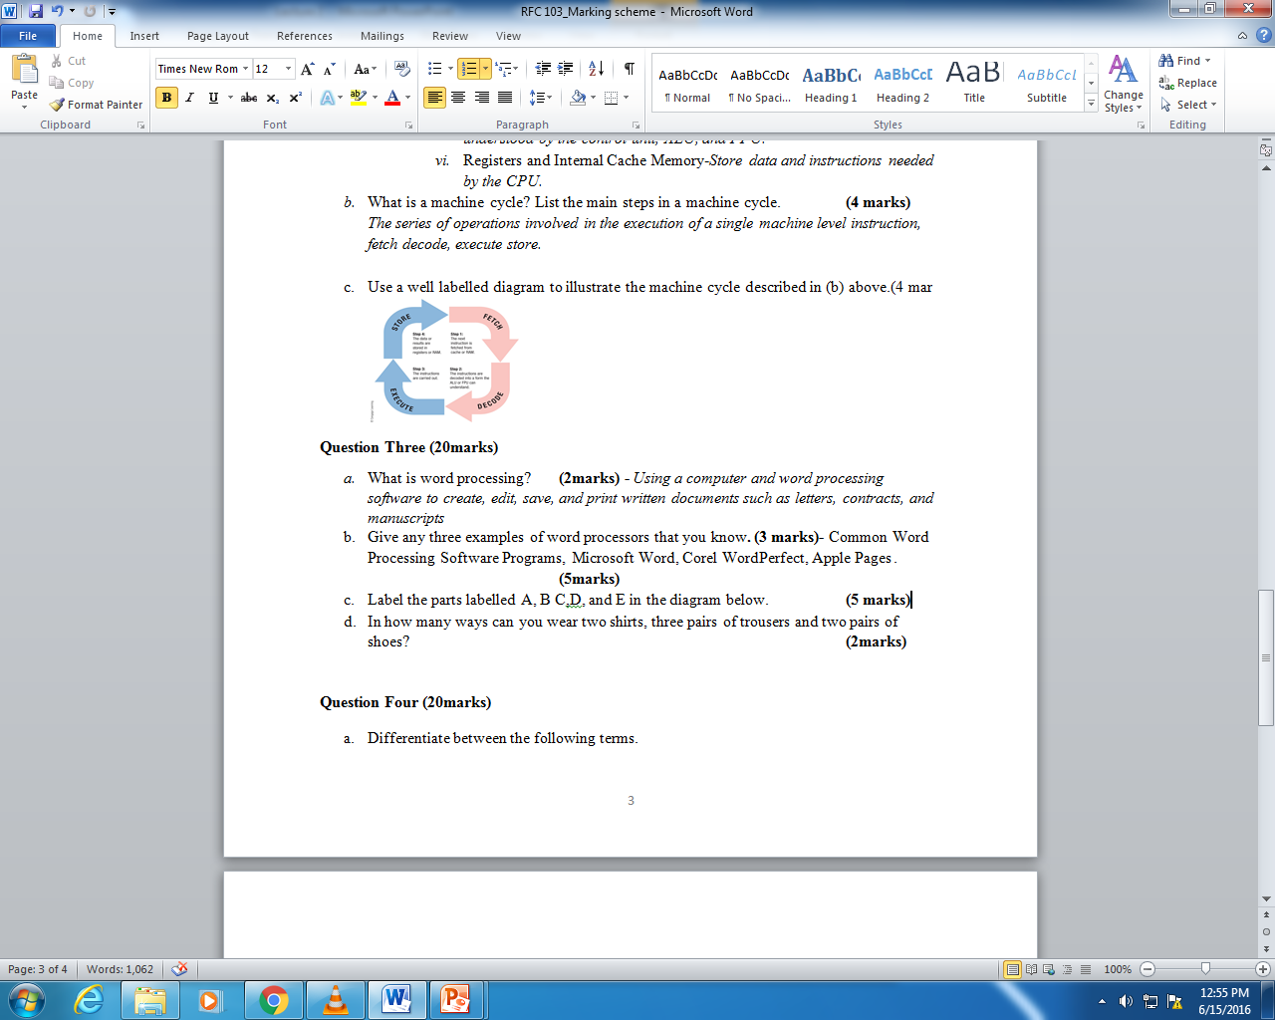

E

D

C

B

A

1. Explain the following word processing activities? (10 marks)
   * 1. Word wrap
     2. Character formatting.
     3. Paragraph formatting.
     4. Page formatting.
     5. Document formatting.

Question Four (20marks)

1. Give three of the most widely used spreadsheets? (3 marks)
2. Use the diagram below to answer the following questions. 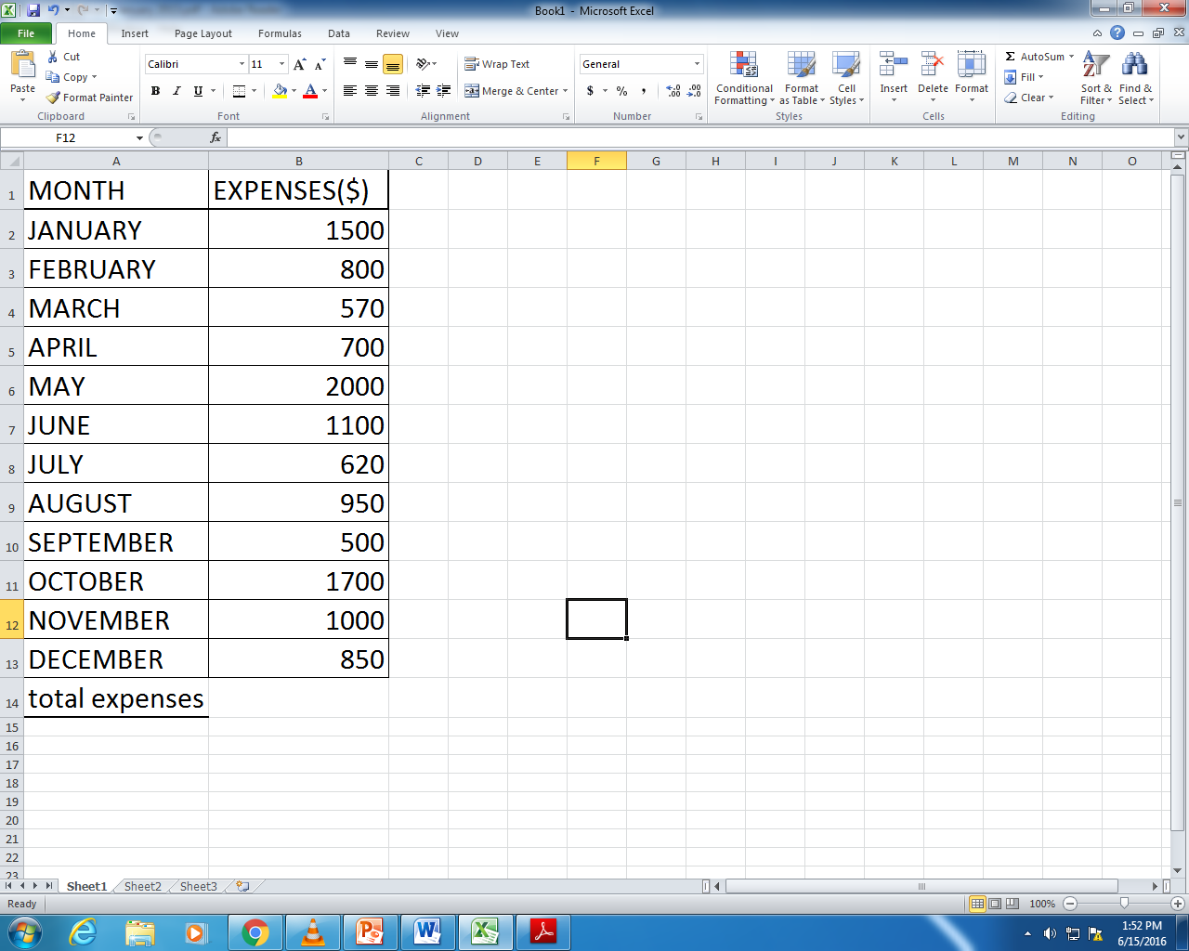
3. Explain how you would and a row just below “DECEMBER” to calculate highest expense. (3 marks)
4. What formula would you use to calculate highest expenditure for the whole year? (4 marks)
5. Give a formula to calculate the total expenditure for the year.(4 marks)
6. Assume that column C was for ‘EARNINGS’ and you are expected add D for “SAVINGS”, describe how you can use Excel to automatically fill column D. what formula would you use in D2? (6 marks)