Instructions to Candidates
This Paper consists of TWO SECTIONS I and II
Answer ALL questions in SECTION I and ONLY FIVE questions in Section II in the spaces provided.
All answers and workings must be on the questions paper in the spaces provided below each question.
Non-programmable silent electronic calculators and KNEC Mathematical tables may be used.

Advice to Candidates
Negligence and slovenly work may be penalized
You should show ALL the steps in your working, giving your answer at each stage
Marks may be awarded for correct method even if the answer is wrong.

For examiners Use only
SECTION I
12345678910111213141516
SECTION II
1718192021222324
This paper consists of 16 printed pages.
Candidates should check the question paper to ensure that all the pages are printed as indicated

TOTAL
GRAND TOTAL

TURN OVER
Candidates Name: ………………………………………. ………… Adm. No:……………………….
School: ………………………… …..............Date Done: ……….Returned: ………..Revised:……..
Teachers Remarks:………………………………………………….............................................................
THE 2017 K.C.S.E CONTINUOUS ASSESSMENT EXAMINATION

Kenya Certificate of Secondary Education

121/2 FORM FOUR PREMOCK EXAMINATIONS
MATHEMATICS ALT A MARCH/APRIL 2017
PAPER 2
TIME: 2½ HOURS

R
9
7
8
9
9
6
6
7
5
6
8
9
3

SECTION 1(50Marks)
Answer all the questions in this section in the spaces provided.

1. Solve the simultaneous equation
3s + 2t =4440 (3 marks)
4s + 2t = 5120

2. A fridge was bought on hire purchase terms. A down payment of sh. 6,000 was required and 12 monthly installments of sh. 1500 each. Calculate its cash price to the nearest ten if it was 18% higher than the hire purchase price. ( 3 marks )

3. Find the center and radius of the circle whose equation is 2x² + 2y² -30x + 14y – 38=0.
(3 marks)

4. A point P divides the line RT in the ratio -2:5. Find the coordinates of P given R (3,1) and T(6,-5). (3 marks)

5. Expand (1 + 2x) ⁷ up to the term in x³. Use your expansion to estimate (1.02)⁷to 4dp. . (3 marks)

6. (a) Use a ruler and a pair compasses only to construct triangle ABC in which
AB = 6cm, BC =8cm and angle ABC =60⁰. (2 marks)
(b) Determine the distance from A to the ortho-centre of the triangle in (a) above. (2 marks)

7. Simplify the expression
4t² - 25a²
6t² + 9at - 15a² (3 marks)

8. H varies directly as v and inversely as the square of r. find the percentage change in H if v is increased by 20% and at the same time r is increased by 50%. (3 marks)

9. Solve 1 + 2 sin 2x = 0 for 0⁰ ≤ 360⁰. (3 marks)

10. Make X the subject of the formula
P = KQ^{X} + R (3 marks)

11. A mixture contains two powders P and Q with masses in the ration 3: 11. If the mixture costs sh.670 per kg and powder P costs sh.560 per kg, find the cost of a kg of powder Q. (3 marks)

12 Given that x = 2i +j – 2k, y =-3i + 4j – k and z = -5i + 3j + 2k and that p = 3x – y + 2z,
Calculate the magnitude of p correct to 3 significant figures. (3 marks)

13. Simplify without using mathematical tables or calculator.
$\frac{6}{\sqrt{7}+\sqrt{3}}−\frac{4}{\sqrt{7}−\sqrt{3}}$ (3 marks)

14. Calculate the relative error in $7\text{.}9÷4\text{.}3$ (3 marks)

15. Use logarithms to evaluate the value of
$\frac{{\left(0\text{.}\text{4027}\right)}^{{}^{\frac{1}{3}}}}{{\left(0\text{.}\text{098}+5\text{.}6\right)}^{−2}}$
Give your answer correct to 4 significant figures. (3 marks)

16. The figure below shows a circle center O, radius 10 cm. The chord PQ = 16cm. Calculate the area of the unshaded region. (3 marks)
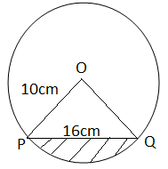

SECTION II (50Marks)
Answer ONLY FIVE questions in this section in the spaces provided

17. In the figure below Angle CBD = 37º, angle BCD = 20º and ABC is a tangent to the circle at B.
E
A
B
C
D
20⁰
37⁰

- Find:
- Angle BED (2 marks)

- Angle ABE (1 mark)

- Angel BDC (1 mark)

- With reasons state whether triangle BDC is similar to triangle CBE. (2 marks)

- Given that the radius of the circle is 2.5 cm and the length BC= 6cm, find the
length EC using the cosine rule. (4 marks)

18. The frequency table below shows the marks scored by the 40 pupils in a mathematics test.

Marks | 30 - 39 | 40 - 49 | 50 - 59 | 60 - 69 | 70 - 79 | 80 - 89 | 90 - 99
Number of pupils | 2 | 3 | 10 | 12 | 8 | 3 | 2

(a) State the modal mark. (1 mark)

(b) Calculate the mean mark. (2 marks)

(c) Estimate the median mark. (3 marks)

(d) Calculate the Standard deviation. (4 marks)

19. The product of the first three terms of a geometric progression is 64. If the first
term is a and the common ratio is r.

(a) Express r in terms of a. (3 marks)

(b) Given that the sum of the three terms is 14; Find the values of a and r and hence write down two possible sequences each up to the 4th term. (5 marks)

(c) Find the product of the 50th terms of the two Sequences. (2marks)

20. The figure below shows a direct –belt drive system consisting of two pulleys of radii 40cm and 25cm. The centers of the pulleys X and Y are 86cm apart. Calculate the total length of the belt to 4 s.f. (10 marks)
X
P
Y
Q
40cm
86cm
θ
25cm

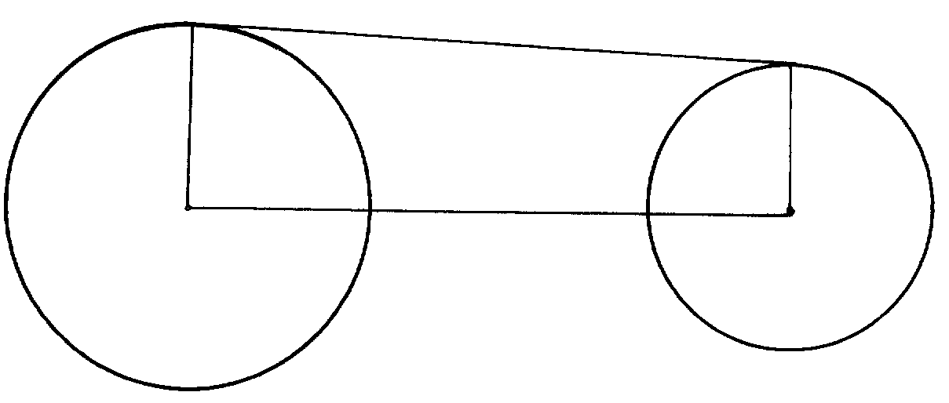

21. (a) Complete the table below for the function y = 3x² – 2x – 1 for -3 ≤ x ≤ 4. (3 marks)

X | -3 | -2 | -1 | 0 | 1 | 2 | 3 | 4
3x² |  |  | 3 |  |  |  | 27
-2x | 6 |  |  |  |  |  |  | -8
-1
Y |  | 15 |  |  |  | 7

(b) Draw the graph of y = 3x² – 2x – 1. (4 marks)
(c) Draw the line y =3x + 1 on the same axis hence find the values of x for
Which y = 3x + 1 and y = 3x² – 2x – 1 are equal. (3 marks)

22. (a) Complete the table below for graphs of:
y = 3 sin (2x – 30º) and y = sin x for -120º< x < 120º Correct to 2 d.p.

xº | -120º | -90º | -60º | -30º | 0º | 30º | 60º | 90º | 120º
y= sin xº | -0.87 | -1.00 |  | -0.50 | 0 |  | 0.87 | 1.00
y = 3sin (2x-30º) |  | 1.50 |  | -3.00 | -1.50 | 1.50 |  | 1.50
- marks)
- On the grid provided draw the graphs on the same axes of y = sin x and y = 3 sin (2x – 30º) (4 marks)

Take the scale: 1cm for 15º on x-axis and 2cm for 1 unit on the y-axis.

- State the amplitude and period of each wave. (2 marks)

- Find the value of x: for which
Sin (2x – 30º) – ¹/₃ sin x = 0. (2 marks)

23. (a) Construct triangle PQR such that PQ = 7.5cm, the ratio of ∠QPR : ∠PQR = 5: 3 and ∠QRP = 60°. (4 marks)
(b) Construct the locus of a point S, on the same side as R which moves such
that ∠PSQ = 75°. (3 marks)
(c) Construct the locus of a point T which moves such that it is always equidistant from lines PQ and PR and produce it to intersect the locus of S at M. (1 mark)
(d) By dropping a perpendicular from M onto PQ at N, measure MN and hence calculate the area of triangle PMQ. (2 marks)

24. The probability that it will rain on a certain morning is ¹/₃ . If it rains, the probability that Tim misses the bus is ¾ . If it does not rain, the probability that he catches the bus is ⁵/_{6.}
a) Represent the above information in a tree diagram. (2 marks)

b) Calculate the probability that on a given morning
i) it rains and he catches the bus. (2 marks)

ii) it rains and he misses the bus. (2 marks)

iii) he misses the bus. (2 marks)

iv) it does not rain and he misses the bus. (2 marks)

This is the last printed page

