NAME--------------------------------------------------INDEX NO---------------------------

ADM.NO-------------------------------

Candidates sign-----------------------

Date ----------------------------------
AGRICULTURE
PAPER 2
THEORY
JULY/AUGUST 2017
2HRS

SUKEMO MOCK

INSTRUCTIONS TO CANDIDATES
- Write your name and index number in the spaces provided above
- Sign and write the date of the examination in the spaces provided above
- This paper consists of THREE sections;A,B and C
- Answer all the questions in sections A and B and TWO questions in section C
- ALL answers should be written in the spaces provided on the question paper
- Candidates should answer the questions in English.

Section A (30MKS)
1.State the use of each of the following tools in bee production. 2mks
- Swam net

- Catcher box

2. State the class of each of the following feedstuffs. 2mks
- Molasses

- Mac lick

3.Name the type of breeding system represented below 1mk
Ayrshire sire x Boran Dam F₁ heifer x Ashire sire

4. State ONE reason why Blackhead Persian sheep is suitable for drier areas. 1mk

5.Outline two characteristics of livestock that are used in mass selection (1mks)

6.State one negative effect of pulling teats as a method of milking in cows (1mk)

7.Give two conditions under which a farmer may prefer to use an ox-cart instead of a tractor drawn trailer? 1 mk

8.Give two causes of soft shell in eggs. 1mk

9.State any two disadvantages that may arise from inbreeding in livestock production. 1mk

10.Name two hormones that control milk letdown in cattle. 2mks

11.Name any four bacterial diseases affecting livestock. 2mks

12. Give the meaning of ratio 3:3:3 as commonly used in pig production. 1mk

13.StateTWO ways in which digestion of food in pigs differs from that in ruminants.1mk

14.Differentiate between a stir-up pump and a knapsack sprayer. 2mks

15State TWO functions of additives in silage making. 1mk

16.Give TWO factors a farmer should consider when selecting garden tools for cultivation
(1mk)

17.Differentiate between tactical and strategic treatment. 1mk

18.name any four parts of a marking gauge (2mks)

19.Using the pearson square method, compute a 300kg ration with 24% DCP from wheat containing 14% DCP and cotton seed cake containing 64% DCP (show your working) (4 marks)

20.a) Give the meaning of the following terms as used in livestock breeds. (1 ½ mks)
i) Steer……………………………………………………………………………………..
ii) Capon

iii) Kindling

b) Name the exotic beef breed of cattle with the following characteristics;
* White / cream in colour
* Heavily built
* Originated from France ( ½ mk)

SECTION B (20MARKS)
21. Study the diagram of an egg below and answer the questions that follow.
A
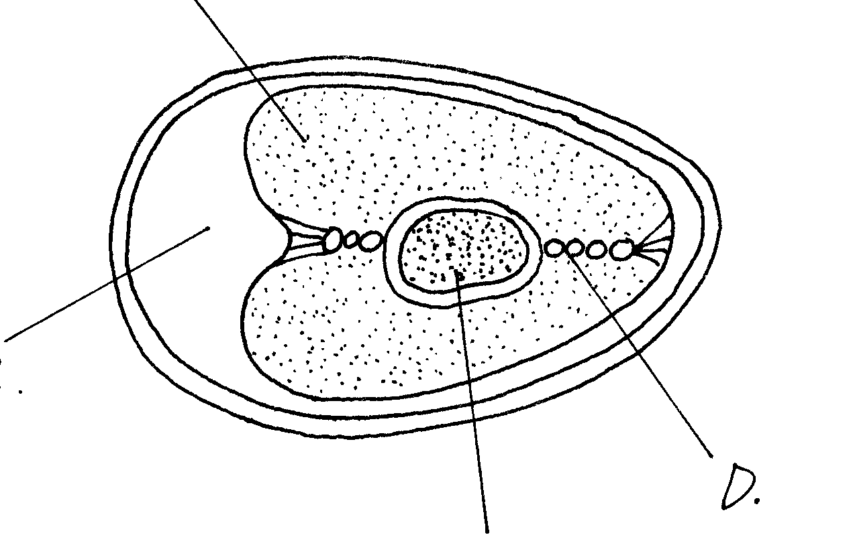
B
C
D

(a)Name the parts labeled A,B C and D. 4mks
A
B
C
D
b)State the roles of parts labeled A and D during incubation. 2mks

22. Study the illustration of a farm structure below and answer the questions that follow.
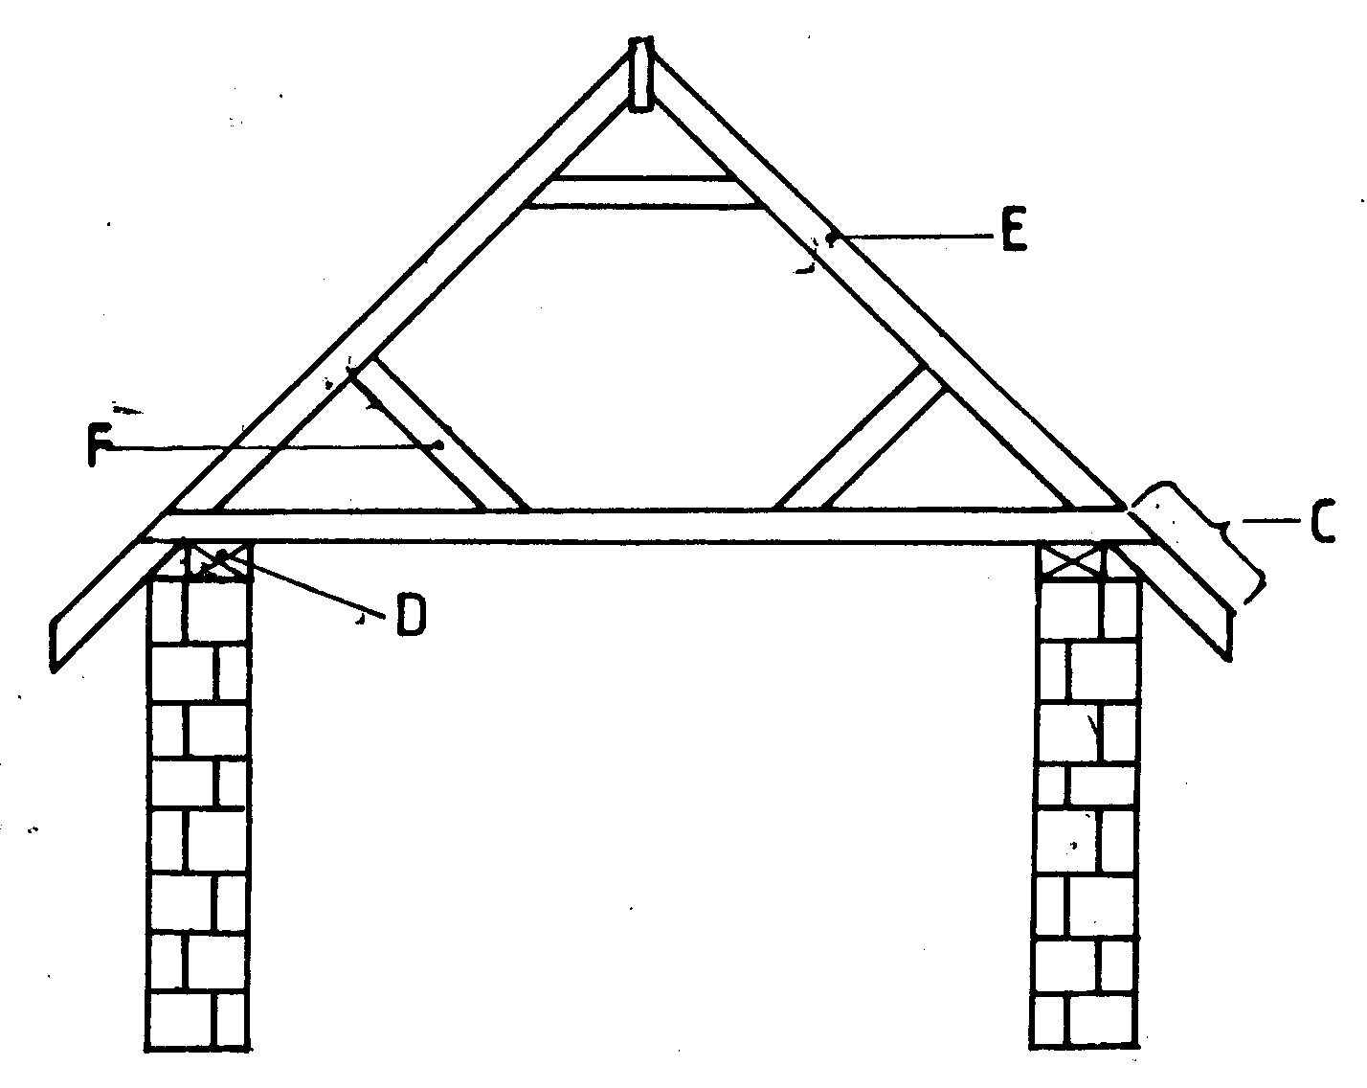
a) Name the parts labelled C, D, E and F. 2mks
C
D
E
F
b) State the functions of the parts labelled C,D,E and F. 2mks

c) Name two chemical preservatives used to treat the wooden parts of the structure against insects and fungal damage. 1mk

23.Use the diagram to answer the question below:
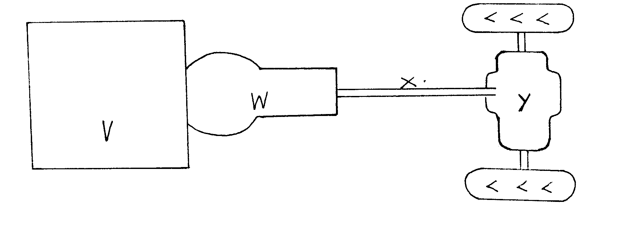

- Name the parts labeled V, W, X, and Y in a tractor power transmission system. 2mks
V
W
X
Y
(ii) State two ways of improving the traction force in land wheel. 2mks

24.. Study the diagrams of livestock production tools below and answer questions that follow.
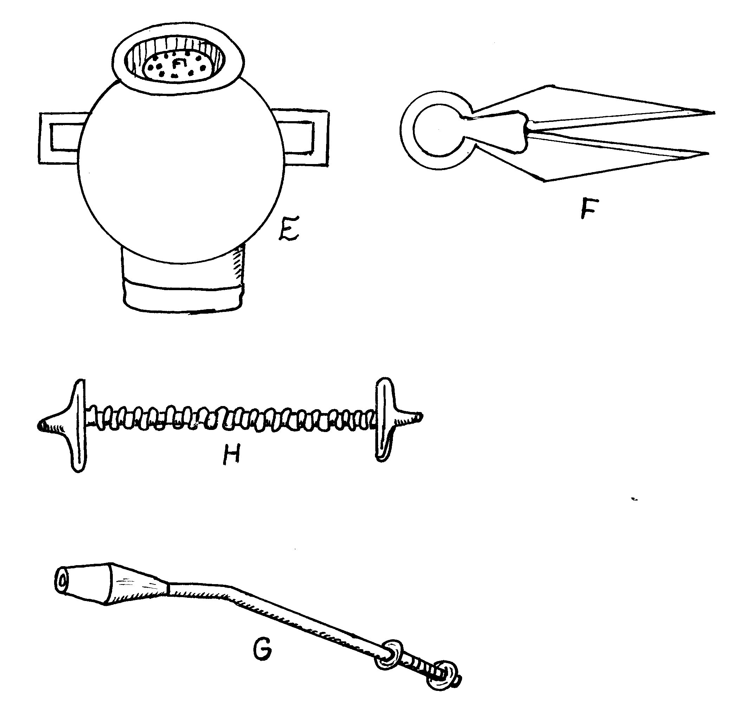
a) Identify the tools E, F, G and H. (4mks)
E……………………………………………………………………………………………
F……………………………………………………………………………………………H……………………………………………………………………………………………G……………………………………………………………………………………………
b) State two maintenance practice of the equipment E. (1mk)
………………………………………………………………………………………………………………………………………………………………

SECTION C
25. (a) State the management practices one should carry out to ensure effective dipping (10mks)
(b) State the characteristics of an ideal beef cattle (10mks

26. (a) Describe the signs of internal parasites attack in livestock (10mks)
(b) Describe the life cycle of a liver fluke Fasciolaspp (10mks)

27. Describe the management of layers in a deep litter system from the point of lay. 20mks

