NAME……………………………………………………………INDEX NO…………………
SHOOL…..………………..
DATE……………….……..
SIGNATURE………….….

231/2
BIOLOGY
PAPER 2
THEORY
MAY/JUNE 2016
TIME: 2 HOURS

EKSIKA JOINT EVALUATION TEST
KENYA CERTIFICATE OF SECONDARY EDUCATION
231/2
PAPER 2
BIOLOGY

Instructions To Candidates
- Write your name and index number in the spaces provided above.
- Sign and write the date of the examination in the spaces provided above.
- This paper consists of two sections; A and B.
- Answer all the questions in section A in the spaces provided.
- In section B answer questions 6(compulsory) and either question 7 or 8 in the spaces provided after question 8.
- This paper consists of 10 printed pages.
- Candidates should check the question paper to ascertain that all pages are printed as indicated and that no questions are missing.
- Candidates should answer questions in English.

For examiners use only
Section | Question | Maximum Score | Candidate’s Score
A | 1 | 8
 | 2 | 8
 | 3 | 8
 | 4 | 8
 | 5 | 8
B | 6 | 20
 | 7 or 8 | 20
 | Total | 80

SECTION A
Answer all the questions in this section in the spaces provided.

- The diagram bellow shows the arrangement of teeth in the upper jaw of human

a. (i) Write the dental formula (1mk)

(ii) Using the dental formula, determine the total number of teeth (1mk)

b. Name an enzyme involved in digestion in the mouth (1mk)

c. Name the tooth X and Y and state how they are adopted to their functions (4mks)

 | Name | Adaptation
X
Y

d. Name one dental disease. (1mk)

2. The table below shows some mammalian hormones their sources and function. Fill in the blank spaces
a.)
Hormone | Source | Function
Aldosterone | Adrenal gland
 |  | Stimulate conversion of glycogen to glucose
Anti-diuretic hormone
(5mks)

b). Explain why glucose is not found in the urine of a healthy person (1mk)

c.) Give two reasons why some plants drop their leaves during the dry season (2mks)

3. The diagram below represents respiration in a cell.

a. (i) Name the process M and N (2mks)

(ii) Name substance X (1mk)

b. In which part of the cell do the following processes occur? (2mks)
M

N

c) The oxidation of a certain fat is represented by the chemical equation shown bellow

C₅H₁₀₄O₆+8O₂ 56CO₂+52H₂0+Energy

Calculate the respiratory quotient (RQ) of the fat (show your working) (2mks)

d. Name the type of alcohol produced by anaerobic respiration in plants (1mk)

4. The photomicrograph represents blood tissue

a) Identify the structure labeled (2mks)
X-

Y-

b) State the function of:
X-

Y-

c) Using features on the diagram, state how structure Z is adapted to its function (2mks)

d) On measuring the diameter of structure labeled Z from point A to B in millimeters, the length is 40 mm
Calculate the actual size of structure Z in micrometers (2mks)

5. The diagram below represent a flower of a leguminous plant-crotalaria

- Name on the diagram the parts labeled A and D (2mks)

- Give the difference between structures B and C in wind and insect pollinated flowers (2mks)

 | Insect pollinated | Wind pollinated
B
C

c) State any two changes that will take place in the flower after fertilization (2mks)

d) Classify the Crotalaria plant into the following taxonomic levels (2mks)

Division:

Class:

SECTION B (40MKS)
Answer question 6 (compulsory) and either question 7 or 8 in the spaces provided after question 8.

6. A culture of bacteria was incubated in nutrient agar at 35⁰c.samples were take at intervals in order to estimate the number of bacteria in the population. The data obtained is shown in the graph.
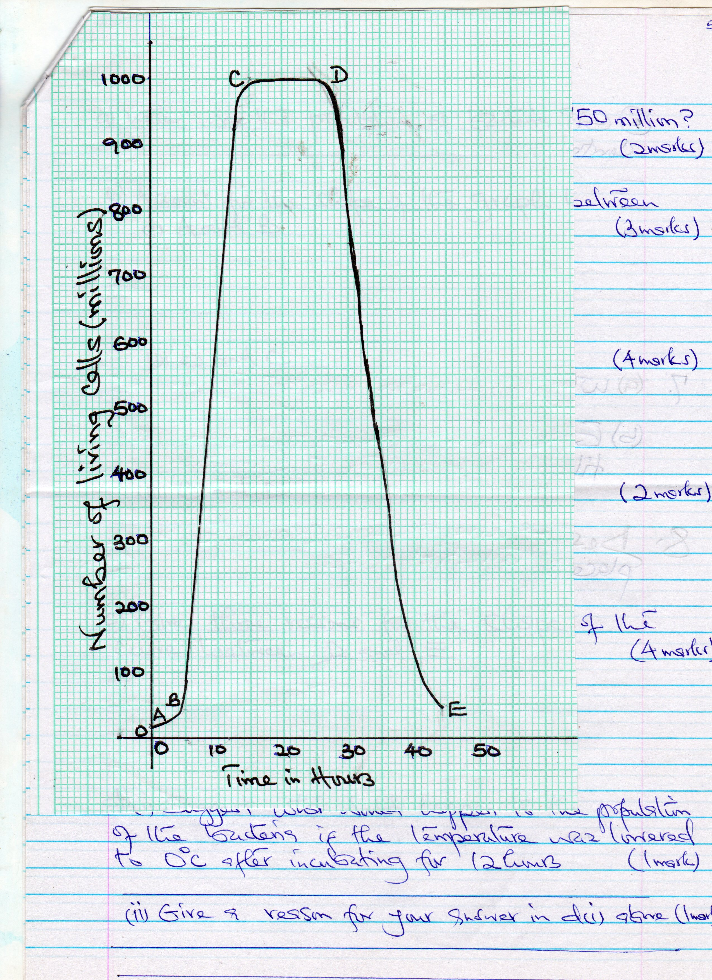

a) When was the population of bacteria 750 million? (2mks)

b) Account for the shape of the graph between

(i)A and B (3mks)

(ii)B and C (4mks)

(iii)C and D (2mks)

c) Give three reasons for the slope of the curve between D and E (4mks)

d. (i) Suggest what would happen to the population of the bacteria if the temperature was lowered to 0⁰c after incubating for 12 hours (1mk)

(ii)Give a reason for your answer in d (i) above (1mk)

e) Give three reasons why it is important to control human population growth in Kenya (3mks)

7. (a) Why is locomotion important to animals? (4mks)

(b) Explain how a finned fish such as tilapia is adapted to swimming (16mks)

………………………………………………………………………………………………………………………………………………………………………………………………………………………………………………………………………………………………………………………………………………………………………………………………………………………………………………………………………………………………………………………………………………………………………………………………………………………………………………………………………………………………………………………………………………………………………………………………………………………………………………………………………………………………………………………………………………………………………………………………………………………………………………………………………………………………………………………………………………………………………………………………………………………………………………………………………………………………………………………………………………………………………………………………………………………………………………………………………………………………………………………………………………………………………………………………………………………………………………………………………………………………………………………………………………………………………………………………………………………………………………………………………………………………………………………………………………………………………………
………………………………………………………………………………………………………………………………………………………………………………………………………………………………………………………………………………………………………………………………………………………………………………………………………………………………………………………………………………………………………………………………………………………………………………………………………………………………………………………………………………………………………………………………………………………………………………………………………………………………………………………………………………………………………………………………………………………………………………………………………………………………………………………………………………………………………………………………………………………………………………………………………………………………………………………………………………………………………………………………………………………………………………………………………………………………………………………………………………………………………………………………………………………………………………………………………………………………………………………………………………………………………………………………………………………………………………………………………………………………………………………………………………………………………………………………………………………………………………
………………………………………………………………………………………………………………………………………………………………………………………………………………………………………………………………………………………………………………………………………………………………………………………………………………………………………………………………………………………………………………………………………………………………………………………………………………………………………………………………………………………………………………………………………………………………………………………………………………………………………………………………………………………………………………………………………………………………………………………………………………………………………………………………………………………………………………………………………………………………………………………………………………………………………………………………………………

8. Describe how gaseous exchange takes place in terrestrial plants (20mks)
………………………………………………………………………………………………………………………………………………………………………………………………………………………………………………………………………………………………………………………………………………………………………………………………………………………………………………………………………………………………………………………………………………………………………………………………………………………………………………………………………………………………………………………………………………………………………………………………………………………………………………………………………………………………………………………………………………………………………………………………………………………………………………………………………………………………………………………………………………………………………………………………………………………………………………………………………………………………………………………………………………………………………………………………………………………………………………………………………………………………………………………………………………………………………………………………………………………………………………………………………………………………………………………………………………………………………………………………………………………………………………………………………………………………………………………………………………………………………………
………………………………………………………………………………………………………………………………………………………………………………………………………………………………………………………………………………………………………………………………………………………………………………………………………………………………………………………………………………………………………………………………………………………………………………………………………………………………………………………………………………………………………………………………………………………………………………………………………………………………………………………………………………………………………………………………………………………………………………………………………………………………………………………………………………………………………………………………………………………………………………………………………………………………………………………………………………………………………………………………………………………………………………………………………………………………………………………………………………………………………………………………………………………………………………………………………………………………………………………………………………………………………………………………………………………………………………………………………………………………………………………………………………………………………………………………………………………………………………
………………………………………………………………………………………………………………………………………………………………………………………………………………………………………………………………………………………………………………………………………………………………………………………………………………………………………………………………………………………………………………………………………………………………………………………………………………………………………………………………………………………………………………………………………………………………………………………………………………………………………………………………………………………………………………………………………………………………………………………………………………………………………………………………………………………………………………………………………………………………………………………………………………………………………………………………………………………………………………………………………………………………………………………………………………………………………………………………………………………………………………………………………………………………………………………………………………………………………………………………………………………………………………………………………………
………………………………………………………………………………………………………………………………………………………………………………………………………………………………………………………………………………………………………………………………………………………………………………………………………………………………………………………………………………………………………………………………………………………………………………………………………………………………………………………………………………………………………………………………………………………………………………………………………………………………………………………………………………………………………………………………………………………………………………………………………………………………………………………………………………………………………………………………………………………………………………………………………………………………………………………………………………………………………………………………………………………………………………………………………………………………………………………………………………………………………………………………………………………………………………………………………………………………………………………………………………………………………………………………………………………………………………………………………………………………………………………………………………………………………………………………………………………………………………

