NAME:………………………………………………………………INDEX NO……………………………...
SCHOOL:…………………………………………………………..CANDIDATE’S SIGN…………………
DATE………………………………….
443/1
AGRICULTURE
PAPER 1
JULY/AUGUST- 2016
TIME: 2 HOURS
KIRINYAGA EAST SUB- COUNTY
CENTRAL ZONE STRATEGIC ALLIANCE EXAMINATION - 2016 Kenya Certificate of Secondary Education K.C.S.E.
443/1
AGRICULTURE
PAPER 1
INSTRUCTIONS TO CANDIDATES
- Write your name and index No. in the spaces provided.
- This paper consists of THREE SECTIONS A,B, and C.
- Answer ALL questions in section A and B and ANY TWO in section C.
- All your answers must be written in the spaces provided.
FOR EXAMINERS USE ONLY
SECTION | QUESTIONS | MAXIMUM SCORE | CANDIDATES SCORE
A | 1-20 | 30
B |  | 20
C |  | 20
 |  | 20
 | TOTAL | 90

This paper consists of 12 printed pages. Candidates should check the question paper to ensure that all pages are printed as indicated and no questions are missing.
SECTION A (20 MARKS)
Answer all questions in this section
- State three limitations of tissue culture. 1 ½ mks
………………………………………………………………………………………………………………………………………………………………………………………………………………………………………………………………………………………………………………………………………………………………………………………………………………………………
- Give two types of labour records. 1mk
………………………………………………………………………………………………………………………………………………………………………………………………………………
- Give three disadvantages of surface irrigation 1 ½ mks
………………………………………………………………………………………………………………………………………………………………………………………………………………………………………………………………………………………………………………………………………………………………………………………………………………………………
- State three conditions that ensure maximum utilization of herbicides 1 ½ mks
………………………………………………………………………………………………………………………………………………………………………………………………………………………………………………………………………………………………………………………………………………………………………………………………………………………………
- a) At what stage of beans should mechanical weed control be avoided? ½ mk
…………………………………………………………………………………………………………………………………………………………………………………………………………………………………………………………………………………………………………………………………………………………………………………………………………………………………………

b) Name three examples of working capital in wheat production. 1 ½ mks
………………………………………………………………………………………………………………………………………………………………………………………………………………
- State four factors considered when identifying a farming system in an area. 2mks
………………………………………………………………………………………………………………………………………………………………………………………………………………………………………………………………………………………………………………………………………………………………………………………………………………………………
- Name any two types of micro-catchment used in the soil and water conservation. 1mk
………………………………………………………………………………………………………………………………………………………………………………………………………………………………………………………………………………………………………………………
- List four benefits of draining a water-logged land. 2mks
………………………………………………………………………………………………………………………………………………………………………………………………………………………………………………………………………………………………………………………………………………………………………………………………………………………………………………………………………………………………………………………………………
- State four symptoms of viral disease attack in crops. 2mks
………………………………………………………………………………………………………………………………………………………………………………………………………………………………………………………………………………………………………………………………………………………………………………………………………………………………
- Name three books of accounts used in book keeping. 1 ½ mks
………………………………………………………………………………………………………………………………………………………………………………………………………………………………………………………………………………………………………………………………………………………………………………………………………………………………
- Give three conditions that may lead to sub-division of land. 1 ½ mks
………………………………………………………………………………………………………………………………………………………………………………………………………………………………………………………………………………………………………………………………………………………………………………………………………………………………
- Name three reasons for carrying out primary cultivation. 1 ½ mks
………………………………………………………………………………………………………………………………………………………………………………………………………………………………………………………………………………………………………………………………………………………………………………………………………………………………
- Give three sources of capital in agriculture. 1 ½ mks
………………………………………………………………………………………………………………………………………………………………………………………………………………………………………………………………………………………………………………………………………………………………………………………………………………………………
- State three characteristics of a good rootstock for grafting. 1 ½ mks
………………………………………………………………………………………………………………………………………………………………………………………………………………………………………………………………………………………………………………………………………………………………………………………………………………………………
- State two benefits of a good soil structure in crop production. 1mk
………………………………………………………………………………………………………………………………………………………………………………………………………………………………………………………………………………………………………………………
- Differentiate between fertilizer grade and fertilizer ratio as used in fertilizer chemistry. 1mk
………………………………………………………………………………………………………………………………………………………………………………………………………………………………………………………………………………………………………………………………………………………………………………………………………………………………
- Give two functions of calcium in plant growth. 1mk
………………………………………………………………………………………………………………………………………………………………………………………………………………
- State four factors that contribute to competitive ability of weeds. 2mks
………………………………………………………………………………………………………………………………………………………………………………………………………………………………………………………………………………………………………………………………………………………………………………………………………………………………
- Give two advantages of strip grazing. 1mk
………………………………………………………………………………………………………………………………………………………………………………………………………………
- State four factors that determine the nutrient content of hay. 2mks
………………………………………………………………………………………………………………………………………………………………………………………………………………………………………………………………………………………………………………………………………………………………………………………………………………………………
SECTION B (20MARKS)
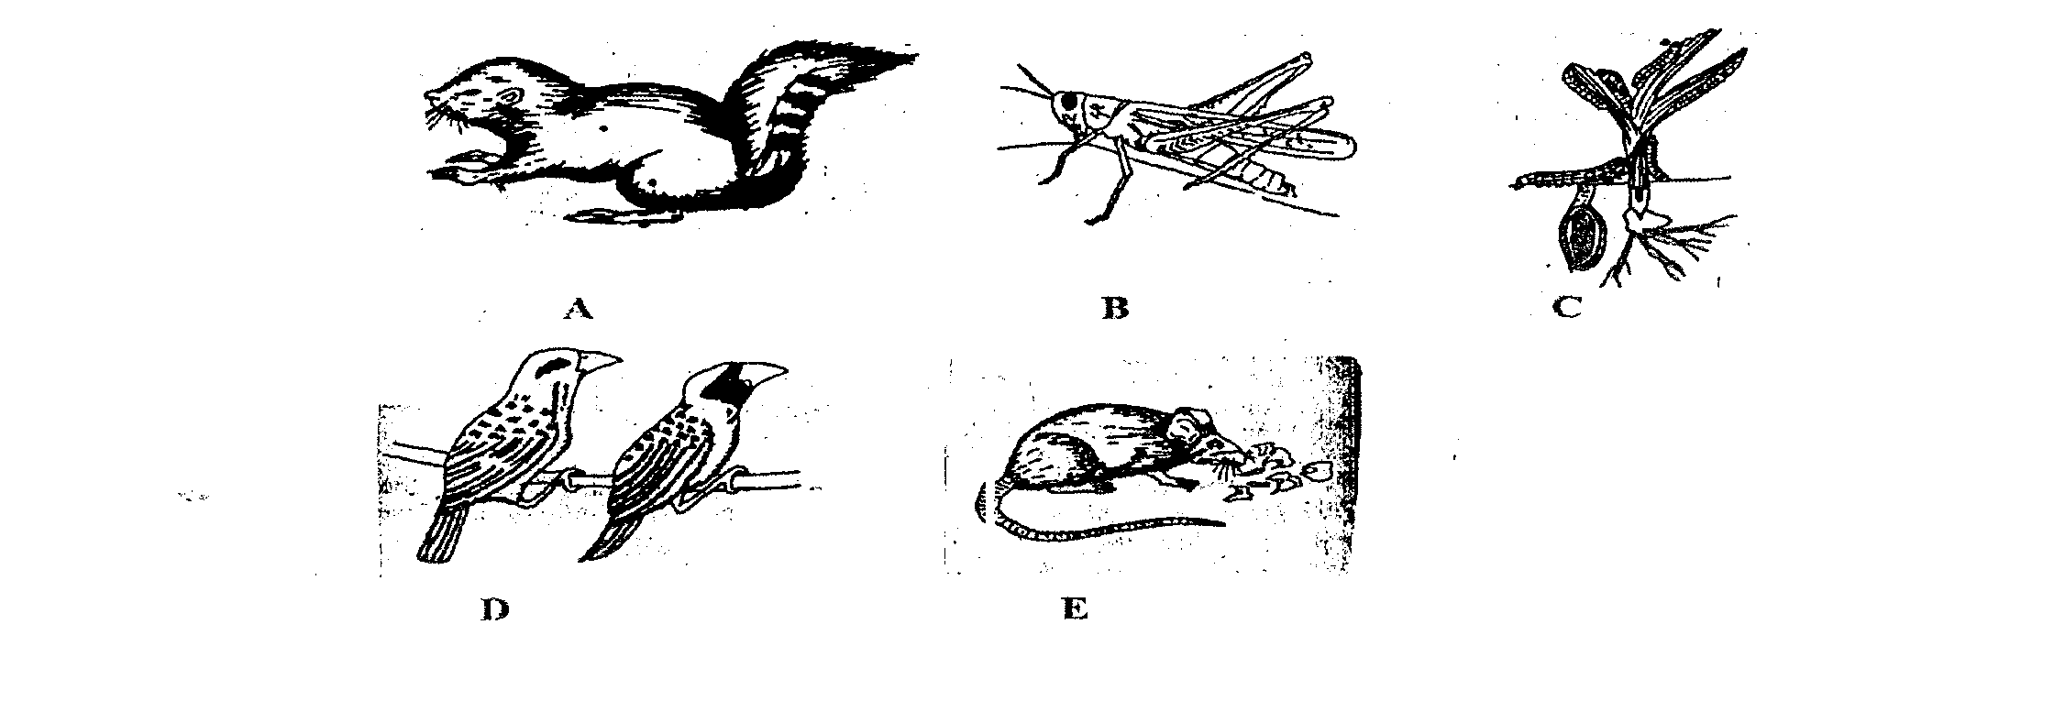
- Study the illustration given below representing crop pest and answer the questions that follow.

i) Identify the pest represented by A,C,D and E.
A -
C –
D –
E –
ii) Name a crop disease that is spread by pest labeled B. 1mk
…………………………………………………………………………………………………………………………………………………………………………………………………………………..
iii) Name two damages caused by pest E. lmk
……………………………………………………………………………………………………………………………………………………………………………………………………………………
iv) Give two control measures for the pest labelled D. lmk
……………………………………………………………………………………………………………………………………………………………………………………………………………………..
- A farmer wishes to change her enterprise from vegetable and flower production to cattle rearing. The cost she incurred in growing vegetable and flower are:
Flower | Tomatoes
Weeding – 200/=  Harvesting – 300/=  Fertilizer – 500/=  Seeds – 400/= | Weeding – 200/=  Pruning – 300/=  Harvesting – 400/=  Chemical – 1,000/=  Seeds – 150/=

When she changes her enterprise to dairy cattle rearing, she incurs the following costs:
- Cost of buying cattle - 10,000/=
- Disease control - 2,000/
- Salary of milk person - 3,000/=
- Fencing - 1,500/
The revenue she gets when growing tomatoes is 10,000/= and flowers is 4,000/= ln dairy cattle
production, the revenue from milk sales is 20,000/= and manure sale is 1,000/=.
Prepare a partial budget (4mks)

Is it worthwhile to effect the change? (lmk)
……………………………………………………………………………………………………………………………………………………………………………………………………………………
- The following is a diagram of maize cob attacked by disease.
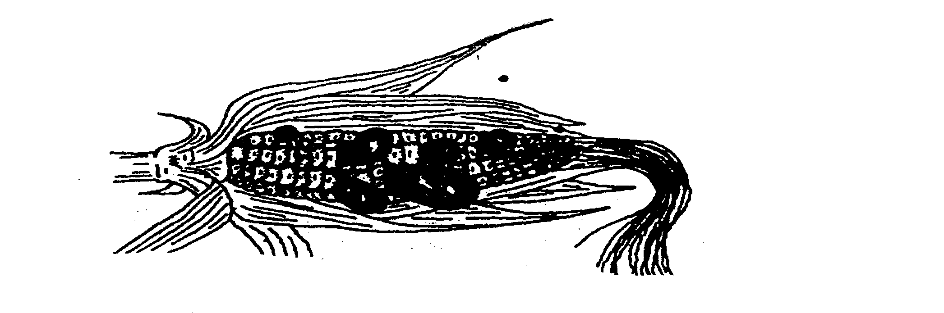

- Identify the disease. 1mk
……………………………………………………………………………………………………………………………………………………………………………………………………
ii) List down three control measures of the above disease. 1 ½ mk
………………………………………………………………………………………………………………………………………………………………………………………………………………………………………………………………………………………………………………………………………………………………………………………………………………………………
iii) Name one other crop attacked by similar disease. ½ mk
………………………………………………………………………………………………………………………………………………………………………………………………………………
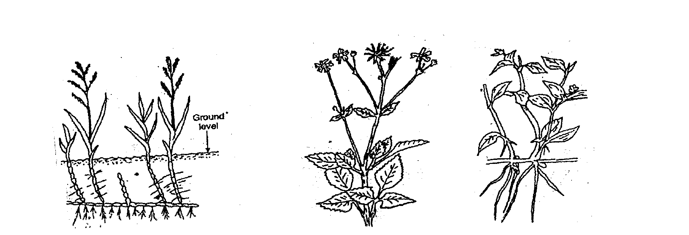
- The diagrams F,G and H show weeds.
F
G
H

- Identify the weeds labeled F,G and H
F - …………………………………………………………………………………… .½ mk
G - ……………………………………………………………………………………. ½ mk
H – …………………………………………………………………………………… ½ mk
- Why is difficult to control weed labeled F. 2mks
………………………………………………………………………………………………………………………………………………………………………………………………………………

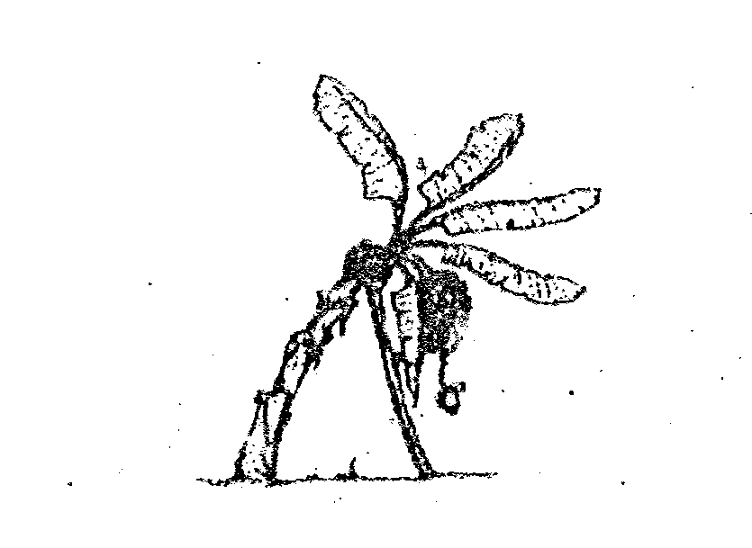
- The diagram below illustrates a field practice study it carefully and answer the questions that
follow.

a) Name the practice. ½ mk
………………………………………………………………………………………………………………………………………………………………………………………………………………
b) Give three reasons for carrying out the practices named in (a) above. 3mks
………………………………………………………………………………………………………………………………………………………………………………………………………………………………………………………………………………………………………………………………………………………………………………………………………………………………
SECTION C (40 MARKS)
Answer any two questions from this section in the spaces provided after question 28.
- a) Explain five factors considered in designing a crop rotational programme. 5mks
b) Outline seven advantages of land consolidation in land tenure reforms. 7mks
c) Describe the practices that a farmer should carry out to ensure uniform germination of seeds. 4mks
d) Give four reasons why burning is not recommended as a method of land clearing. 4mks
- a) List eight benefits of using organic matter for mulching. 8mks
b) Describe the field production of Maize under the following sub-headings.

- Ecological requirements 4mks
- Seed bed preparation. 3mks
- Planting. 3mks
- Field management. 2mks
- a) Explain ways in which a farmer can improve soil fertility. 10mks
b) Discuss various methods which a farmer can use to prevent water pollution. 5mks
c) Below is a graph showing the relationship between demand and supply in price determination.
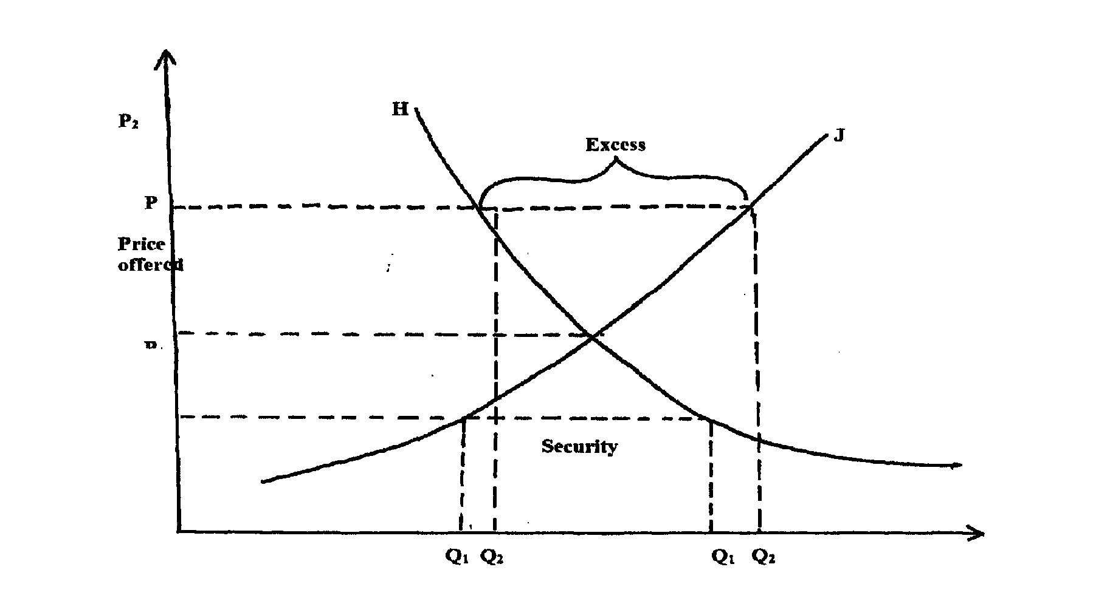

i) Name the curve labelled H and J. 1mk
ii) State the name given to the point where the two curves H and J intersect. 1rnk
iii) Give two reasons why there is excess supply above P2. 1mk
iv) If the price of millet in a market changes from 10/= to 12/= per kg resulting in a change of supply from 400kg to 600kg, Calculate the elasticity of supply. 2mks
………………………………………………………………………………………………………………………………………………………………………………………………………………………………………………………………………………………………………………………………………………………………………………………………………………………………………………………………………………………………………………………………………………………………………………………………………………………………………………………………………………………………………………………………………………………………………………………………………………………………………………………………………………………………………………………………………………………………………………………………………………………………………………………………………………………………………………………………………………………………………………………………………………………………………………………………………………………………………………………………………………………………………………………………………………………………………………………………………………………………………………………………………………………………………………………………………………………………………………………………………………………………………………………………………………………………………………………………………………………………………………………………………………………………………………………………………………………………………………………………………………………………………………………………………………………………………………………………………………………………………………………………………………………………………………………………………………………………………………………………………………………………………………………………………………………………………………………………………………………………………………………………………………………………………………………………………………………………………………………………………………………………………………………………………………………………………………………………………………………………………………………………………………………………………………………………………………………………………………………………………………………………………………………………………………………………………………………………………………………………………………………………………………………………………………………………………………………………………………………………………………………………………………………………………………………………………………………………………………………………………………………………………………………………………………………………………………………………………………………………………………………………………………………………………………………………………………………………………………………………………………………………………………………………………………………………………………………………………………………………………………………………………………………………………………………………………………………………………………………………………………………………………………………………………………………………………………………………………………………………………………………………………………………………………………………………………………………………………………………………………………………………………………………………………………………………………………………………………………………………………………………………………………………………………………………………………………………………………………………………………………………………………………………………………………………………………………………………………………………………………………………………………………………………………………………………………………………………………………………………………………………………………………………………………………………………………………………………………………………………………………………………………………………………………………………………………………………………………………………………………………………………………………………………………………………………………………………………………………………………………………………………………………………………………………………………………………………………………………………………………………………………………………………………………………………………………………………………………………………………………………………………………………………………………………………………………………………………………………………………………………………………………………………………………………………………………………………………………………………………………………………………………………………………………………………………………………………………………………………………………………………………………………………………………………………………………………………………………………………………………………………………………………………………………………………………………………………………………………………………………………………………………………………………………………………………………………………………………………………………………………………………………………………………………………………………………………………………………………………………………………………………………………………………………………………………………………………………………………………………………………………………………………………………………………………………………………………………………………………………………………………………………………………………………………………………………………………………………………………………..

