**Name:….….…………………………………………………… Adm. No: ………………………..**

**School:…….…………………………………………………… Date: ………………………………**

**121/1**

**MATHEMATICS**

**PAPER 1**

**November 2017**

**TIME: 2 ½ HOURS**

***Kenya Certificate of Secondary education (K.C.S.E)***

***Form three [3]***

***Mathematics***

***Paper 1***

**INSTRUCTIONS TO CANDIDATES:-**

* *Write your* ***name*** *and* ***admn. number*** *in the spaces provided above.*
* ***Sign*** *and write the* ***date*** *in the space provided above.*
* *This paper contains* ***two*** *sections:* ***Section I and II.***
* *Answer* ***all*** *the questions in* ***Section 1*** *and any* ***five*** *questions from* ***Section II.***
* *All working and answers* ***must*** *be written on the question paper in the spaces provided below each question.*
* *Show* ***all*** *steps in your calculations, giving your answers at each stage in the spaces provided below each question.*
* *Marks may be given for correct working even if the answer is wrong.*
* *Non-programmable silent electronic calculators and**KNEC mathematical tables may be used*

**For Examiners’ Use Only.**

**Section I**

|  |  |  |  |  |  |  |  |  |  |  |  |  |  |  |  |  |  |
| --- | --- | --- | --- | --- | --- | --- | --- | --- | --- | --- | --- | --- | --- | --- | --- | --- | --- |
| **Questions** | 1 | 2 | 3 | 4 | 5 | 6 | 7 | 8 | 9 | 10 | 11 | 12 | 13 | 14 | 15 | 16 | **Total** |
| **Marks** |  |  |  |  |  |  |  |  |  |  |  |  |  |  |  |  |  |

**Section II**

**GRAND**

**TOTAL**

|  |  |  |  |  |  |  |  |  |  |
| --- | --- | --- | --- | --- | --- | --- | --- | --- | --- |
| **Questions** | 17 | 18 | 19 | 20 | 21 | 22 | 23 | 24 | **Total** |
| **Marks** |  |  |  |  |  |  |  |  |  |

***This paper consists of 16 printed pages.***

***Candidates should check to ascertain that all pages are printed as indicated and that no questions are missing.***

**Section 1 [50mks]**

***Answer all questions in this section***

1. Evaluate without using a calculator [3mks]



2. The line 3*x* – 2y + k = 0 passes through point A [6, 2] and is parallel to the line a*x* – 2y + 7 = 0.

Find the values of a and k [3mks]

3. A farmer bought 60 sheep at shs.800 each. Three of them died on the way. He then sold

of the remainder at shs.1000 and the rest at shs.790 each. What was the total profit



in shillings [3mks]



4. Two similar containers weigh 40Kg and 625kg respectively. If the surface area of the smaller

one is 112cm2. Find the surface area of the bigger one in m2 [3mks]

5. Solve the equation;  [3mks]



6. The interior angle of regular polygon exceeds the exterior angle by 135o. Find the number

sides of the polygon. [2mks]

7. Mr Mwololo sells two types of mathematical sets, type A and type B. Twenty four type A and ten typeB cost Kshs.2,520, while eighteen type A and thirty type B cost kshs.3240. Mr. Mwololo bought

eighteen type B. how much did he pay for them [4mks]

8. A two digit number is such that the sum of the digits is 15. When the digits are reversed

the new number formed is more than the original number by 27. Find the number [3mks]

9. Use tables of reciprocals and cubes only to evaluate; [3mks]



10. Town X is 20km in the direction of 060o from Y and Z is 30km in the direction of 150o from Y.

Using the scale 1cm rep 5km. find by scale drawing;

[a] the bearing of Y from Z [3mks]

[b] The distance of X from Z [1mk]

11. Given that . Determine the value of *x* for  [3mks]



12. By use of a sketch map, calculate the area in hectares of a farm whose measurements are

entered in a surveyor’s field book in metres as shown below; [AD = 450m] [3mks]

|  |  |  |
| --- | --- | --- |
|  | D  370 |  |
|  | 270 | 80 to E |
| 60 to C | 210 |  |
|  | 180 | 60 to F |
| 120 to B | 160 |  |
|  | 100  A | 15 to G |

13. The G.C.D of two numbers is 18 and their L.C.M is 630. If one of the numbers is 126,

find the number [2mks]

14. A rectangular tank A measuring 48m long 2.1 m wide and 1.5m high is three quarters full

of water. The water is then emptied into a cylindrical tank B of diameter 3.6m. Find the

depth of water in tank B to the nearest centimeter [4mks]

15. Find the mean, median and mode of the following set of numbers; [3mks]

0, 1, 2, 2,1, 0, 4, 3, 2, 0, 1, 1, 4, 3

16. The angle of depression from the top of the building 50m high to the points A and B on

the ground are 25.4o and 64.7o respectively. How far is A from B? [4mks]

**Section II [50mks]**

**Answer any five questions**

17. [ a] On the graph paper provided draw the graph for the range 



[4mks]



[b] On the same grid draw the line  [2mks]

[c] Using your graphs solve the equations;

[i]  [2mks]



[ii]  [2mks]

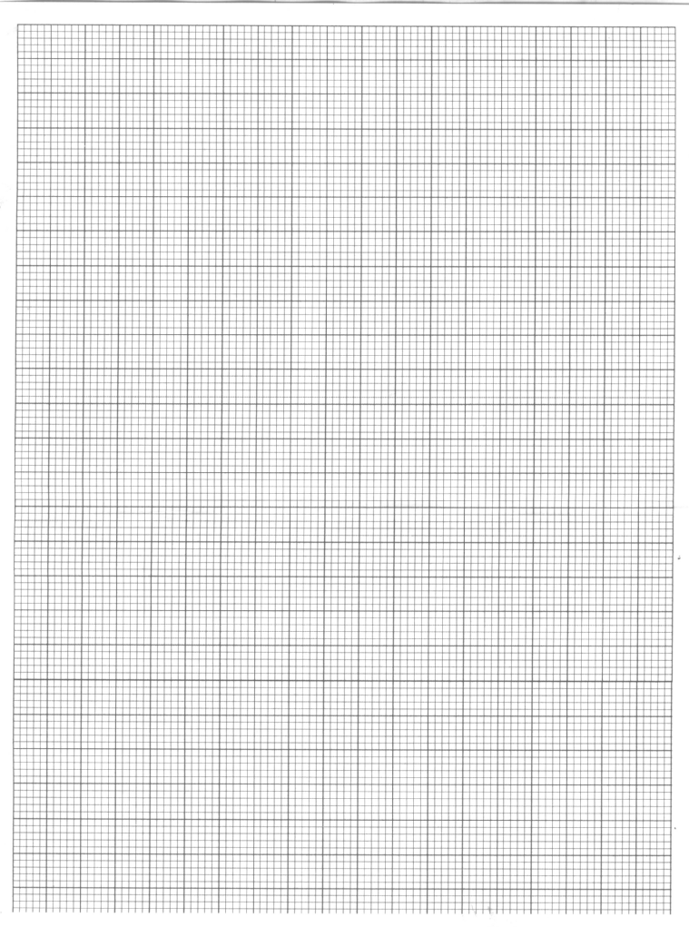

18. Transline bus left Nairobi at 8:00a.m and travelled towards Mombasa at an average speed

of 80km/hr. at 8:30a.m. Lamu bus left Mombasa towards Nairobi at an average speed of

120km/hr. given that the distance between Nairobi and Mombasa is 400Km. calculate;

[a] the time Lamu bus arrived in Nairobi [2mks]

[b] the time the two vehicles met [4mks]

[c] the distance from Nairobi to the meeting point [2mks]

[d] the distance of the transline bus from Mombasa when Lamu Bus arrived in Nairobi [2mks]

19. Two equal circles with centres O and Q and radius 8cm intersect at points A and B as shown

below:

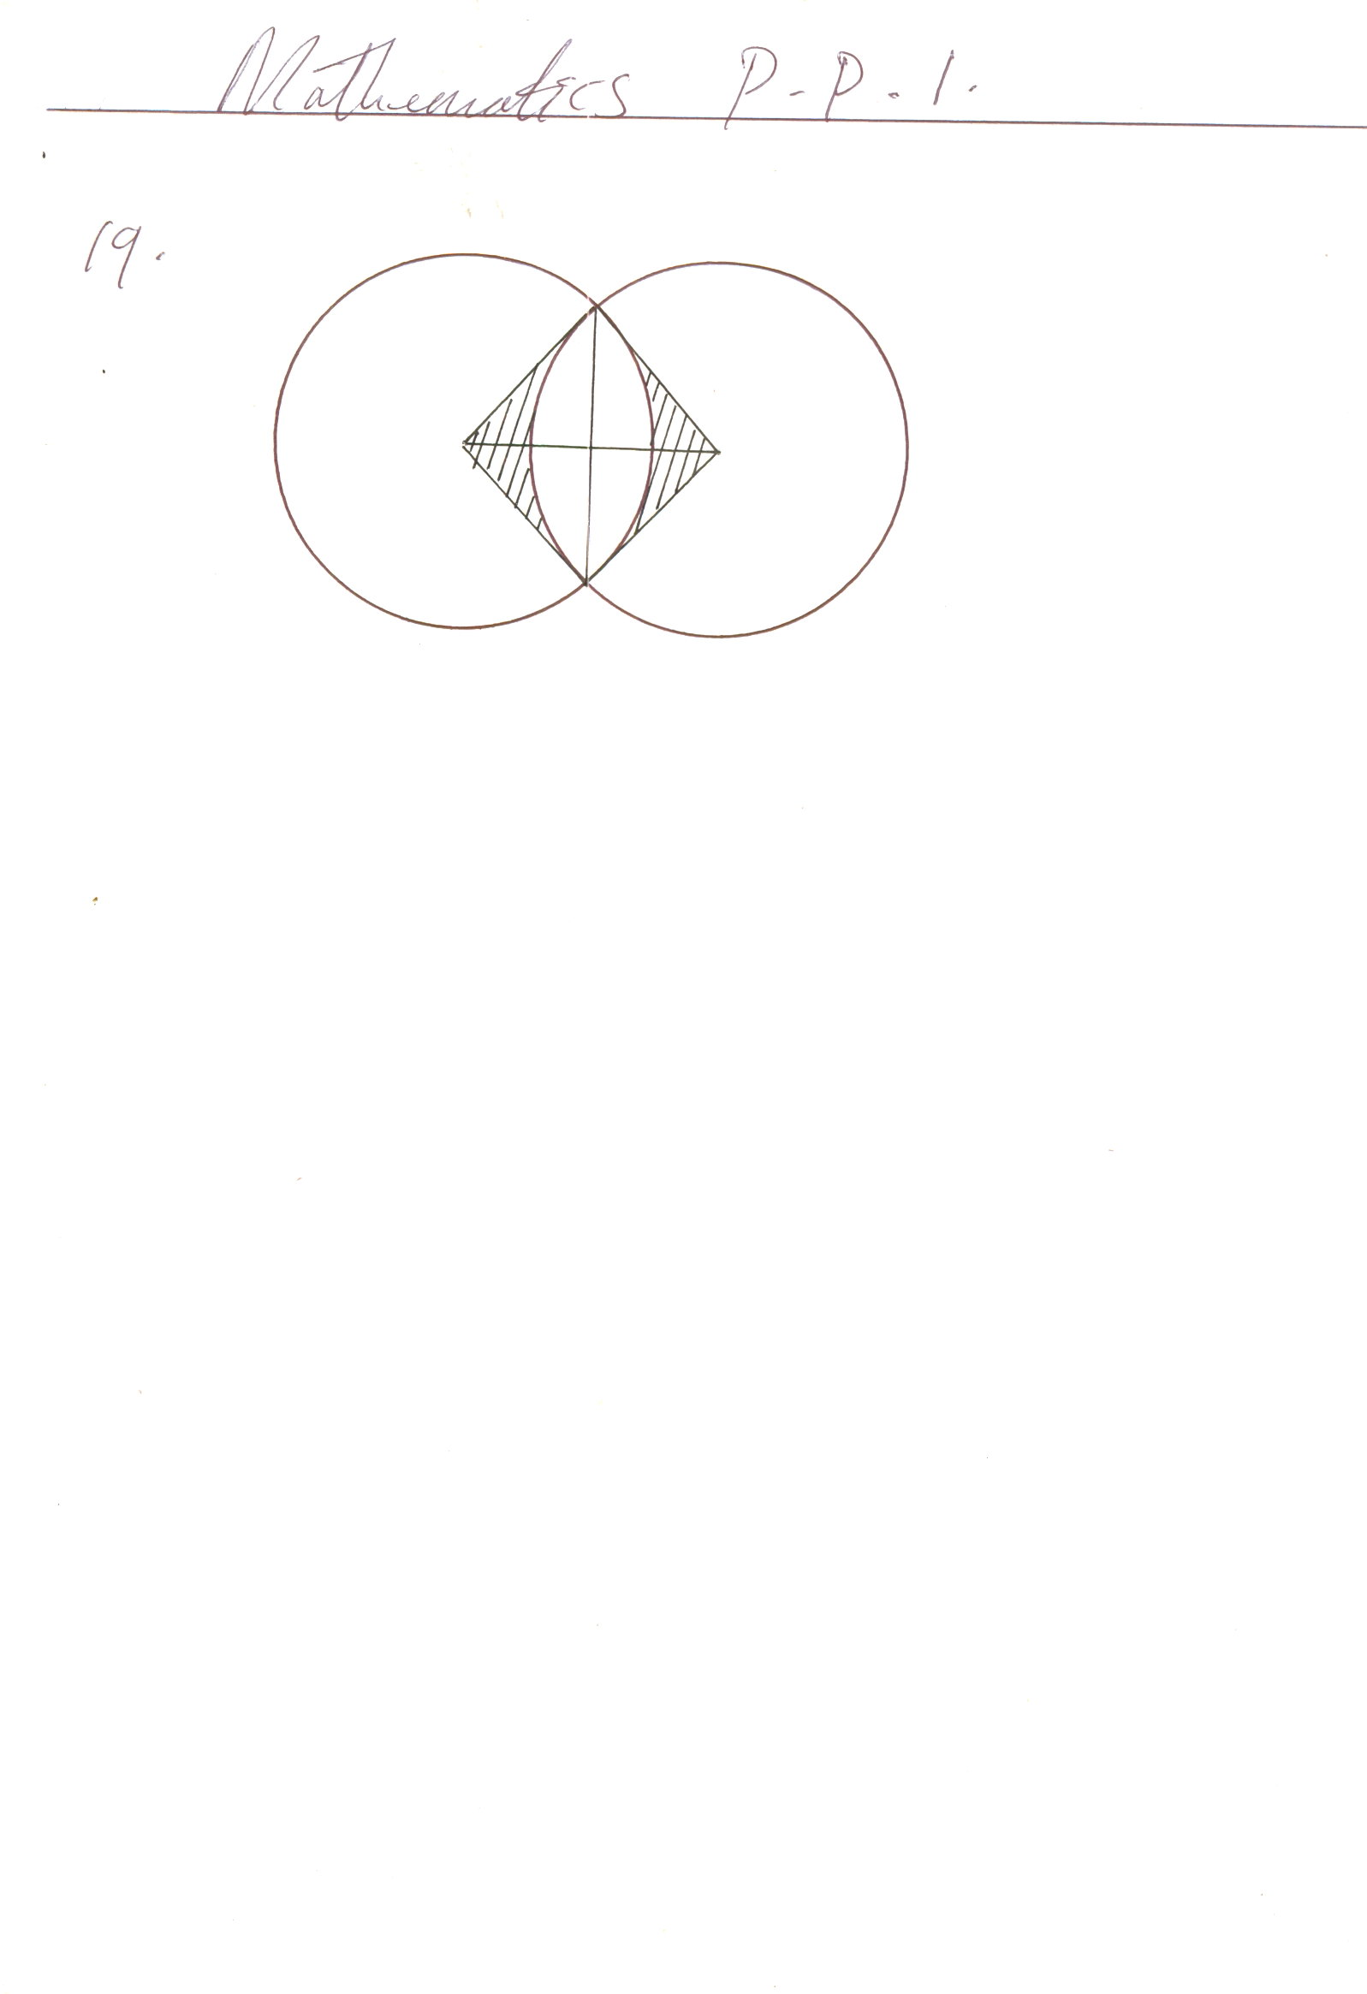

A

Q

X

B

O

Given that the distance between O and Q is 12cm and that line AB meets OQ at X, find;

[a] the length of chord AB [2mks]

[b] the area of the shaded region [6mks]

[c] the reflex angle AOB [2mks]

20. The table below shows marks scored in an examination by some candidates;

|  |  |  |  |  |  |  |  |  |  |
| --- | --- | --- | --- | --- | --- | --- | --- | --- | --- |
| 54 | 77 | 69 | 21 | 82 | 15 | 57 | 65 | 12 | 89 |
| 47 | 86 | 50 | 31 | 07 | 12 | 94 | 83 | 37 | 69 |
| 39 | 72 | 42 | 23 | 58 | 45 | 73 | 72 | 51 | 77 |
| 60 | 50 | 45 | 30 | 54 | 89 | 57 | 92 | 46 | 80 |
| 23 | 35 | 70 | 52 | 60 | 09 | 51 | 73 | 53 | 83 |

[i] Starting with the class 0-9 draw a frequency distribution table for the data [2mks]

[ii] Estimate the mean [4mks]

[iii] Estimate the median mark [4mks]

21. a] i] Use a ruler and a pair of compasses only to construct a triangle ABC in which

AB=4.6cm, BC = 5.4 cm and angle ABC = 75o [2mks]

[ii] Measure AC [1mk]

[b] Drop a perpendicular from B to meet AC at N and measure BN and AN [2mks]

[c] Calculate the area of the triangle ABN [2mks]

[d] Construct a perpendicular bisector of AB and BC to meet at O. Use OA as the radius

to draw circle. Find the area of the circle [3mks]

22. The floor of a room is in the shape of a rectangle 10.5m long by 6m wide. Square tiles of

length 30cm are to be fitted onto the floor;

[a] Calculate the number of tiles needed for the floor [4mks]

[b] A dealer wishes to buy enough tiles for fifteen such room. The tiles are packed in cartons each containing 20tiles. The cost of each carton is Kshs.800. calculate;

[i] The total cost of the tiles [2mks]

[ii] If in addition, the dealer spends Kshs.2000 and Kshs.600 on transport and subsistence

respectively at what price should he sell each carton in order to make a profit of 12.5%.

Give your answer to the nearest Kshs. [4mks]

23. The population of a town in 1989 census was shown 60000 people with a female, male ratio 3:2. Another census had been taken in 1979 and another one is due in 1999. Statistics show that the growth rate of the town population is 20% of the population at proceeding census. Determine;

[a] The population of the town in 1979 [3mks]

[b] the expected population in 1999 [3mks]

[c] The expected number of males and females in 1999 census [4mks]

24. A certain type of paper weighs 70g/m2. Each sheet of paper measures 30cm by 20cm and is 0.12mm thick and there are 500 sheets in one ream. Calculate;

[a] the total area that would be covered by all the sheets in the ream [3mks]

[b] The weight of one ream of paper [3mks]

[c] The volume of paper that would be removed if two circular holes with a radius of 5mm were punched through each sheet. [4mks]

**End**