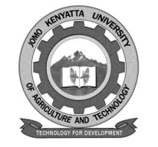
W1-2-60-1-6
JOMO KENYATTA UNIVERSITY OF AGRICULTURE AND TECHNOLOGY

University Examinations 2015/2016
STAGE V SPECIAL/SUPPLEMENTARY EXAMINATION FOR THE DIPLOMA IN INFORMATION TECHNOLOGY

DIT 0504: DATABASE PROGRAMMING

DATE: APRIL, 2016 TIME: 2 HOURS

INSTRUCTIONS: Answer Question ONE and Any Other TWO Questions.

Question One

a) Define the following terms. [9 marks]

- DBMS
- DDL
- DML

b) Discuss the role of database administrator. [10 marks]

c) List and explain four major model of databases. [11 marks]

Question Two

a) Describe the major phases during development of a database management system.
[10 marks]

b) Describe the advantages of using database management system. [10 marks]

Question Three

a) Write syntax for the following commands in SQL. [10 marks]

- Create database
- Select
- Where
- Update
- Delete

b) Define the term data type and discuss three major classifications of data types of mySQL. [10 marks]

Question Four

a) Describe the forces that has led to growth of outline database application. [10 marks]

b) Differentiate between relational database and logical database model. [10 marks]

Question Five

Discuss the major database access methods commonly used in database. [20 marks]

