NAME ……………………………………………………… INDEX NO………………..………..…..……

SCHOOL ………………………………………………….. CANDIDATE’S SIGNATURE………..…… DATE…………………………………………

231/3
BIOLOGY
PAPER 3
(PRACTICAL)
JULY/AUGUST 2013
TIME: 1¾ HOURS

KIRINYAGA CENTRAL DISTRICT JOINT EXAMINATION - 2013

Kenya Certificate of Secondary Education
BIOLOGY
PAPER 3
(PRACTICAL)
TIME: 1¾ HOURS

Instructions to candidates
(a) Write your name and index number in the spaces provided above.
(b) Sign and write the date of examination in the spaces provided above.
(c) Answer all the questions in the spaces provided.
(d) You are required to spend the first 15 minutes of the 1¾ hours allowed for this paper
reading the whole paper carefully before commencing your work.
(e) Additional papers must not be inserted.
(f) This paper has three questions and 6 pages.
(g) Students should check the question paper to ascertain that all the papers are printed
as indicated and that no questions are missing.

For Examiner’s Use Only
Question | Maximum  Score | Candidate’s  Score
1 | 12
2 | 14
3 | 14
Total score | 40

Biology Paper 3 Turnover
1. You are provided with a specimen labeled K. With the help of a hand lens examine the specimen.
(a) (i) State the phylum to which the specimen belongs. (1mk)

________________________________________________________________

- Using the observable features only, name the class to which the specimen belongs. (1mk)

________________________________________________________________

(iii) Give a reason for your answer in (a)(ii) above. (1mk)

________________________________________________________________

________________________________________________________________

________________________________________________________________

(b) Using the observable features only, state how the animal is adapted to living in its habitat. (3mks)

______________________________________________________________________

______________________________________________________________________

______________________________________________________________________

______________________________________________________________________

- Cut three of specimen K into tiny pieces. Place the pieces into a boiling tube.
Add 5m of water. Boil for five minutes. Decant the extract into a clean test tube.
Using the reagents provided, identify the food substances in the extract.
Record the food substances being tested for observations and conclusions in the
table below. (6mks)

Food substance | Procedure | Observations | Conclusion

Biology Paper 3 2
2. You are provided with five photographs of plant specimens. They are labeled specimen
D₃, D₄, D₅, D₆ and D₇. A dichotomous key is provided below the photographs.

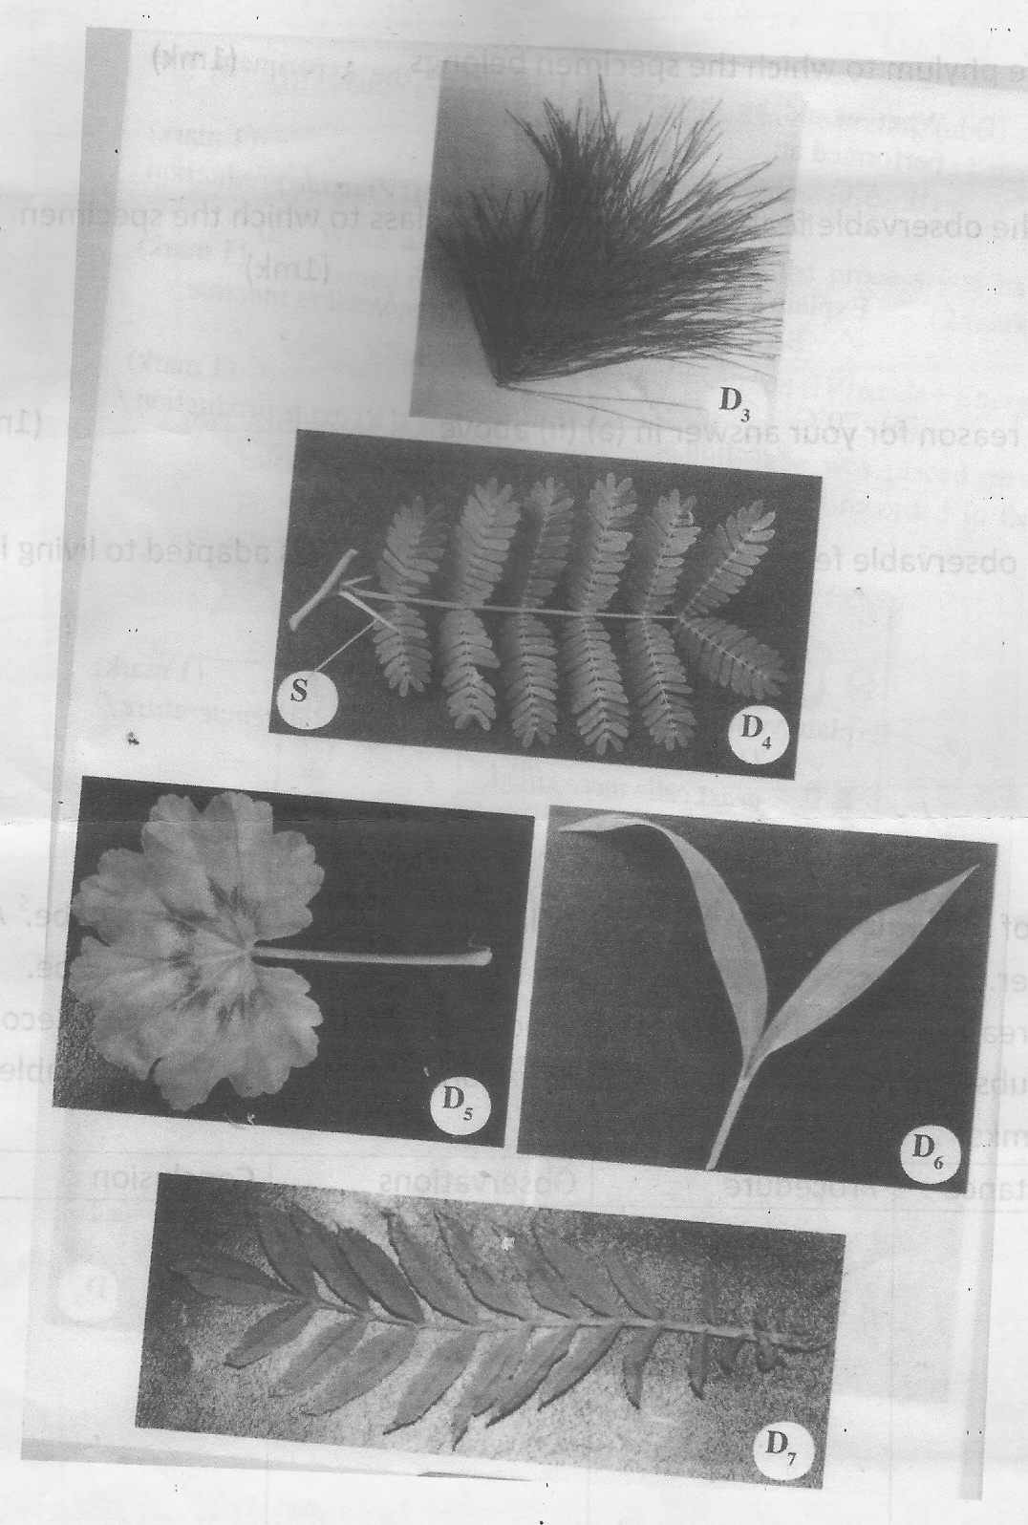

Biology Paper 3 3
1. (a) Leaves arranged in clusters on stem ……………………….. Pinaceae
(b) Leaves not arranged in clusters on stem …………………… go to 2

2. (a) Leaves compound……………………………………………. go to 3
(b) Leaves simple………………………………………………… go to 4

3. (a) Leaf pinnate………………………………………………….. Rosaceae
(b) Leaf bipinnate………………………………………………... Mimosaceae

4. (a) Leaves parallel veined……………………………………….. Graminae
(b) Leaves net veined……………………………………………. Geranaceae

- Use the dichotomous key to identify the taxonomic group of each of the five
specimens in photographs provided. (10mks)
Specimen Steps followed Identity

(b) (i) Suggest the possible habitat that specimen D₄ is adapted to. (1mk)

________________________________________________________________

- Name one observable features that adapts specimen D4 to the habitat you have mentioned in (b)(i) above. (1mk)

________________________________________________________________

(iii) Give one reason for your answer in (b)(ii) above. (1mk)

________________________________________________________________

________________________________________________________________

________________________________________________________________

(iv) What is the importance of the structure marked S in specimen D₄? (1mk)

________________________________________________________________

________________________________________________________________

________________________________________________________________

Biology Paper 3 4
3. You are provided with a photograph of a chloroplast and animal cell as seen under the
electron microscope. Examine them and use them to answer the questions that follow.
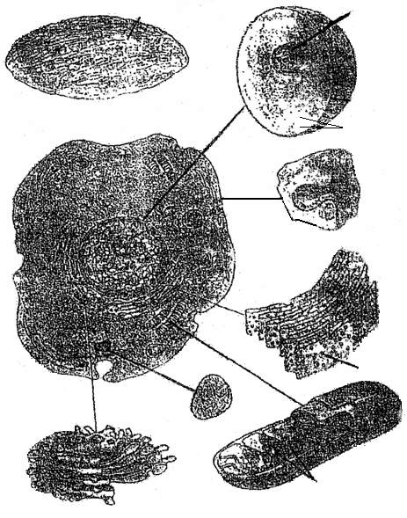
W
Y
B
A
X
C
Z
D
Plasma membrane
Chloroplast from a plant cell
Nucleus
Nuclear membrane
Chromosomes

- Name the organelles labeled: (4mks)

A ___________________________________________________________________

B ___________________________________________________________________

C ___________________________________________________________________

D ___________________________________________________________________

(b) State the functions of the structures labeled W, X, Y and Z. (4mks)

W ___________________________________________________________________

X ___________________________________________________________________

Y ___________________________________________________________________

Z ___________________________________________________________________

Biology Paper 3 5
(c) In the photograph, label the following structures: (2mks)
(i) Vacuole.
(ii) Pinocytic vesicle.

(d) Relate the structure of the organelle labeled C to its function. (2mks)

_____________________________________________________________________

_____________________________________________________________________

_____________________________________________________________________

(e) State the functions of the structure labeled D. (2mks)

_____________________________________________________________________

_____________________________________________________________________

_____________________________________________________________________

_____________________________________________________________________

Biology Paper 3 6

