Name: …………………………………………………. Index Number: ……………………..

KISIMA MIXED SECONDARY SCHOOL
BEGINNING OF TERM EXAMINATIONS – TERM ONE
FORM FOUR – 2018
MATHEMATICS – 100 MARKS

SECTION I - 50 marks

Answer all the questions in this section in the spaces provided.

- Use logarithms, correct to 4 decimal places, to evaluate: (3 marks)
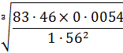

- Factorize completely (3 marks)

- Simplify the following expression completely 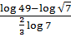 (3 marks)

- Make T the subject of the formula 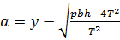 (3 marks)

- The mean weight of 36 students is 45kg, two of the students leave and the mean increases by
0.5kg. If one of the students who left weigh 43kg, find the weight of the other one. (3 marks)

- P varies as square of M and inversely as square root of N. find the percentage change in P
when M increases by 20% and N decreases by 36% (3 marks)

- Write down the first four terms of the expression in ascending powers of giving your answer in simplest form. Hence find the value of , giving your answer correct to 3 decimal places. (3 marks)

- A radio costs sh8000 when new. Its value depreciates at a rate of 5% p.a for the first 2 years then
it depreciates at a rate of 3% p.a for the next 5 years. Express its value 6 years after it was
bought as a percentage of its value when new. (3 marks)

- Simplify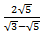 leaving your answer inform of , where a, b and c are rational numbers. (3 marks)

- The data below represents the ages in months at which 6 babies started walking: 9, 11, 12, 13,
11 and 10. Without using a calculator, find the exact value of the variances. (3 marks)

- The base and height of a right angled triangle were measured as 6.4cm and 3.5cm respectively.
Calculate the maximum absolute error in the area of a triangle. (3 marks)

- Under a transformation defined by , an object in area is mapped onto
an image whose area is . Find the value of (3 marks)

- Given that and that
. Find the magnitude of p to 4 s.f. (4 marks)

- Three representatives are to be selected randomly from a group of 7 girls and 8 boys. Calculate
the probability of selecting two girls and one boy. (3 marks)

- In the figure below, the tangent ST meets chord VU produced at T. chord SW passes through
the center, O, of the circle and intersects chord VU at X. line ST=12cm and UT=8cm.

S
V
O
X
W
8 cm8 cm
U
12 cm
T
12 cm
T

8 cm
U
O
X
v
v

W

(a) Calculate the length of chord VU. (2 marks)

(b) If WX=3cm and VX:XU=2:3, find SX. (2 marks)

- Form the three inequalities that satisfy the given region R. (3 marks)

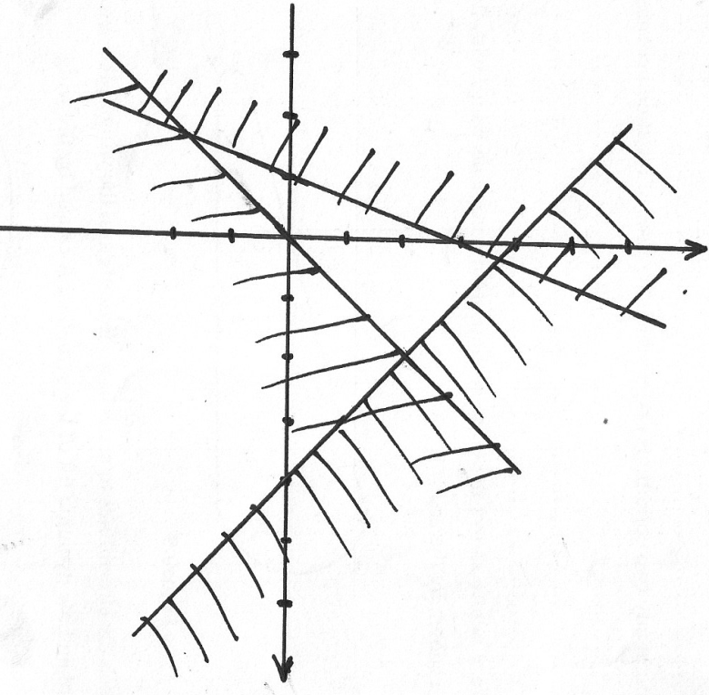

SECTION II - 50 marks

(Answer ANY FIVE questions in the spaces provided)
- A number of students were asked to cut 30cm length of binding wire without measuring. Later
100 pieces were collected and measured correct to the nearest 0.1cm and the data filled on the
table below.

Length in cm | 28.0-28.4 | 28.5-28.9 | 29.0-29.4 | 29.5-29.9 | 30.0-30.4 | 30.5-30.9 | 31.0-31.4 | 31.5-31.9
No. of pieces | 5 | 8 | 30 | x | 10 | 20 | 10 | 4

(a) Calculate the value of (1 mark)

(b) State the modal class (1 mark)

(c) Using 29.7 as working mean, calculate
(i) The mean (4 marks)

(ii) The standard deviation (4 marks)

- (a) On 1st July 2008, Halima deposited a certain sum of money in a bank that pays simple
interest at a certain rate. On 30th June 2013, her total amount in the bank was
sh 496,000. If the interest earned each year is sh 35,200, find;

(i) The amount of money that she deposited. (2 marks)

(ii) The annual rate of interest that the bank paid. (2 marks)

- A set of furniture whose marked price is sh 120,000 is sold at sh 162,000 on hire
purchase terms. The hire purchase terms require a deposit of 30% of the marked price
and a certain number of equal monthly installments.

- Rajab bought the set on hire purchase terms. If his monthly installments were of
sh 5,250, find the number of installments. (3 marks)

- Rehema bought the set on cash. She was allowed a discount 7.5% on the marked
price. Find the difference in the amounts that Rajab and Rehema paid and express
it as a percentage of the marked price. (3 marks)

- Two tanks of equal volume are connected in such a way that one tank can be filled by pipe A
in 1 hour 20 minutes. Pipe B can drain one tank in 3 hours 36 minutes but pipe C can alone
drain both tanks in 9 hours. Calculate;

(a) The fraction of one tank that can be filled by pipe A in 1 hour. (2 marks)

(b) The fraction of one tank that can be drained by both pipes B and C in 1 hour. (4 marks)

(c) Pipe A closes automatically once both tanks are filled. Assuming that initially both tanks
are empty and all pipes opened once, calculate how long it takes before pipe A closes. (4 marks)

- On the upper part of line AB, using pair of compasses and ruler only, construct locus of points
(a) T such that angle ATB = 45° (3 marks)
(b) M on AB which is equidistant from A and B (2 marks)
(c) S which is equidistant from A and B and lies on T (1 mark)
(d) Calculate the area bounded by loci T and line AB (4 marks)

A
B

- In the figure below (not drawn to scale)
C
D
6 cm
8 cm
B
A
7 cm
D

7 cm
C

6 cm

B
A

Calculate to 2 decimal places

(a) The length BC (3 marks)

(b) The size of angle ABC (2 marks)

(c) The size of angle CAD (3 marks)

(d) The area of triangle ACD (2 marks)

- There are 2 bags A and B. Bag A has 4 white balls and 6 red balls. Bag B has 2 white balls and
3 red balls. Each bag has an equal chance of being picked. If a bag is selected randomly and 2
balls picked with replacement in bag A and without replacement in bag B. Find the probability
that:

(a) They are both white. (2 marks)

(b) They are of different colors. (3 marks)

(c) At least one ball is red. (2 marks)

(d) None of the balls is white. (3 marks)

- A piece of wire can be bent into a rectangle whose dimensions are such that its length is 3 cm
longer than its width. The area of the rectangle so formed is 28 cm².
(a) Determine;
(i) The dimensions of the rectangle. (4 marks)

(ii) Perimeter of the rectangle. (2 marks)

- The wire can also be folded into a circle. Find the radius and the area of circle
(Take $\text{pi}=\frac{\text{22}}{7}$). (4 marks)

- The following table shows values of and some of their corresponding values of for the
curve in the range
 | -4 | -3 | -2 | -1 | 0 | 1 | 2
 | -1 |  |  | 2 | -1

(a) Complete the table. (2 marks)

(b) On the grid provided, draw the graph of for the range (3 marks)

(c) By drawing a suitable straight line on the same grid as (b) above, solve the equation
(5 marks)

This is the last printed page.

