NAME………………………………………………… INDEX NO…………………………………
Candidate signature…………………………………..
DATE……………………………………..
AGRICULTURE MOCK 2015
PAPER 1
TIME: 2HOUR

INSTRUCTIONS
The paper consists of three sections A , B and C
Answer all questions in section A and B in the spaces provided
Answer any two questions from section C on foolscaps provided

FOR OFFICIAL USE ONLY
section | Question | Maximum score |  | Candidate score
A | 1- 18 | 30
B | 19 -22 | 20
C | 23  24  25 | 40
 | TOTAL |  | 90

SECTION A (30MARKS)
Answer all questions from this section in the spaces provided
1. State three advantages of single fertilizer (1½ marks)
………………………………………………………………………………………………………………………………………………………………………………………………………………………………………………………………………………………………………………………………
2a) Give two characteristics of Calcium Ammonium Nitrate fertilizer (1 mark)
……………………………………………………………………………………………………………………………………………………………………………………………………………………
b) Why is Diammonium phosphate fertilizer considered to be acidic? (½ marks)
…………………………………………………………………………………………………………
3. List three factors that affect quality of Farm Yard manure (1½ marks)
………………………………………………………………………………………………………………………………………………………………………………………………………………………………………………………………………………………………………………………………
4. State four factors that would influence the demand of casual labour in a farm (2marks)
…………………………………………………………………………………………………………………………………………………………………………………………………………………………………………………………………………………………………………………………………………………………………………………………………………………………………………
5. Name three financial documents. (1½ marks)
………………………………………………………………………………………………………………………………………………………………………………………………………………………………………………………………………………………………………………………………
6. State two control measures of squirrels in a rice field (1mark)
……………………………………………………………………………………………………………………………………………………………………………………………………………………
7. State two ways of overcoming the problem of water logging in crop production. (1 marks) ……………………………………………………………………………………………………………………………………………………………………………………………………………………
8. Given that at a price of Ksh 100 per bag, 30 bags are demanded but when price changes to Ksh400 per bag then 20 bags are demanded. Calculate the Elasticity of demand. (2marks) ……………………………………………………………………………………………………………………………………………………………………………………………………………………………………………………………………………………………………………………………………………………………………………………………………………………………………………………………………………………………………………………………………………………
9. Differentiate between a bulbul and a bulb as storage organs for propagation. (2marks)
………………………………………………………………………………………………………………………………………………………………………………………………………………………………………………………………………………………………………………………………
10 a) What two factors encourage shifting cultivation? (1mark)
……………………………………………………………………………………………………………………………………………………………………………………………………………………
b) List two characteristics of fixed inputs. (1mark)
……………………………………………………………………………………………………………………………………………………………………………………………………………………
c) State the law of equi-marginal returns. (1mark)
……………………………………………………………………………………………………………………………………………………………………………………………………………………
11. Give two advantages of adding organic matter to clayey soils. (1marks)
……………………………………………………………………………………………………………………………………………………………………………………………………………………
12. Give two symptoms of bacterial diseases to crops. (1 mark)
……………………………………………………………………………………………………………………………………………………………………………………………………………………
13 What three factors influence labour productivity in a farm? (1½ marks)
……………………………………………………………………………………………………………………………………………………………………………………………………………………………………………………………………………………………………………………………..
14. Give three importance of ridging. (1½ marks)
………………………………………………………………………………………………………………………………………………………………………………………………………………………………………………………………………………………………………………………………
15. Why should a farmer regularly test the soil on his farm? (2marks) ………………………………………………………………………………………………………………………………………………………………………………………………………………………………………………………………………………………………………………………………
16. Give two ways through which aphids attack crop plants. (1 marks)
……………………………………………………………………………………………………………………………………………………………………………………………………………………
17. Define the following terms as used in pasture establishment and management. (2marks) i)Topping
………………………………………………………………………………………………………… ii)Re-seeding
…………………………………………………………………………………………………………
18.a) Give four importance of farm budgeting (2marks) …………………………………………………………………………………………………………………………………………………………………………………………………………………………………………………………………………………………………………………………………………………………………………………………………………………………………………
b)List two functions of Pyrethrum board of Kenya. (1mark) ……………………………………………………………………………………………………………………………………………………………………………………………………………………

SECTION B (20 marks)
Answer all questions in the spaces provided
19.a) Identify the following crop pests and diseases (2marks)
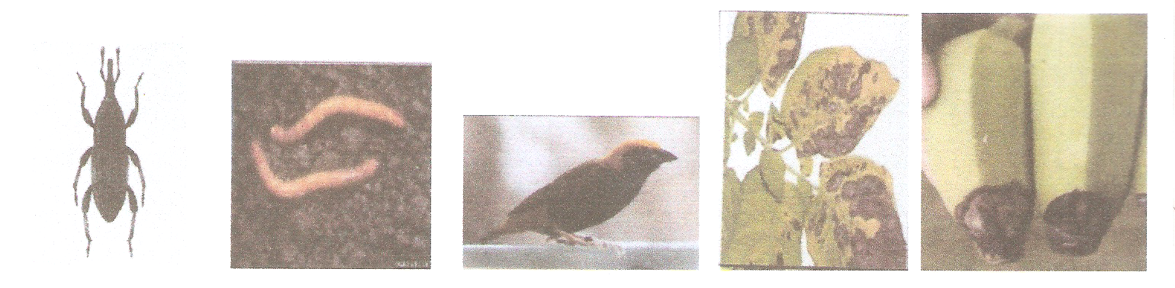
b)Name the causal organisms for diseases D and E. (1mark) …………………………………………………………………………………………………………………………………………………………………………………………………………………..
c)State two ways through which pest B affects crop production. (2marks) ……………………………………………………………………………………………………………………………………………………………………………………………………………………
d) List two ways of controlling disease D. (2marks) ……………………………………………………………………………………………………………………………………………………………………………………………………………………
20a)Identify the weeds in the photograph below. (2 marks)
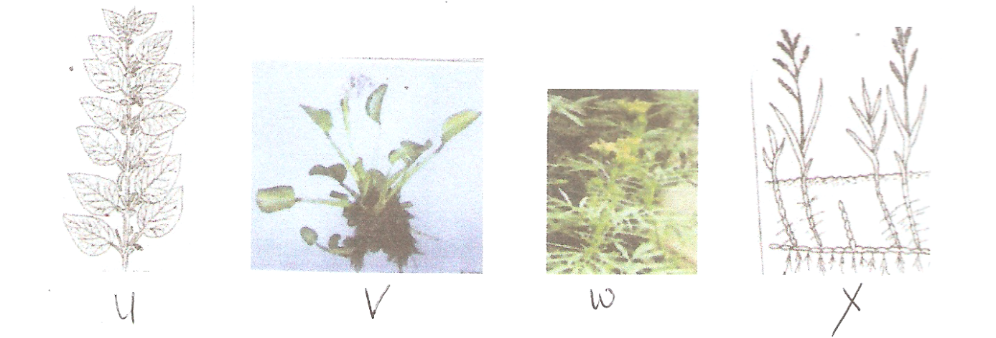
b) Classify the weeds according to their morphology. (2marks) ……………………………………………………………………………………………………………………………………………………………………………………………………………………………………………………………………………………………………………………………..
c)How is weed W and X propagated? (1mark) …………………………………………………………………………………………………………………………………………………………………………………………………………………..
21.Study the graph below and then answer the questions that follow.
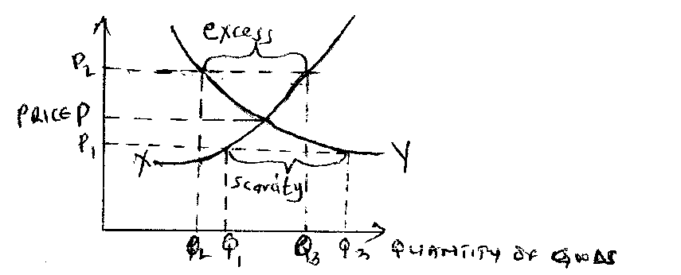
a)What is the name given to the part labelled P? ( ½ mark) ………………………………………………………………………………………………………
b)What is the relationship between P₁, Q₁ and Q₃? . (2marks) ……………………………………………………………………………………………………………………………………………………………………………………………………………………
c)State why there is excess of supply at P₂. (1mark) ……………………………………………………………………………………………………………………………………………………………………………………………………………………
d)Identify market forces that influence price theory. (1mark) ……………………………………………………………………………………………………………………………………………………………………………………………………………………
22a) Identify the following soil structures. (1½ marks)
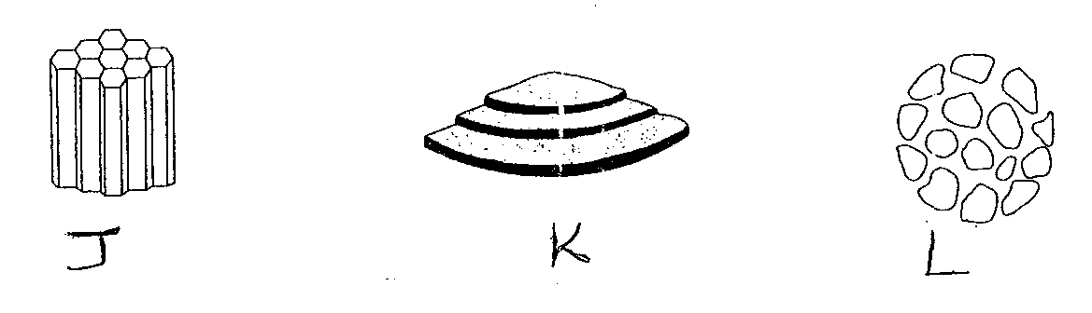
b) Which of the structure(s) above are found in the sub soil. (1mark) …………………………………………………………………………………………………………

c)Distinguish between soil structure and soil texture. (1mark) ………………………………………………………………………………………………………………………………………………………………………………………………………………………………………………………………………………………………………………………………

SECTION C (40marks)
Answer any two questions only from this section on foolscaps provided

23a) List five advantages of budding. (5marks)
b) Discuss factors that affect spacing in crops (8 marks)
c)Describe harvesting and precautions to be observed during tea plucking. (7marks)

24 a) Describe human factors that influence agricultural production. (7marks) b)Describe the preparation of Farm Yard Manure clearing stating the factors that influence the quality. (8marks)
c)State five objectives of million acre scheme. (5marks)

25 a)The following is a list of financial transactions and position of Mr Kamau’s farm for the year ended 2007. Study it and then answer the questions that follow
purchase of fertilizer sh 1600, coffee sales sh 7000, wages sh 3400, milk sales sh 4300, Interest payable sh 700, purchase of hand hoes sh 5000, construction of crush sh 1600, opening valuation sh 8000, purchase of dairy meal sh 2000, purchase of fungicides sh 1250. Closing valuation sh 16000, veterinary bills sh 1800, sale of sheep sh 4000, depreciation of machinery sh 3700

i)Prepare a profit and loss account for the farm. (10marks)
ii)Calculate the percentage profit or loss (2marks)
iii)State the information contained in an invoice (3marks)
b)Describe the basic concept of agricultural economics. (5marks)

