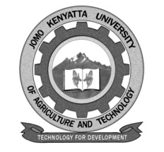
W1-2-60-1-6

JOMO KENYATTA UNIVERSITY OF AGRICULTURE AND TECHNOLOGY

University Examinations 2018/2019

FOURTH YEAR SECOND SEMESTER EXAMINATION FOR THE DEGREE OF BACHELOR OF COMMERCE

HBH 2406: CONTEMPORARY ISSUES IN HUMAN RESOURCE MANAGEMENT

DATE: DECEMBER, 2018 TIME: 2 HOURS

INSTRUCTIONS: ANSWER QUESTION ONE (COMPULSORY) AND ANY OTHER TWO QUESTIONS

QUESTION ONE: 30 MARKS

a. A large percentage of the workforce today consists of employees born after 1978, thus generation / employers. Examine the characteristics of this group employees and the challenges that they may pause to an organization and suggest ways of managing them effectively. (20 marks)

b. Explain ways in which technological development can help the Human Resource Department of an organization carry out its functions effectively. (10 marks)

QUESTION TWO: 20 MARKS

Examine the challenges that both individual employees and the organizations
encounter when employees reach their retirement age and suggest coping
strategies for them.

QUESTION FOUR: 20 MARKS

Organizations should consider full outsourcing the Human Resource Management
function. Discuss

QUESTION FIVE: 20 MARKS

Examine the approaches that can be used to Audit the effective functioning of
Human Resource Department and high light the key areas the audit should capture.

