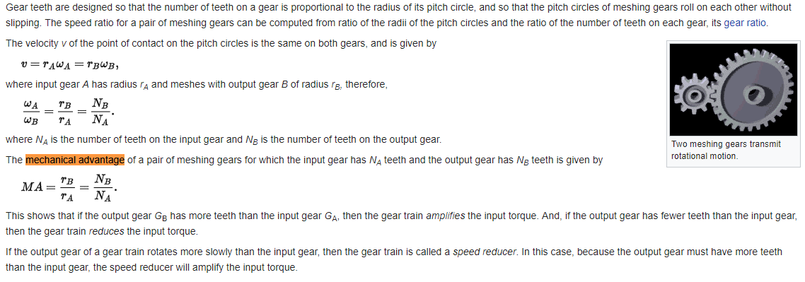

There for is the input teeth =25, output teeth =100 with 85% efficiency
Then $\frac{100}{25}×\frac{85}{100}=3.4$
So the mechanical advantage is the gear train will amplify the input torque by 3.4 times.

